**Course Introduction**

Amazon become an empire of different services, specifically when it comes to cloud, **it is the 800-pound gorilla in the room, and its name for public cloud.**

**The Course at a Glance**

A lot of people think: cloud will take away their jobs that the cloud is another form of outsourcing,in terms of replacing you.

It is a form of outsourcing in terms of replacing the redundant hardware, racks, stack, cable, maintain, facilities, yes. But the only thing that you retain when you go to the cloud is the most important thing, that's the human capital. That's the intellectual property that organizations have invested and paid for, that's you. Those resources cannot be outsourced. We still need operators and architects to design on the cloud, and that's what I want to emphasize.

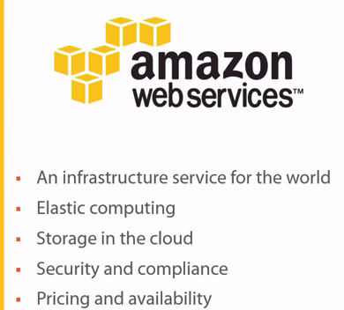

1.) You can leverage that infrastructure service for the world to deploy your applications on a worldwide basis. Yes, you can do that without necessarily having to build data centers across the globe. Why do that, leverage AWS?

Ex: If you're a marketing company that uses a lot of bulk emails, you need an email server just to send a lot of bulk emails. Well typically you would have to build an infrastructure, an entire infrastructure for that application to send emails. And you would have to worry about email reputation, and how to make sure you're not getting filtered for spam, et cetera.

Well, guess what? Amazon has a service, for example, called **Simple Email Services.** That's a service for hosted applications where you can leverage Amazon's email reputation, you can leverage their email service for outbound emails.

**Now keep in mind this is not going to replace your on-premises exchange or in the cloud exchange server.** There's no mailboxes that get created here. This is a service that you leverage to send out bulk emails.

**Amazon is in the mindset of a service-oriented architecture, SOA.** **That's what you should be thinking about** when you're in the cloud. In the cloud, everything is bits and pieces. If you need email services, guess what? There's a service for that.

If you need notifications services, there's a service for that. If you need queuing services for your applications, there's a service for that. If you need virtual machines, you can provision them. If you need storage, you can provision it. If you need database services, you can access them. So everything is in these chunks of services that you can consume, and not everything is on the same server.

Not everything has to build on the same server, or the way that we've been building traditional infrastructures for the longest time.

2.) So keep that in mind, it's definitely a new, it's a fresh approach at doing things. One that's very different then the way that we've built data centers in the past. So it's all about elastic computing, something that we would have a hard time doing on-premises. How do I grow and shrink the environment, you know, in a matter of minutes whenever I need, you know, 500 new virtual machines. Let's spin them up. Well, I don't need 500 new virtual machines, I need 200 virtual machines. Well you spin them down, right? Now you're probably saying, well I can do this today with my virtual environment. You could, depending on how much you've over-provisioned your environment. If you've over-provisioned your environment to a capacity to a capacity of 500 VMs, great, you can go up to them. But what if you acquire a company, or what if there's a new product that requires 1,000 VMs? **Well guess what, now you have to go out buy hardware, you have to integrate that hardware, you have to test that hardware. That'll take you weeks and months.**

On the Amazon Web Services platform, that'll take you minutes. So the elastic computing, the idea of being able to expand and shrink your environment is crucial.

3.) Storage in the cloud. Leverage the storage. You can leverage tiered storage. You can have fast SSD. You can have a long term archiving type storage. You can have object based storage. There's a lot of different storage capabilities that you can leverage in the cloud.

4.) Security and compliance, everybody seems to think, hey, we're not going to the cloud, it's not secure. Guess what? **All of the major companies and enterprises that have had security breaches to this day have not have a security breach because they were in the cl**oud. All of their on-premises data centers have been breached. All of them.

You're going to find very rare instances where a big brand name where it was breached in the Amazon cloud. In most cases when you get breached in the Amazon cloud, or in any other of these loud, large hyperscalers, it's a matter of you haven't done enough due diligence, enough work to secure your environment in the cloud.So we're going to talk about that as well.

4.) Pricing and availability. One of the biggest barriers to entry into the cloud is not knowing how to configure pricing. So if you're going to go in with the mindset of, you know what, I have 1,000 virtual machines, and you're going to take your 1,000 virtual machines and you're going to put them in the Amazon cloud, and they're going to run for 24/7. It's going to be more costly than what you have on-premises today. Yes, it's not going to be cost effective.

The idea behind cloud is that it forces you to rethink things. It forces you to think, do I need this virtual machine to be on 24/7? If not, I need to power it off. What are the times that I need this virtual machine to be on? That's how you're going to save money in the cloud, by doing your homework.

It's not as easy as saying I'm just going to keep everything powered on. The reason we do that on-premises is because you really don't feel the costs, we have no repercussions if we keep a virtual machine powered on for 24/7.

We don't account for how long or how much it takes to cool the server that the virtual machine is on. We don't take into account, well I could power down these 100 virtual machines and then power down the hosts, and do a lot of things that would save me on power, on cooling, on facilities.

We don't take any of those into account, and as a result, we don't have the accountability of price when it comes to on-premises. Which is why when you're going into the cloud, everything is accounted for, which is why you have to properly study your pricing.

5.) And then we get into availability. Well today you have one data center. Whereas with Amazon, I am giving you access to the world. Wherever they have regions availability zones, you can deploy resources. Think of that. Think of that as we start to go through this course. Think of how you can expand your business. Think about what that does for mergers and acquisitions. Think of what that does for getting your compute or your resources closer to where your users are around the world. The AWS story is a fascinating one, and I'm going to show you how you can leverage it to improve your career and to build upon it.

**What Is Cloud Computing?**

What is cloud computing? Six or seven or eight years ago, putting a question like this out there, would have been like saying, who killed JFK? It's like a mystery wrapped in a riddle inside an enigma. What did Joe Pesci say in the movie JFK? He said, "Even the shooters don't know," so that's how complicated cloud computing was.

NIST (National Institute of Standards and Technology) define cloud computing, it's "a model for enabling ubiquitous, convenient, "on-demand network access, "to a shared pool of configurable computing resources, "for example, networks, servers, storage, "applications, and services "that can be rapidly provisioned and released "with minimal management effort "or service provider interaction."

Easier definition for what is cloud computing:

Cloud computing is the automation of highly virtualized environments.

Five essential characteristics, three service models, and four deployment models that make up cloud computing...

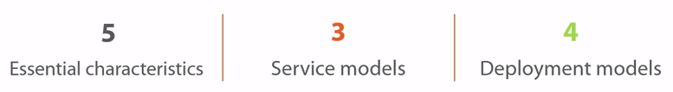

**Essential characteristics:**

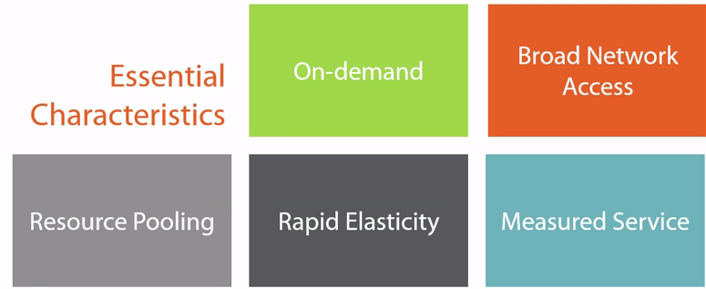

**On demand:** beauty of cloud computing. On demand, you can get access to resources. You don't have to wait for weeks to get the servers. You don't even have to wait for days to get those servers, or even hours to get those servers. You want those servers, you can go in and provision them yourself**. So it's on demand, it's instant.**

**Broad network access**: you can access the cloud from anywhere. You don't necessarily have to be tied to your organization's network to do that. You can do that across the internet. You can do that across the WAN, LAN.

**Resource pooling:** gives you the ability to, to have four or five, or 10, or hundreds of servers and you're pooling resources from them as far as CPU, as far as storage, as far as networking is concerned.

**Rapid elasticity:** means you can scale up and scale down very quickly. You need 100 servers for a week? Sure, no problem. You can do that on-demand, immediately, right now, get 100 servers.

Well, at the end of next week, you don't need these 100 servers anymore, guess what? You can scale down, get rid of maybe 90 of servers and stay on 10. So that elasticity, the ability for you to rapidly expand your environment or decrease your environment is also crucial as far as an essential characteristic of cloud.

**Measured services:** the ability for you to measure the services that you're using. If you're using a particular server and we're going to stick with servers just because it's easier to understand. If you're using it for 10 hours, then you'd pay for 10 hours. If you're using it for an entire day then you pay for a day. **It's that pay as you go** mentality of being able to measure these particular services and **paying for what you're**, for what you're using as well.

Measured services can also be related to service levels. So if you require a particular application or a particular server to perform at a certain level, then those can also be measured and you can be compensated if, for instance, those service levels drop below what you are contractually, what you've contractually agreed upon with your service provider.

**Service models:**

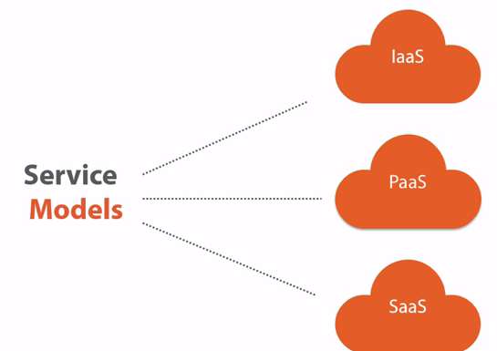

1. **Infrastructure as a service.** it's an abstraction layer between the data center. And now, what's in a data center typically? Well, you have facilities, you have air conditioning, you have servers, you have networking, you have storage, you have cabling, you have all the components that make up a data center.

Infrastructure was a service is coming and saying, you know what? I'm going to abstract all of that. I'm going to take away all of that complexity. You don't have to deal with any of that. You don't have to worry about facilities. You don't have to worry about security in that facility. You don't have to worry about networking, cabling, testing, nothing. Forget about all of the hardware complexity. Focus on your service. What is it that you're trying to accomplish? You need to install a change server? Great. Provision a virtual server, install your exchange application on it, move forward and forget about everything else. What they're essentially saying is, hey, we're going to abstract all the hardware, but on top of abstracting all the hardware, the reason it's an infrastructure as a service, and it's not a managed service where you're hosting it somewhere else and someone's managing your hardware which is a model that we're used to. Infrastructure as a service gives you that automation and orchestration. Gives you that elasticity. Allows you to scale up and down. All the characteristics that we just talked about applied to infrastructure as a service, which is what makes it cloud. It's what cloudifies it, is these components, that self-service, do-it-yourself mentality of being able to go in there and provision servers and applications and networks and load balances and all of those components that you used to have to do on physical equipment in your data center in the past. Now you do it on virtual equipment that's running in a data center that you have absolutely no clue where it is.

**So infrastructure as a service is an abstraction layer not just from your data center. It's the ability to also do things on-demand, through a self-service portal, without the help of anyone else, and everything else gets automatically, automagically provisioned in the background.**

1. platform as a service:

When you can have your developers again, develop the applications against a particular platform. Now this is when we start to get into service oriented architectures or SOAs, and how they're different from a client server application.

With the platform as a service, the application is aware of the infrastructure. If a particular portion of the application is suffering, for instance, if the application is under load and it requires additional database services, the application can provision additional database services. If a portion of the application fails, the application is aware that some apportion fails and it can redirect traffic or provision additional resources in order to support the load. So you're getting into a different dynamic with platform as a service and it's geared towards developers that can develop whether it's dot net or, any of the other platforms that are out there where you can develop your applications directly against a platform.

1. **Software as a service:** Software as a service are things like sales force. It's the stuff that you can consume. You're not necessarily developing against it. You're not necessarily hosting services, as is the case with infrastructure as a service. You are consuming an application. Now, that application can be.. It can allow you to build additional services, but it's already there. There's something there that you are then leveraging to create something else. Whereas with infrastructure as a service and platform as a service, these are essentially infrastructure-like services that you can then build services on top of. Software as a service is an application that's ready, that you can leverage that application to create additional services.

A good example, sales force. On the sales force platform or on the service now platform, you can build additional services but that exists already. You're not building it from scratch.

**Deployment models:**

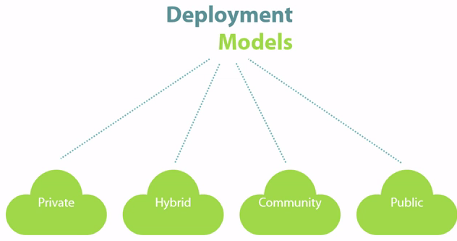

You can deploy the cloud a couple different ways. You can deploy privately.

**Private:** it could be on-premises, that's the most commonly used word for private cloud is on-premises deployment of a private cloud, where you have that Amazon infrastructure as a service like deployment, but it's on-premises.

You can also have a private cloud in the public cloud, where maybe the idea behind a public cloud is that you're sharing resources with other organizations and then logically, you are securing those, but you can very well be on the same server or on the same storage array with 10 or 20 or 200 other customers.

Well, in a private cloud in the public cloud, you might not want to be on shared resources so you carve out your own portion of the cloud, where you ensure that nobody is on that equipment. Nobody is on those servers. Nobody's on that storage, and you have it hosted somewhere else in the cloud. **Not as popular, and in my opinion, that's not going to be the model that's going to be popular moving forward,** but that's also a deployment method that's available, so there are two deployment methods when it comes to private cloud. That's the on-premises and then there's the private cloud in the public cloud deployment.

**Hybrid**. Now, with the hybrid model, you're able to extend your on-premises private cloud to the public cloud. So if, for example, you have a private cloud with a, I don't know, a capacity of 100 servers. And all of a sudden you need 50 additional servers, but you don't want to necessarily have to wait two weeks to get the equipment and build out that extra resource within your private cloud. What you do is then, you extend into the hybrid cloud, into the public cloud. That extension is the hybrid cloud.

The ability to take your private cloud and essentially stretch it and build those 50 additional services that we're talking about on the public cloud platform and access them as if they were locally on your private cloud, so that the ability to do that hybrid cloud is also very crucial.

**Community clouds** are also interesting. Community clouds are essentially vertical clouds. So you might see, for example, and we'll talk about this later, that Amazon Web Services has a vertical specifically for government, the Gov Cloud. You have to be a government institution in order to be able to access Gov Cloud. And Gov Cloud has a series of certifications and regulatory compliance and requirements that it meets.

The same thing might happen with maybe a health cloud, where you have all the HIPAA compliance all the regulatory compliance that are necessary for the health care industry. Financial is another one, and so on and so forth. It's a verticalized cloud specific to a particular industry. And then you have public cloud.

**Public cloud** is where you can use things like, for instance, infrastructure as a service from Amazon Web Services. That's where you can go out. Its shared resources. Again, you and other customers will most likely be on the same servers, on the same storage, so again, it's that pooling of resources and the ability to leverage the scale and reach of cloud providers such as Amazon.

**Key Dates in the History of Cloud Computing**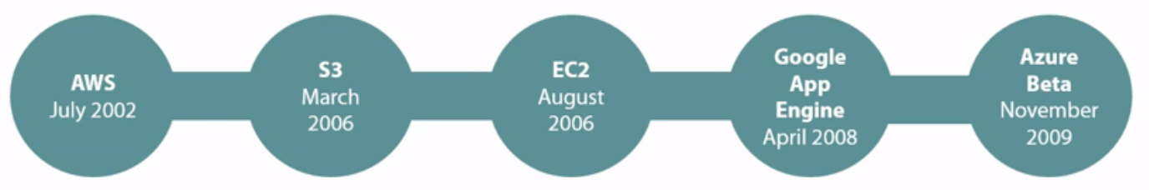

The launch of AWS in 2002. In 2006, S3 and EC2, Google App Engine, Microsoft Azure. These are all key dates that you should be aware of.

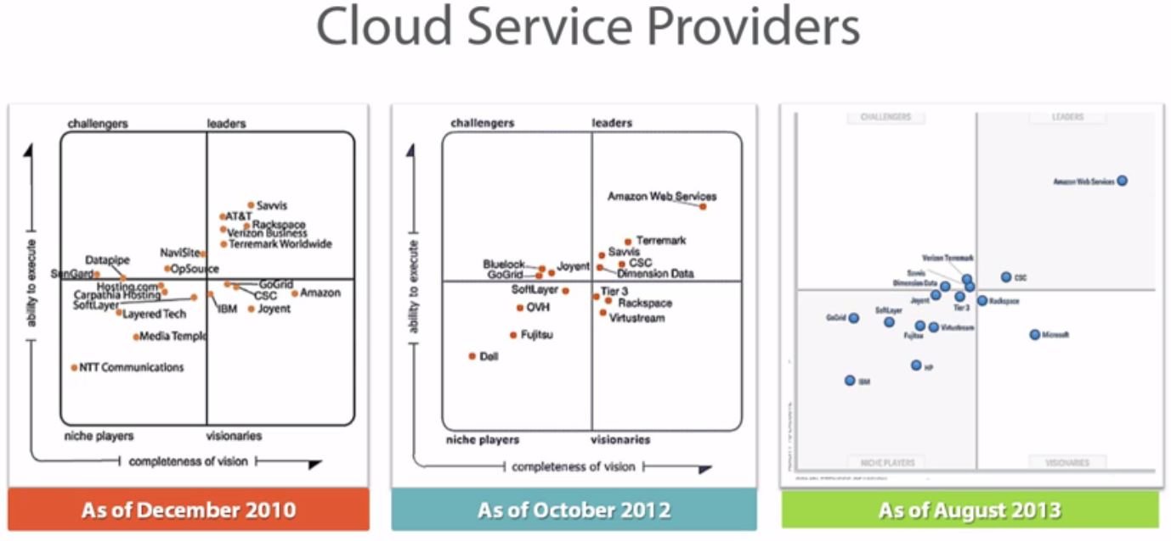

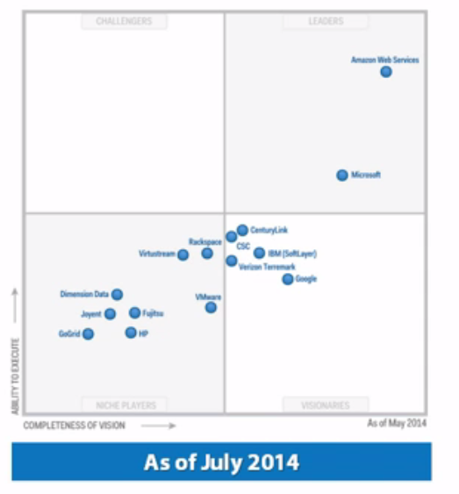

With cloud computing, there's a shift from the traditional build-and-operate that we're used to consume that we need to get used to. So what does built-and-operate mean? 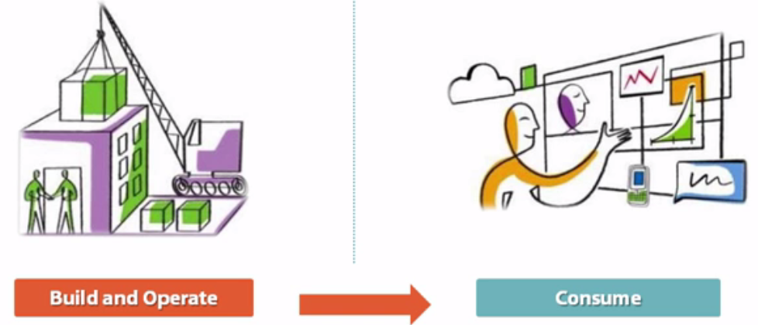

Well, for the last 20, 30 years, however long you've been in technology, you've had this mindset, this mentality, that we would build and operate our data center. Now, maybe we wouldn't build the facilities. Back then we were building the facilities and then hosting the equipment in them, and then we started gravitate a little bit towards...

Let's consume the facilities from somewhere else. Let's go to a hosted provider. We'll have a cage in there and we'll still put our equipment and we'll build our data center, but we don't want to be in the facilities business. So you see how our mentality started to change as well.

🡪We went from building the facility, putting the air conditioning and worry about heating and cooling and all of that, to finding a more optimal way of doing it which is the host our data center somewhere else and then we kept, again, building our servers and our storage in an infrastructure and then building the operating system and the software, rack, stack, cable, all of that was build and operate.

**Well, we need to start changing our mentality to a consumption mentality.**

Which means, let's not worry about the facilities. I don't care where it's hosted. Let's not worry about the physical servers and the virtual servers and...

Well, the virtual servers we do, but the physical servers and the physical network and the physical storage and the cabling and the racking and the stacking and the cooling and the security and all of the logistics that come with that.

Let's not worry about that, and let's just worry about consumption. Do you need a virtual server? Great, go get it. How fast do you need it? As fast as you can swipe your credit card, you need it. You didn't even need to swipe your credit card. If your credit card is stored, then all you have to do is basically select that particular sever and it'll take minutes before it's provisioned for you. You need network? Go ahead, consume it. Take it. You need a load balancer? Great. Consume it, take it, configure it. VPN, go ahead. Build it. The idea of focusing on the services. Focus on your business as opposed to focusing on being in the building and operating mentality of the last 30 years. That is essentially the difference. That is the shift from the on-premises to the cloud. Now, that doesn't mean on-premises is going away. It's not going away. It's just going to be for more valuable assets that are going to remain on-premises. And then almost everything else can go in the cloud. You're certainly at a phase where we were with virtualization. With virtualization today, you say, justify a physical server, right? Well, in a few years, you're going to start saying justify putting it in the on-premises data center because it's expensive to host it there. So unless it's absolutely necessary, very high security, very important stuff, that stays on-premises, maybe. Everything else, you should be able to leverage the public cloud, and do it in a way where it's easier for you to consume and it's cheaper for you to consume.

**So again, it's a shift from the traditional build-and-operate and we're going to do everything ourselves, to the consumption model of, don't worry about the hardware aspect, worry about your services. And you can worry about your services in varying models. If you still want to build servers and desktops, even if you want to, and install applications, you can do that. Don't worry about the physical aspect. Just worry about operating system and up. If you want to take that one step further and maybe get into platform as a service, you start abstracting more stuff.**

Do not think of cloud computing as a threat to your job. If you think about it that way, you're going to be stuck. You're going to be in defense mode. And this train isn't going to stop. You're not going to stop this wave. You can stand in front of it, it's just going to... It's going to run all over you. My recommendation is, make yourself more valuable. And the way you make yourself more valuable, well, you're watching this course, so you're obviously smart. You're jumping on board the cloud computing bandwagon. You already know how to do the on-premises stuff. Now, learn how to do the cloud stuff as well. **So, make yourself more valuable as opposed to trying to fight this wave of cloud computing.**

**Introduction to AWS**

**AWS History**

Amazon's chief, Jeff Bezos (CEO):

2002🡪delivering information to partners via Web Services.

In 2006, EC2 and S3.

**On-premises Components**

Look at what it takes to run a on-premises data center: You need security, you need cooling, you need connectivity, you need servers, you need storage, you need intellectual capital expertise, you need networking hardware, you need cabling, you need facilities.

You need intellectual capital expertise in almost every one of them, right? If you think about it, today in your environment, you'd probably have a team that deals with servers and operating systems.

You probably have another team that deals with networking. Keep in mind those circles as I'm talking. You'd probably have another team that deals with storage, hmm. You'd probably have another team that deals with facilities, mm. Cabling might fall under that, cooling might fall under that, maybe connectivity could fall under that or it could fall under networking. You have another team, definitely, that deals with security. Guess what?

These are silos within your environment, and every one of those silos requires intellectual capital expertise to make it run.

🡪Realistically, again, step outside of your IT persona for a second and tell me what does this bring value to the business? Yes, they're important, but they're very expensive, and as you grow your data centers over time, maintaining these silos of intellectual capital where you need these folks and then you need another set of folks to do applications and operating systems, sometimes they're the same, sometimes they're not, it becomes very frustrating.

Scaling this and being able to build those repeatable processes, putting in these automation systems and having the documentation, all of this becomes almost a business within a business, and becomes very expensive. So all of these on-premises components, yes, they've worked for the last 30 years, but realize that the world wasn't moving at the speed that it is today. Realize that globalization and the fact that we're doing business worldwide, not just Amazon, every business today is doing business worldwide, which means you have to be able to scale to the size of Amazon without necessarily having the deep pockets that Amazon has. So all of these are components that you're familiar with. All of these are on-premises components that you need in order to build data centers.

Let’s see before and after:



All of the components that I just showed you, you can go out and buy individually, right? You can go out and buy all of these components, and put this beautiful bike together yourself. It will take you time. It will take you longer than just going to the store, buying the bike and just starting to ride it.

So if you are someone who wants to get in shape or if you're an athlete that wants to, I don't know, maybe you're trying to compete and you need a bike, well, you have two options. If you want to compete or if you want to start training tomorrow morning or even today, you can go to the store and buy a bike. This bike is completely built. It's built to specs by machines, maybe, et cetera, and it's ready. You just go buy it and you start riding it.

Now, alternatively, you can buy a kit that has all the components to make up the bike. Maybe you want different brakes on this bike. Maybe you want different colors for the handles, the seat should be different. Maybe the tires should be different. Maybe you just want to customize this great-looking bike and you just want to build it yourself. Sure, you can buy all of those components, but unless you're a bike builder, it will most likely take you hours, if not days, to put this bike together.

**So realistically, if your objective, and here we're going to take this example:**

If your business objective is to train for a marathon, then you probably want to go out and buy the bike and start practicing sooner rather than later. If your objective is to learn how to build a bike, then maybe you should go out and buy all of these components and build the bike yourself. I can give you multiple examples of that.

For my video training, I can either go buy a computer and a server and start recording with a microphone, or I can try to build my own computer by buying the motherboard, the RAM, the video card, et cetera, putting it together, installing the operating system. It's just a matter of priorities.

**How fast do you want to start on the more important thing in your life, the objective? If your objective is to train for the marathon, then you probably want to go out and buy a bike immediately, right away, now. If your objective is to learn how to build a bike, well, maybe you go out and buy a kit. If your objective is to run a marathon, but you're not really in a hurry, and you want to build a bike because you think that it'll be more reliable and faster, then by all means, go out and buy it.** Again, you're probably going to maybe not have all the tools required. You're definitely not going to have all the know-how, especially if it's a bike that you've never built before. But you get the idea, before and after. It's the same thing with data centers and Amazon.

Sure, we've been building data centers for the last 20 or 30 years, and we've gotten really good at it. **Now what Amazon is offering is, look, instead of you wasting your time on facilities and worrying about all of this stuff, we are going to do it on a massive scale. We're going to put automation in there, and I'll show you a little bit later on some really cool stuff. And we're essentially going to become masters at this. Why don't you focus on the stuff that makes your business run? Why don't you focus on how you can become more profitable, quicker?**

Now, that doesn't mean that you're not going to be building servers, except you're not going to be racking, stacking, cabling, putting memory in, testing the memory. All of that is abstracted. Focus on bringing up that virtual server, put the right application, hand it over to the application server people so that we can get to the point where we're making money faster. Because it today's world, those that make money faster are going to always be ahead. That's the idea behind this bike that I wanted to share with you.

**Do-it-yourself (** DIY) **vs. AWS**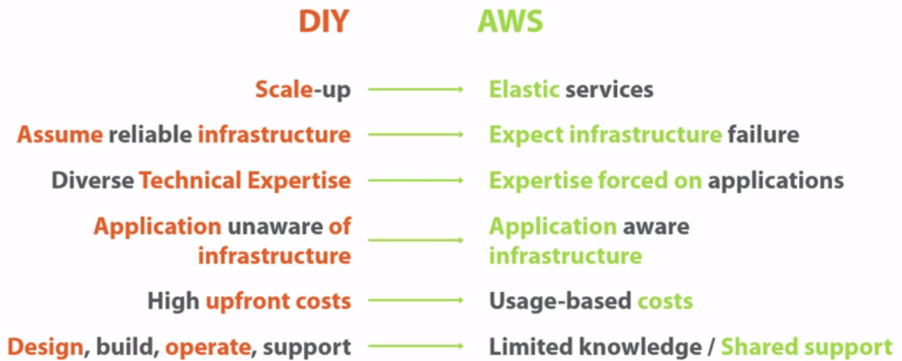

**1.)Concept of scale up**: With do it yourself:

You make a large purchase today of a hundred servers, and that might serve you for, let's say, six months or a year, and then you make an acquisition or a merger, something happens where you need more capacity.

So what do you do? The business tells you that, "We're acquiring another company, and that other company is maybe half of our size." Well, half of our size means I might need another 50 servers. So what do you do automatically? You overprovision, which means if you need 50 servers, you're most likely going to go out and buy a hundred servers.

So you've just added another hundred servers, for a total of 200 servers and so on and so forth.

With AWS, you don't need to do that. The elastic service allows you to scale up and scale down as you need. So if you need a hundred servers today, you can scale up to a hundred servers. If tomorrow you don't need these hundred servers, and all you need is 50 servers, you scale down to 50 servers. Just imagine the cost savings in terms of capital expenditure that you've just saved between the do-it-yourself method and AWS, and it's on the fly. It's not it takes weeks, it's immediately you can take advantage of these types of services.

2.) With do it yourself, with a traditional on-premises data center, without the cloud, you have to **assume reliable infrastructure.** You're building your infrastructure in a way where the application is assuming reliable infrastructure.

You're doing clustering at the operating system level.

You're replicating your sends.

You have fillover capabilities on the network.

You are building a reliable infrastructure. …Guess what?

With Amazon Web Services, with cloud in general**, expect infrastructure failure.** What are you, crazy, Eli? No, I'm not crazy. They are giving you a platform, and they're telling you it is going to fail. Build your applications, build your infrastructure around the concept that it's going to fail.

Now, if you step back and think about it for a second, which option would you prefer? Obviously, for the longest time I was on the left. I would prefer to build and assume a reliable infrastructure.

But as you start to think about it, if you change your mindset and expect infrastructure failures, you can then build your applications in a way to expect the infrastructure failure and kind of get over it. There are ways of doing that, and we'll talk a little bit later on design principles and how you can **expect an infrastructure failure, and again, react to it.** But those are the two differences there.

3.) You have diverse technical expertise versus expertise that's focused on applications. Diverse technical expertise means that there are different silos within your environment. You have a networking team, a storage team, a services team, servers team, a facilities team, et cetera, so you need technical expertise and you got application teams. You have all of these teams with diverse technical expertise.

With AWS, let's take away a large chunk of that, focus on your applications. That doesn't mean you don't need administrators anymore, you do. That doesn't mean you don't need networking folks anymore, you do. But those networking folks are now not just focused on networking. Why? Because they're not managing the hardware. They just need to be able to configure the networking the way you want it. So they should be able to also manage the servers and they should be able to also manage the storage. Now that person who was a technical expert in just one silo can take on more because of the simplification. **So focus on the applications mean we're going to abstract all the complexity of the physical hardware. You focus on the virtual and the logical pieces, and focus on your applications, focus on what's going to make your business money.**

1. In a do it yourself, the applications are unaware of the infrastructure versus with AWS, the application could, could be aware of the infrastructure based on how you've developed it. What do I mean by that? Let me kind of dig a little deeper into that.

If you're installing an application on top of Microsoft Server, Windows Server, the application doesn't know if you've clustered that server. The operating system knows that it's clustered, but the application doesn't. The application is expecting that infrastructure to be up and running. If the infrastructure fails, the application fails automatically. So the application is unaware, it can't see it, it can't make any calls to the infrastructure, it can't request more capacity, nothing. All the application can do is perform poorly, and as a result, you would have to figure out why is this application performing poorly? Does it need more RAM, does it need more CPU? What's causing that slowness, and then you address it that way.

**With AWS** and with cloud, in general, applications can be aware of infrastructure, depending on how they've been developed, which means if you're developing your application properly against the cloud, the application can be aware of the infrastructure and can make requests, can make calls to the infrastructure to provision additional resources when it needs them. **So if the application requires more web servers because the load went up, the application can make a request to provision more web servers. If it requires more database servers or services, it can make that request, as well. The application is in tune, it's connected to the infrastructure and can manipulate the infrastructure to a large degree.** Those are differences.

Again, the application would have to be developed that way. You're not going to take a traditional client-server application and make it aware of the infrastructure. What you can do is take a traditional client-server application and put some automation around it, which means if the application hits 80% CPU utilization, I want you to automatically provision three more web servers. You can do stuff like that.

But true service-oriented architectures, SOAs, are built with the application controlling the infrastructure, instead of the application unaware of the infrastructure and just expecting it to be reliable.

1. With do it yourself, you have high upfront costs. Again, we go back to that same example. You buy a hundred servers, but your need is just 50 servers. Then when you cross that boundary of a hundred servers, you buy another hundred servers when your need is just 50 servers additional. You have to buy all the networking and storage and facilities that, again, correspond to this server purchase that you just made. So all of these are high upfront costs.

With AWS, it's usage-based costs. If you need 50 servers, you use 50 servers, you pay for 50 servers. You don't need 50 servers, you don't pay for them. It's pay per use, as opposed to those high upfront costs.

1. You have design, build, operate and support. With traditional do it yourself, you have to do all of those. With AWS, they've taken away a lot of that complexity.

You need limited knowledge of the AWS environment. But you don't really need to know how they've configured their storage. You need to know how you can leverage their storage. You need to know how many tiers of storage they have so that if the application requires high-speed storage, you know where to put it**. But you don't really need to know the Python code that they're using, for example, for storage. You don't need to know what type of storage they have. Is it EMC or Hitachi or NetApp or whatever? You don't need to know all that stuff. You don't need to know how they're replicating it.** You just need to know that the data is being replicated. Now, you also have the concept of shared support. Support is never going to be a 100% Amazon or 100% you in a cloud, it's going to be shared because there's a portion that Amazon is responsible for, and we'll talk about that later, and there's a portion that you're responsible for, so there's that shared support model that's going on there, as well.

**Understanding AWS Global Infrastructure**

**What Is Elastic Computing?**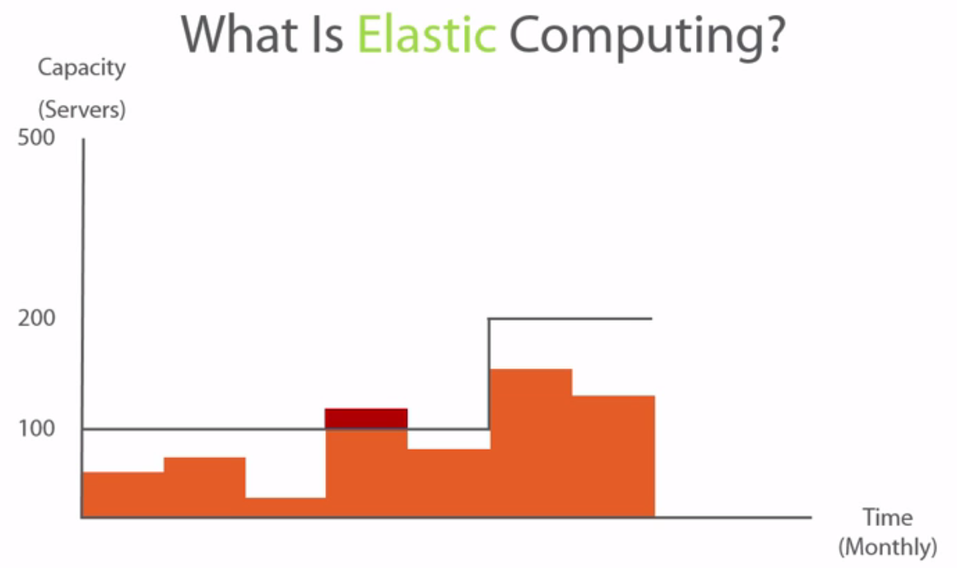

What it is and about the scale up and the scale down capabilities..

Real world use case---company called dollarshaveclub.com. Dollarshaveclub.com is a company that offers razors right? So instead of you going to the supermarket or wherever you go to buy your razors they'll ship you the razors that you need for a dollar a month.

Now let's assume this was your organization, and within your organization you've established that in order for you to run your current business the way it's trending, well, you need to have a capacity of about a hundred servers. So let's establish that as our baseline.

Now, as with any other organization you're going to have ups and down as far as workloads, and as far as capacity is concerned, and as far as performance, right? So it's going to look something like this. Sometimes it's up, sometimes it's down, sometimes you need all the servers, sometimes you don't, et cetera, et cetera.

Every once in a while, what's going to happen is maybe you'll get a spike where the need or the load has exceeded what your server, what your maximum server's capacity can deliver. That's that red that you see over there. That's, okay, someone is calling, someone is complaining, the performance is slow, customers can't purchase off of your website, whatever the case might be that's the red because, again, you've gone over your capacity. And maybe it was, I don't know Christmas, and as a result that capacity went through the roof for the first time.

Now after Christmas passes what happens is, well, it goes back to fluctuating, right? So, again, it went down. But during that peak, that red made your management nervous, your management came and said, "Hey, what's up? "We're going to be growing. "Christmas is gone but we're going to have other events." so on and so forth, right? So we need to be prepared. So what do you do? Well, you tell your management,

"Hey, in order for us "to avoid that spike we need to make another purchase. "We need to increase the capacity that we have "in order to support those fluctuations." So what you do is you raise that baseline.

**So instead of being at a hundred servers you now have raised that baseline to 200 servers.** And as a result, your load has increased, maybe you've done some marketing and as a result, "Okay, well, the load on your servers, "your load in general, has gone up "but now you've also doubled the number of servers, "you've made a huge capital investment there."

So you're fine for a while and that load keeps going up and down. Now the problem is with this particular model, not only is it expensive because every now and then you have to kind of essentially double or add more capital investment over-provision your environment so that you don't get into that situation of that red bar that you see there, you need to always overprovision. Over-provisioning means that you're buying for, **you're buying resources that you don't need immediately, which means you're paying money for stuff you don't really need today.** 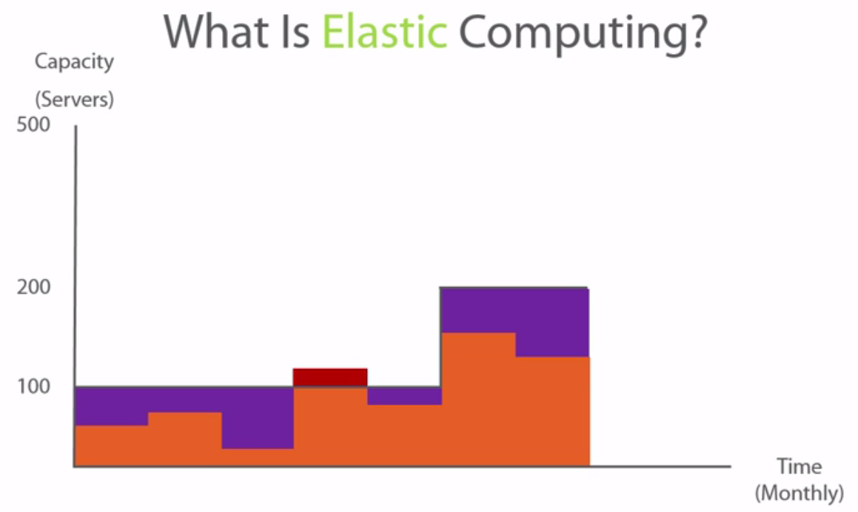

Now, the other idea behind elastic computing is if you can see all of the purple that I've just painted. That's unused capacity. That's capacity that you've purchased and even when you were at a hundred servers and at 200 servers you're not using that all the time so it's sitting there doing nothing.

If most of the time you're using 50 servers or 80 servers and every now and then you pop up and your capacity requires more and you don't have it, but for the most part you have over-provision capacity that you don't need. So with elastic computing that's what we're trying to avoid.

We're trying to give you the ability, if you need a hundred servers today that is what you need then don't over-provision just provision 50 servers. If tomorrow you need a hundred then provision on with 50 more. What does that do? That allows you to save the CapEx that saves your business a lot of money, because again you're not putting up that upfront cost**. And remember, that upfront cost is not just about servers it's about servers, it's about the man-hours that you put in to configure, to rack and stack these servers about the facilities, the cooling, the heating, the networking gear, the ports, the storage, all of the things that are required, the licensing for the software, everything that is required in order to bring those up.** And if you're not maximizing on their usage well they're going unused. Well, why do that?

**If you use cloud computing then you only provision what you need, you never over-provision. Why? Because that capacity is always available to you in order to provision whatever you want.**

Now, let's complicate this scenario a little bit

Well, I want you to visualize, and this actually happened, now I don't know if this scenario that I'm giving you actually, actually happened but dollarshaveclub.com released a YouTube video. It's a pretty cool YouTube video. If you haven't seen it you should go out to YouTube and watch it. And that video got, I believe, over 18 million views. So what does that do? If dollarshaveclub.com was at 200 servers before they released that YouTube video that went viral, what do you think happened after that YouTube video hit? Well, guess what? They probably got a lot of sales from it. Now, what if Dollar Shave Club knew in advance that, okay, we're about to release this video and this video is about to go viral and we need to be ready for it. So, "Hey, IT guys, you need to be ready for this." And the IT guys are like, "Well, how ready?" "We don't know, let's just, I don't know, "let's the double the capacity that we have." So instead of having 200 server baseline you went to a 400 server baseline, okay. Now what ended up happening is once that YouTube was released that baseline went up to 500 servers, which means you, with the provisioning that you did and the over-provisioning that you thought you had done, you went up to 400, you doubled your capacity. But because this is an unpredictable thing there's no way you can tell the response that you're going to get from your customers to this ad, to this ad campaign that you're running.

In this case, it went up to, and I'm going to simplify this, I could've set 5,000 but you were required to have 500 servers to support the load for that marketing campaign that just went out. Now if this was a real world environment what would you have to do? Well, guess what? You would have to order servers. And those servers would have to come in, rack and stack and there goes two weeks before you can be live, right? Well, guess what? In two weeks, your customer isn't going to wait. Not only have you lost customers but you're not getting the return on investment from that marketing campaign that you put out there. So unless you went crazy and ordered 5,000 servers just to be on the safe side and then the load came from the campaign at 2,000 servers and you've over-provisioned by 3,000 servers that means you still lost. You see what I'm trying to get to? The idea here is you can't really pinpoint ho w many servers you need in the age of the internet, in the age of YouTube, in the age of the startups and the dot-coms if you're working for them. Or if you're not working for them and your company releases a campaign, well how much would you provision? Are you going to double your sales? Are you going to triple your sales? Quadruple? Who knows? 18 million views, well, that's going to be a lot of servers. With the elastic compute, if you provision for 200 servers and you need another 500? Guess what? You can do that immediately, with a click of a button you could provision those. Sure, you have to notify Amazon and go through some process because you're provisioning a large amount of servers but it's immediate. It's not two weeks, you can respond quickly. You can even over-provision. They throw out an outrageous number and then once that ad hits and you know approximately where your load's going to be, well then you provision accordingly. So what happens with the elastic compute? Well, with elastic compute now you have the ability to scale up to 400, 500 servers whatever the case might be. With a traditional environment, right, you would've gone up to those 400 and 500 servers and you would've gone back down again and so on and so forth. So the idea behind elasticity, which is what you see in the green on the right here, is you can scale up when you need to scale up to 500 servers and then scale down when you don't need the 500 servers and you need maybe just 300 or 250 servers. You can do that on the fly. You can avoid the CapEx expenditure. Now, I gave you the idea of dollarshaveclub.com as an idea because the video just went viral and just gave me this idea of showing it to you. But you can do this with pretty much anything. Anytime you're trying to have a large jump in capacity, whether it's from 200 to 500, or 200 to 5,000 whatever it is, that large jump is going to be very costly especially when you don't know how many servers you need and especially when you don't know where that load is going to settle at. 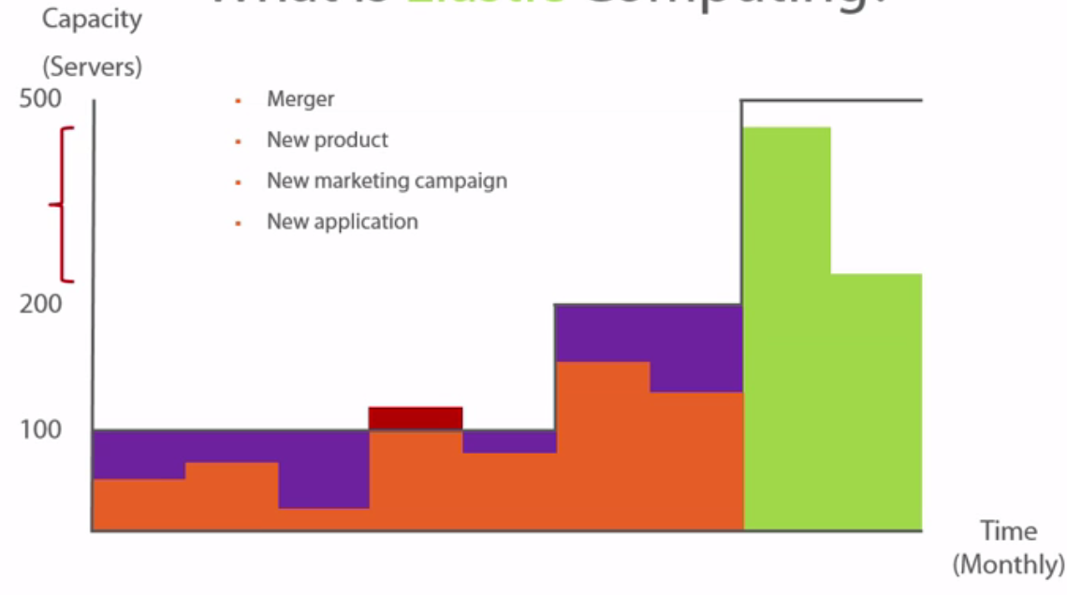

So, yes, there's a spike that happens, but where will it settle? So the dollarshaveclub.com commercial went viral and, oh my God, we're getting bombarded with orders. But a month later, these orders are going to stabilize at a particular threshold. If you've over-provisioned, what do you do with these servers? And if you've under-provisioned, well then again, you're losing money either way. There are several use cases where elastic computing can be useful, right? Whether it's mergers, whether its new product launches, new marketing campaigns, new applications there's a lot of use cases where it's unpredictable and hard to keep up and the idea of over-provisioning in today's world of spending that capital on something that you may use all the time or may not is going to be continue to become a very difficult proposition to sell to the business. What if it's a new service? We failed to mention that. So it doesn't have to be just a new application, it could be an entirely that's out there. If you're curious about, "Well, who else is using "Amazing Web Services?" I have something new service that you're offering as well. Now, Dollar Shave Club is not the only use case of interest to you. So there is a website specifically dedicated to the customer successes that are powered by the AWS Cloud.

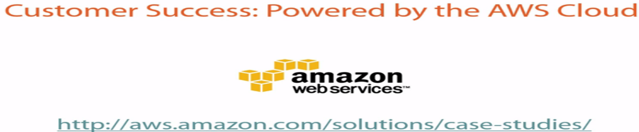

Customer case studies amazon

<https://aws.amazon.com/solutions/case-studies/all/>

Now if you visit this website and I'm going to take you there just because I find it interesting and fascinating to show this to everybody that I talk about Amazon Web Services with. So on this page, you'll find customer success stories that are powered by the AWS Cloud and you'll find some pretty big names out there. Netflix is a huge one that leverages the Amazon infrastructure, oh and there it is, for video streaming.

**You got Adobe, you got the Dow Jones, you got Citrix, you got the FDA. I mean these are pretty big names. The CDC, Nokia, Pfizer, Foursquare, I mean Lionsgate, Comcast, talk about video here, Hess.**

I mean, there's a lot of companies out there that are leveraging AWS as a resource. Now they could be using it for everything. Netflix could be an example of that. Back in the day, they were using Amazon Web Services entirely, completely. Dropbox is using it, Pinterest is using it, a lot of the startups are using it. But if I scroll down this list you might be like, "I don't know, this is a pretty short list." Well, check this out. From this dropdown on the left here you can select the use cases that you want to display kind of by vertical. What I like to do, though, is select View All, click on Go. I can be scrolling here for a while with some of the use cases that you can find of customers leveraging AWS. And you're going to find customers across all different types of verticals. So regardless of the vertical that you're in if you're trying to figure out if Amazon Web Services is a good fit for you, you should scroll down either this entire list or narrow it down by your vertical. Now I can keep going. Now you've noticed how long I've been talking and I'm still scrolling down here. So there's a lot of customers that are using AWS. So as you're thinking about this, as you're trying to position this for your management, if management is not entirely bought in just yet make sure that you're taking a look at these use cases, find a company that's similar to yours in the same industry and take a look at what they're doing in order to help justify what you're trying to accomplish as well.

**Regions and Availability Zones**

So let's start exploring the global infrastructure that makes up Amazon Web Services.

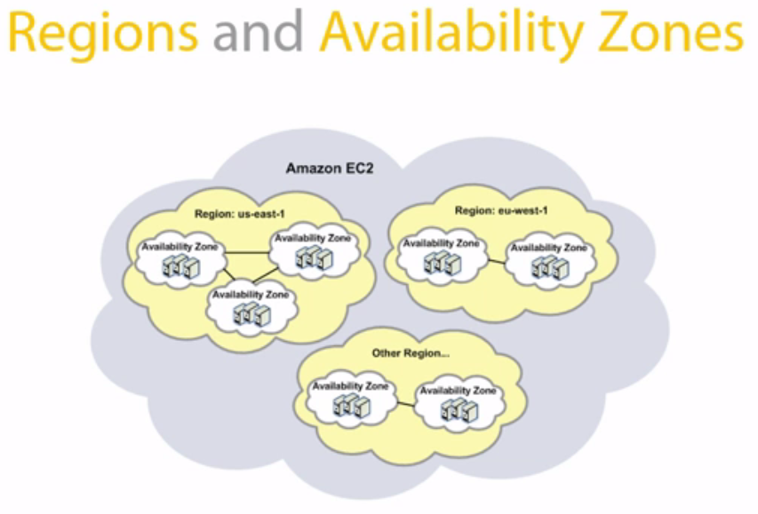

Global Amazon Web Services Infrastructure has multiple regions that scale the world and they have multiple availability zones.

**Region** is a geographical area that Amazon specifies.

An availability zone is a data center within that region that Amazon has.

So, for ex: US East Coast that could be a region. On the East Coast, Amazon might have a data center, for example, in New York and maybe they have a data center in Atlanta..

So, for instance, you have US East, and US West and maybe US Central. And an availability zone is a data center.

**The availability zone** has to be within a particular region. And within every region, you're going to have two or more availability zones, which means two or more data centers. (data centers within that geographical area.)

**Note:** within every particular region, within every particular availability zone certain services may or may not be available. And I'll show you a little bit later on where you can go to figure out which services are available and which region and availability zone etc...

But the idea here is for you to understand that not all of the Amazon Web Services are available in all the regions across all the availability zones.Amazon may release certain services in regions before they release them in others because they're more reliable or that region is older, for a whole slew of reasons you might see certain services that are available on the US East Coast, for instance, before they're available on the US West Coast. **So keep that in mind because that might be a factor in where you place your services.**

*So if you're trying to build a presence, maybe some virtual servers or instances and you need to figure out, "Well, should I put those "in the US East region or the US West region?"* The type of service that you're looking for may help dictate where you end placing these resources.

**Amazon or AWS Edge Locations:**

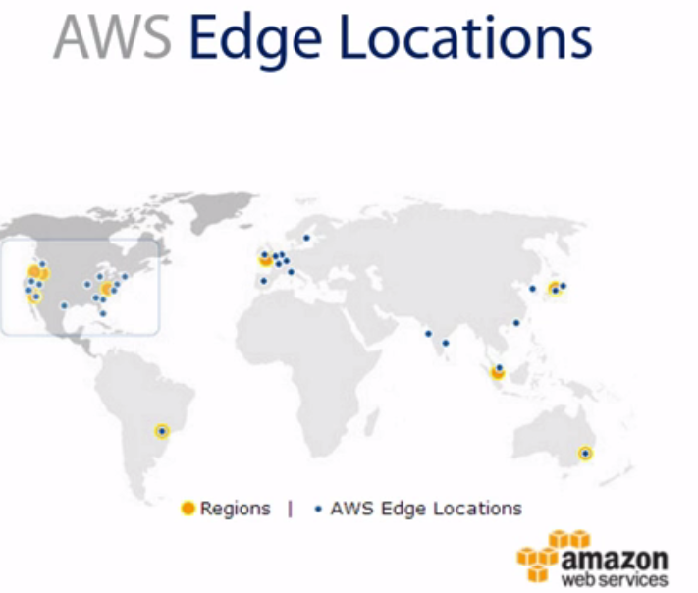

As you'll see on the map here, everywhere there is a **yellow dot there is an Amazon AWS region.** So you'll find that there's a few in North America, there's South America, Europe, you've got Asia, you've got Australia so they've covered the globe, right?

But everything that's a **blue dot is an edge location.** Now, you see that there's plenty of edge locations. Now, **what are edge locations?** Edge locations are services that Amazon offers that are complementary services. They're not services that, they're not something where you can place a resource in. So you can't take an Amazon, an instance, essentially a server, and place it in an edge location. That just doesn't work. But you can consume services that are available in edge locations.

**A really good example of that is DNS**. So Amazon's Route 53 is a rock-solid DNS service that has an SLA of 100%. Amazon will always have DNS up and running. And guess what? DNS is crucial. First, to the performance of your application and second to the availability of the application.

Because if you have a great data center, even outside of cloud and that data center fails and your DNS isn't properly configured to fail over or DNS isn't properly configured to route or to resolve, then no matter how great your infrastructure is that little piece called **DNS could be your Achilles heels, right?** So DNS is crucial.

Now everywhere there's an edge location Amazon has essentially a DNS server, just to simplify things. So if you were looking for a DNS to complement your environment whether you're using Amazon Web Services, the cloud offering or if you just want to use Amazon Web Service just for DNS you can just buy DNS from them.

**You can have a DNS presence in every one of these blue dots which means to simplify it, if** you have an ecommerce site and your users in Australia are trying to resolve that site, instead of that resolution going all across to the US in order for, and headed DNS server to be resolved and then pointed to your IP it can hit anyone of those DNS servers that are closer to it resolve to your website and give your users quicker access.

So your page is going to load a lot quicker that way. **So DNS is an example of the type of things that Amazon uses at edge locations and also have web servers, for delivery of web services faster so and so forth.**

But the idea here is edge locations are not, they're not locations where you can place workloads, but they're locations where you can consume some of the Amazon Web Services offerings that are available there, for example, DNS.

There are 10 regions in all that Amazon Web Services offers. And then you have GovCloud. So, technically, there are 11 regions except the GovCloud region is a cloud that is specifically for government entities.

So if you don't work for a government branch then you cannot take advantage of the government cloud, you cannot place your resources in the GovCloud region. It's specifically for government, US government in this case. So there are 10 other regions where you can place your workloads in. There are several availability zones and several edge locations.

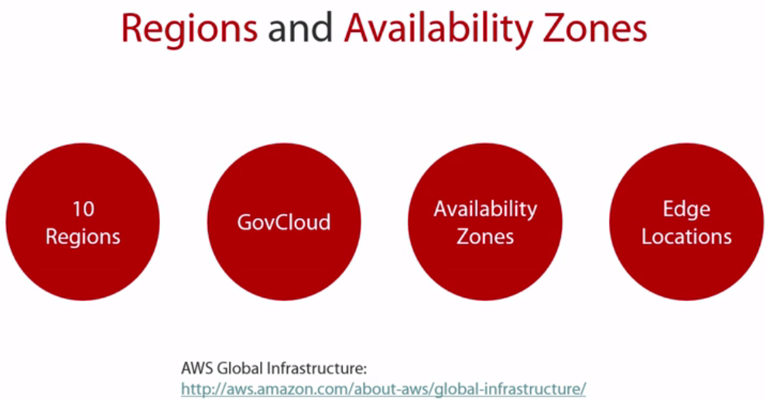This particular website, the AWS Global Infrastructure, gives you an idea about where those 10 regions are, how many availability zones within every region, the edge locations and some of the features and services available in every region. for example,: North America you'll find that you have three regions here and then you have the GovCloud, right?

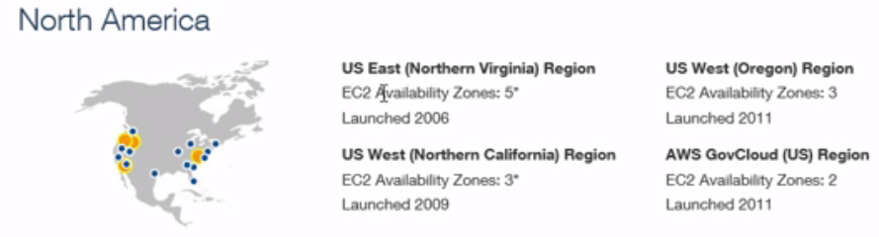

So, US East you'll find that it has five availability zones within US East. And it'll give you when it was launched. So it was launched in 2006. This was the very first region that AWS presented. And because it's such an old region, not old as a bad thing, but old from a reliability, it's been up the longest, typically the US East is where Amazon will launch all of the newer services, all of the newer offerings will be started there first.

Now, if you look a little closer at US East you'll find that there are five availability zones but if you dig a little deeper, you'll notice that maybe there are only three availability zones where you can place workloads. That leaves two other availability zones and you're probably thinking, "Well, why can't I use "the other two availability zones?" There are several explanations. Either it's being phased out, some of the availability zones are being phase out. Or maybe there are availability zones that are being introduced but they're not ready yet.

So maybe they're building a data center but it's not ready for primetime. So as a result there is an availability zone but it's not ready for workloads to be placed there. Or maybe they're phasing it out, they're decommissioning it, it's old, whatever the case is. So either they're taking it out, or they're adding a new service in, or it reached its max capacity. So maybe there's a particular data center that cannot accept any more workloads and as a result it's still available as an availability zone but it's just not accepting new customers or new workloads. So there are several reasons why if you're seeing five but you're only able to add workloads in two, these are some of the explanations that you can get. Now, you can scroll down the list again and take a look.

For instance, in South America, Sao Paolo they'll have two availability zones again there and you'll see that it was launched in 2011 and so on and so forth. 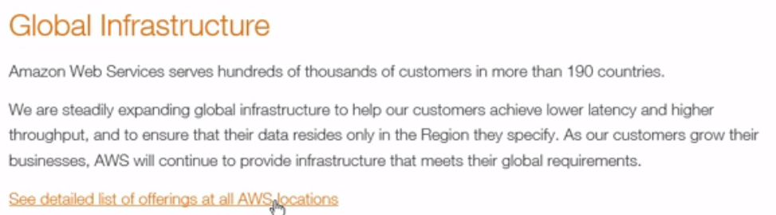

. And then you can go through and take a look at which service is being offered where. So you'll see that there are some gaps down here and these particular services will be offered in those regions or in the availability zones. You can also scroll down and take a look at where Amazon has AWS edge locations. Also, you'll see all of these in North America, South America, I mean these 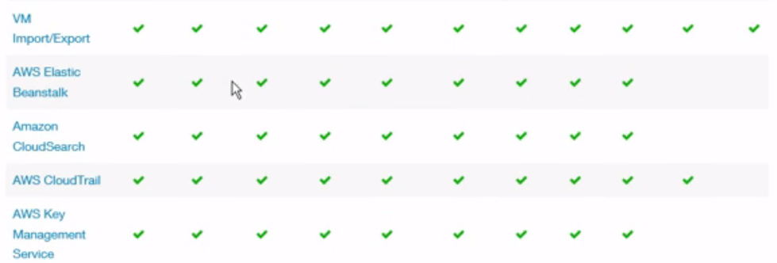lists are just huge. So you could take a look. And, again, one of the reasons I invite you to always check this list is because they're probably going to continue to grow, they're going to be adding more regions and more availability zones all the time, they're going to be adding more services and before you deliver or deploy your workloads you need to have an idea of whether or not these services are available in your region, in your availability zone, yes or no. So this would be the website to visit in order for you to make that determination.

🡪Now, with an infrastructure like Amazon or Azure, or Google or et cetera you're probably saying, "I wonder if they build "data centers the same way I do." And I thought I'd bring this to your attention because I think it's very cool. Do you know what this is? If I told you this was how Amazon builds data centers, this is essentially a shipping container that is made up of all the resources that, it's a mini data center, essentially. So instead of them adding racks and stacks, et cetera they bring these containers and they, essentially, plug them in and these containers are full of servers, they're full of resources, storage, networking gear, et cetera. 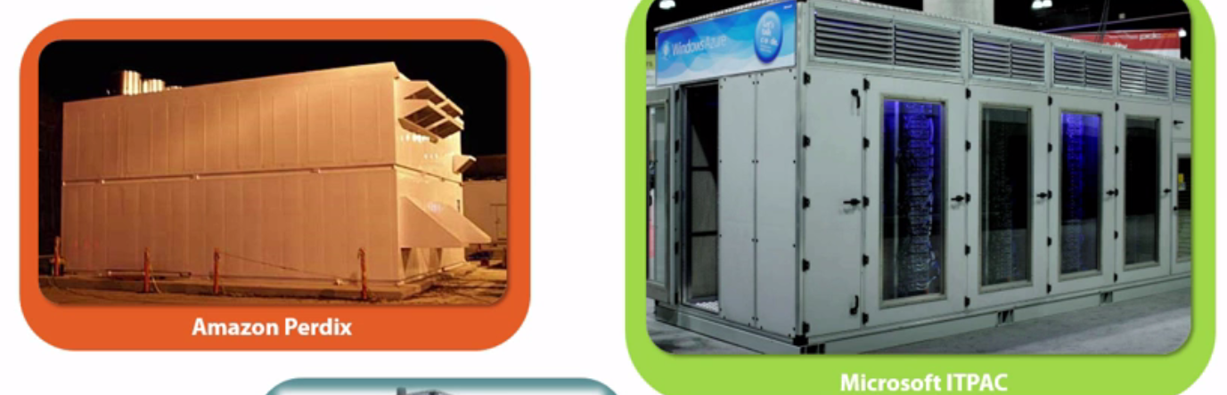

So on the left you'll see that I've posted a rare picture of what Amazon calls the Amazon Perdix which is, essentially, they're data center in a container. And I can imagine the Amazon data centers full of these types of containers that make up that availability zone. So if you were thinking that, "Hey, they build data centers "the same way that we build data centers."

Nope, their servers are different, their servers are very customized. They're not even supermicro servers that even they remove components from a supermicro server so they're customizing the motherboard with exactly the components that they need in order to save on power, so their servers don't necessarily come in any kind of an enclosure. So the way they build their data centers is very efficient. They're dropping these containers that have been tested, validated and these are kind of the Cadillac of a converged or hyper converged infrastructure, right?

So if you're seeing or if you've used converged infrastructure this is kind of a next evolution at the scale that Amazon needs to grow at. Because it doesn't make sense for them to do this the way we do it. They need to be able to scale faster. They need to be able to control the cooling. So every one of those also has controlled cooling. So what they've done is, again, go back to that idea of a system, right, they've come up with a process, a methodology.

Instead of them trying to figure out every time they add two new servers or 10 new servers or 50 new servers what the airflow needs to look like, how much more air-conditioning or cooling they need to do. What they do here is because this container has a specified number of servers and storage and et cetera they know exactly how much it needs to be cooled, how much power it needs, everything. They contain all of that in this container and all they have to do then is just stack containers. It's a pretty elegant thing.

Now on the right, you'll see that Microsoft also has the IT Pack which is essentially the same thing. They're doing a similar approach to what Amazon is doing and I'm pretty sure that the Azure Cloud is probably configured in this scenario as well. So this gives you an idea for how they build their data centers, the efficiency at which they build their data centers which brings up an interesting point that I'm going to leave you with.

**Whenever I have conversations with customers, with friends, with colleagues and I'm like, "Look, no matter how well we do data centers, "no matter how well we build it we'll never be able "to get to the point that Amazon, Azure "and a lot of these large cloud providers get to "in terms of perfection of the process of the system, "of the way they do it."** Now, look at this. How can you have that precision in your environment? They are very methodical. Again, it goes back to the idea of **building your bike or buying the bike.** Sure, you can put the components together. It'll probably not look as efficient as the one that you just purchased. There are machines that are doing it, everything is just perfect there. So this gives you again an idea of how they do it versus how we do it and why they can do it better. How they're able to save money when they do it because again they're customizing things, they're buying things, I don't know if I can say in bulk. They're buying them in containers, let's just put it that way. And as a result they get a lot of synergies from that and they're able to offer all of these cost reductions.

**Summary**

What is elastic computing? We went in-depth as far as the fluctuations, how it scales up, scales down

We gave the idea or the example of the Dollar Shave Club, and we talked about all that wasted capacity that isn't being used and the fact that we over-provision outside of cloud and how with cloud we can use exactly what we need.

Then we talked about regions and availability zone. We talked about the fact that a region is a geographical area and an availability zone, essentially, a data center that lives in that geographical area.

We talked about the fact that Amazon has 10 regions, one GovCloud region, we talked about the fact they have availability zones and edge locations. Edge locations is where they can put services like DNS and make them available worldwide. We covered that and I showed you a webpage where you can go and take a look at the different services that are available in every region.

That being said for Amazon Web Services, edge locations, things like DNS, for example, can be placed there for a really good **SLA 100% uptime.** I mean you can't beat that when it comes to DNS.

# Understanding AWS Security Measures

**The Physical Access**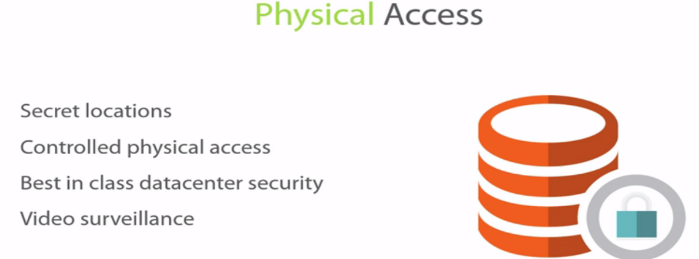

So probably the biggest question, the biggest question mark, the biggest topic, the biggest inhibitor for adopting the cloud is security.

Everybody is so weary about security. Although all the security breaches that you've heard about in the media, have all been against on premises data centers and not against the cloud. And those that have been against the cloud have been because the tenant of the cloud didn't take the proper security measures to protect themselves.

So what I'm here to tell you, in a nutshell, before we get into physical access, is that there is no way we can build the security measures that cloud providers like Amazon and Azure and others have built in because of the sheer scale of things, because of their automation, because of everything they put into it. The advanced technology, the newest hardware, best practices that they follow. Even their resources, their intellectual capital, their human capital that they have will be very, very difficult for us to match on premises.

Let’s take a look. So from a physical access perspective. Well one of the largest, one of the most important things about data center is secrecy. Well if you don't know where that data center is, and we're talking here physical access, there's no way you can attack that data center.

1.) So the first barrier is to identify where the Amazon web services data centers are. If you're trying to physically try to get access. So because they don't advertise that, because it's a secret location, because there's so many of them, you would have to identify that actual data center. You would have to identify if the tenant that you're trying to hack is in that particular data center, which is the availability zone or the AZ zone.

So before we get going here, what I want to say is if someone really wants to hack a system, and they have the know-how, they'll be able to. Your job is to make it as difficult as possible for them to do that so that it's not worth it and they move on to other things. And that starts at every layer, even identifying the address of the data center. If they don't have that address, well you've removed that risk altogether.

**But let's assume someone was able to identify where that particular tenant they want to hack is, where that availability zone is, they were able to identify that location.**

**2.) Well then they are presented with a controlled physical access**. So it's not like they, okay we've identified the data center we're just going to waltz in there. It's a controlled physical access. Which means you have to be able to come up to it, you're probably going to get a retina scan, you're going to get a thumb print. It's going to put you through a tunnel, it's going to weigh you. It's going to do several security checks.

You're going to go through that tunnel where the door opens, you go into the tunnel, it closes, then another door opens, and so on and so forth. And you have several options of keypads and security codes that you have to enter before you can get through even to the lobby of the data center.

3.) **So even if you've identified the location then you have the problem of the controlled physical access. And then you have best in class data center security**. Which means again, that multi-factor authentication, that thumb scan, that retina scan, the weighing, all of that comes into play

4.) In addition to obviously, video surveillance. So in order for someone to worry about physical access, all of the AWS data centers are best in class data center security. They use discrete locations, they don't advertise their locations. So all of the stuff that you're used to in your hosted data center, think of if not better, just as good as that. So depending on how well your hosted data center is, I have been to some that are state of the art.

I mean stuff that comes out of a James Bond movie in order for you to even get past the security. So from that perspective Amazon does a fantastic job at it.

🡪Now let's talk about **servers and network infrastructure:**

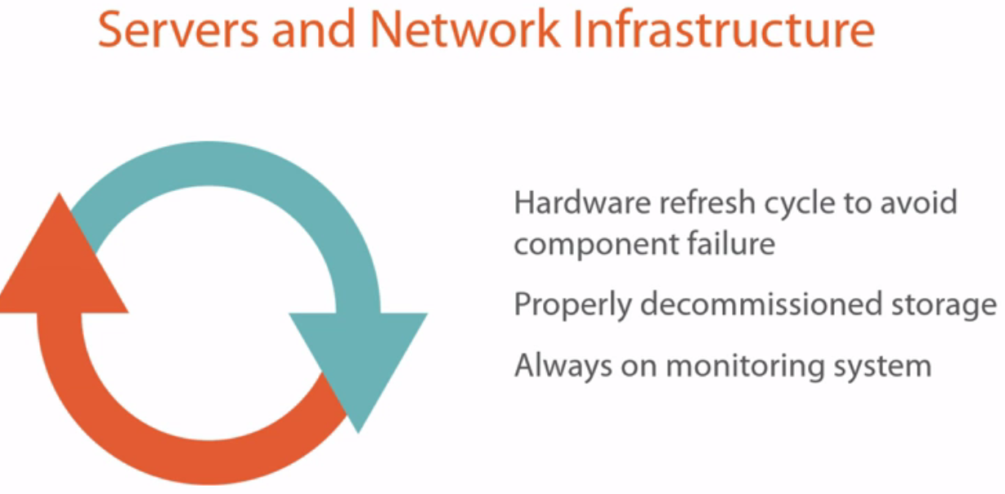

So it's not enough for you to secure your servers or your network infrastructures from an access list perspective, from a username and password perspective. All of that is good, all of that is good at the logical level, right.

1.) But it is the responsibility of the data center provider, it is the responsibility of the cloud service provider to ensure that the hardware refresh cycle is on a best practice kind of period. So that every, let's say four years or three years or two years or six months, whatever, depending on the component life cycle failure, that component is swapped out, so that you're avoiding a failure. But not only failures right. It's not fair to have your users, for example, on a 10 year old server. So there are best practices put in place with Amazon where these components are refreshed on a cycle in order to make sure you're always up to date on the most advanced hardware because that also helps from a security perspective. So the refresh cycle is crucially important when it comes, when we're talking about security.

2.)They're properly decommissioned, especially as far as storage is concerned. So when we say properly decommissioned storage, it's not just, you know, a format, right. It's not just a deletion of the data that's on it. **We're talking about a destruction of the actual storage of the hard drive.** And that's really interesting and cool to see how they decommission hard drives and storage.

3.)It's always on monitoring, so they're monitoring every component that's running in their data center, whether it's servers, it's networking etcetera. So from an operational perspective, they are monitoring every aspect of that data center.

Now just between us two right, how many times do you really look at your monitoring system? Regardless of how advanced it is. If you're anything like me, I'm not looking at it until it's red, right. If it's not red, I'm not looking at it. Well with Amazon, they can't afford to do that, so they're meticulous about how they monitor these systems. Because that plays into their uptime. If they don't maintain their uptime, guess what happens? They get dinged on SLAs, which means they have to give stuff away for free, whether it's usage or payback or whatever.

In our environment we don't monitor it because well, if it goes down we might get slapped on the hand, we might not, and we might be able to come up with a thousand reasons why it wasn't out fault or whatever, right. It might not be our fault. But with Amazon it is their business. So it is their business to make sure that it's always on and that they're monitoring it because if it's not on, they're losing money. So that is the difference here. And the always on monitoring system is state of the art.

🡪 Let's talk about security certifications and compliance:

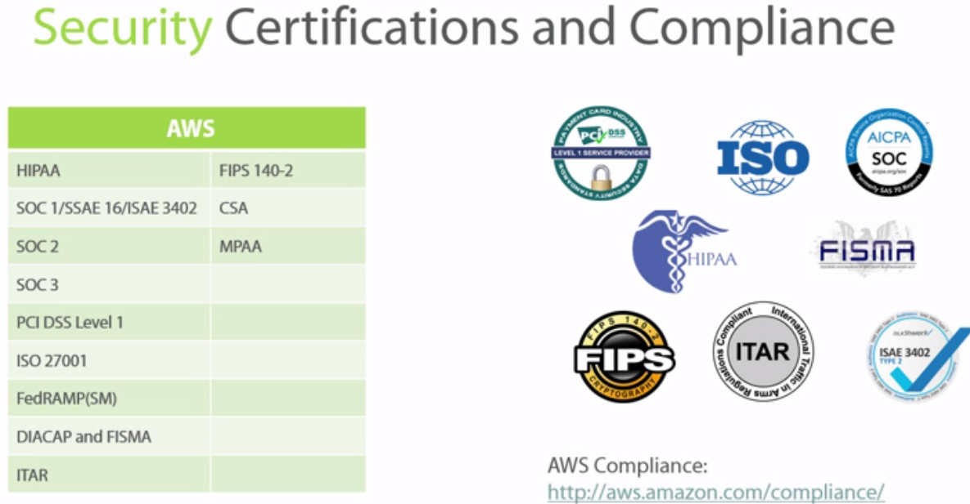

These certificates, these compliance or regulatory compliance achievements are not easy to achieve. You're not just going to waltz into those, right. You're not just going to get HIPAA compliance.

And it's not one body that will certify you for HIPAA or for FIPS or for SOCs right. You're going to get different auditors for different certifications that walk into your data center and give you a list of what is acceptable in order for you to reach these regulatory compliance.

If you're ever tried to certify your data center for any one of these, you'll know that every one of these on its own is a lot of work, it's a lot of work. So for Amazon to have this number of certification under its belts, they must have the process down to a science. Where they're able to provide the level of security that's acceptable to all of these organizations.

**So if you're at this point you're still wondering if the cloud is secure or not, I'm asking you, does your data center have all of these security certifications.** Now you could joking say well I don't really care about these certification, but that's not the point right. These are government certifications with high standards. If your data center doesn't meet these, well what makes your data center more security than the AWS data center? I mean that's really something to think about.

🡪If you don't have your server patched correctly, well there you go, that's a security breech if someone can just get in from there very easily, off the internet. No matter how many certifications and compliance you have, that server is going to be compromised.

A lot of times the clouds are more secure than what we have on premise. Again due to these certifications, due to the fact that they follow things down to a methodological way of doing things.

AWS assurance programs, you'll have, you know, PCI DSS Level 1, you'll have your SOCs compliance, all of this stuff that I may have on my table or may not have had on my table that could be of interest to you.

🡪Listen we are going beyond the call of duty as far as security. We understand security is important. We are taking security very seriously. And here's everything that we're doing. So you can see just from this page, from all of the cases, the use cases, the white papers, the webinars, how much AWS takes security and compliance seriously. And you can even contact AWS again here for the compliance reports and certifications.

# Shared Security Responsibility Model

In order for you to have a secure environment, first you need Amazon to do its part, but you also have to do your part. This is not one or the other. **Any weak link in the chain can compromise the security.**

So there should be a trust level that Amazon is going to do its job, and then there should be what you need to do in order to secure your environment.

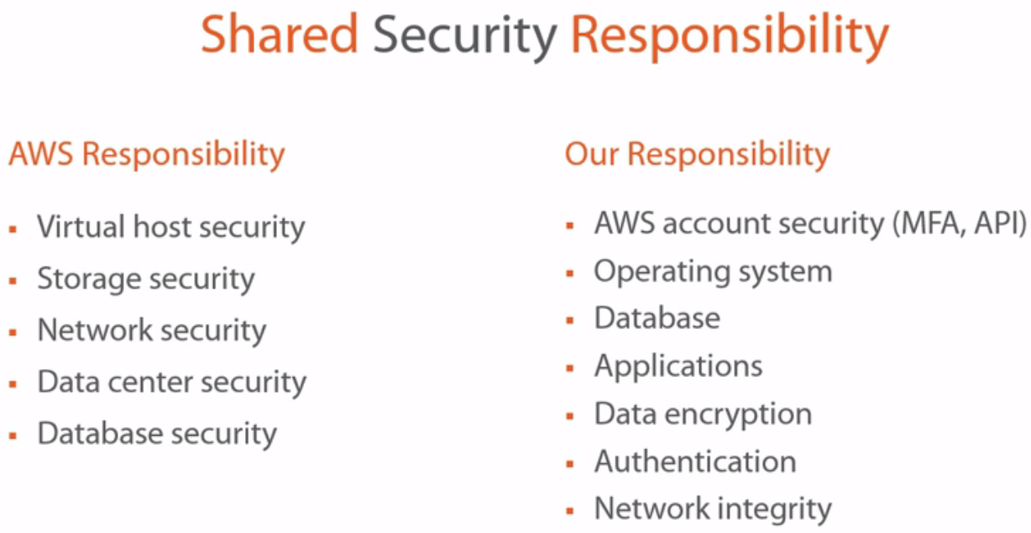

What Amazon should be responsibility for??

**Virtual Host Security:** AWS is going to ensure that your virtual host isn't going to be compromised. So if you have several, if AWS has several tenants on the same server, it will ensure that the virtual hosts on the server are not going to be to compromise one another.

AWS is going to make that guarantee, it's going to build that wrapper around these virtual hosts and make sure that they're not going to talk to each other.

Now this concept shouldn't be scary to you. I mean this is the whole concept of virtualization, right. So there's nothing to say that on your virtual server, let's say it's, you know, ESXI, you can have several tenants and each one has their own virtual machine. **These virtual machines if configured properly from a virtual networking perspective will never talk to one another, right.**

Now AWS is saying, they will ensure virtual host security. Your servers will only communicate with your servers if you've granted them that security. And we'll talk about your responsibility. So they'll ensure virtual host security, they'll ensure that physical server security, right, that's taken care of.

**Storage security:** Well if your information, again, is going to be stored on the same storage array for instance with other companies. Well Amazon is going to ensure that it's building that wrapper around the storage bucket that you have provisions for yourself. Whereas your competitors or the other tenants that are on there are not able to access your storage bucket, your data.

And the same applies to **network security.** Amazon is going to guarantee that it's going to create that virtual networking environment, they call virtual private cloud. And that virtual private cloud is yours, right.

So they're going to ensure that the subnets, your IP addresses, all the traffic that is being communicated in that virtual private cloud is yours and yours alone.

So no one from the outside is going to be able to compromise or share that. So again, that's based on Amazon's responsibility. Now when I say that, that doesn't mean that you cannot overrule these security by some method, right. **So while Amazon is ensuring that physical and that virtual security to an extent, if you go out and create a server and don't put any access lists on it or don't put any rules on it and you expose that to the internet, well sure it's going to get compromised**. **But that's not AWS's responsibility, that's your responsibility for not taking the proper measures**.

So you can bypass some of these security measures that Amazon has put in place by again, not being very attentive or not putting the right security processes in place.

**Data center security**: we talked about that earlier. They are going to ensure data center security, you know, secret locations, difficulty of accessing the data centers. I mean even if someone accesses those data centers and sees all of these containers in there, well now you have to get into the container.

I mean, they make it so difficult where it's not really worth it, accessing the data center from a physical perspective. You'll have better chances of figuring out if there are any servers to compromise from the internet.

**Database security:** if you're leveraging some of the database services that Amazon offers, that means you probably are on the same database server with other tenants. They will ensure that your particular database is only communicating with your servers and others aren't able to compromise your database security. So that is their responsibility.

**Our responsibility.**

1.)a) first and foremost, to protect the AWS account security. If you create an Amazon account and you go out and give the root access, username and password to somebody and your servers get compromised or the environment gets shut down, now whose responsibility is that? It's not that the cloud isn't secure, it's that you didn't do your homework. Now this is a true story.

b.) This actually was on the news and happened in New York some time ago. Where a company that was responsibility for backing up security information for its clients didn't pay a consultant, or something to that extent. And that consultant had, guess what? Their root username and password for the Amazon environment. Well that consultant went in, shut down all of the servers, deleted them, had backup copies of those servers, and held them ransom. Either you pay me this much or I'm deleting your data. They didn't pay and they ended up going bankrupt. But that's not a failure of the cloud, that's a failure of you not taking the proper measures.

You don't give out the root username and password. **The root username and password, once created, should never be used again. You should create roles and users and groups and responsibilities. And the proper security best practices that you should be doing in your environment today.**

c.)So AWS account security is very important. Especially the usage of things **like multi-factor authentication. Protect your API keys right, your application programming interface, right.** You have those secret keys, there's token, those whatever, the host IDs, whatever they are, you need to be able to protect them. Because otherwise, then **if you have a programmer that's doing work for you and you didn't pay that programmer and he's got access, or she's got access to those API keys, well guess what, they'll be able to create instances on your Amazon infrastructure all day long. They might not be able to bring your environment down, maybe they don't have that level of security, but if they spin up 100 or 200 instances and let them run for a couple of days, for 24 hours, guess what, you're going to get hit with a pretty big bill.**

So the idea here is go back to the basics and make sure your AWS account security, all of your AWS account security is secure, right.

d.)Use multi-factor authentication for best practices, secure the API keys, don't use your root account.

2.) **Operating system.** You should be able to secure the operating system. Whether it's Linux, whether it's Microsoft, regardless, there are security best practices, there are patches that need to be implemented. There are Windows Firewall that needs to be turned on with the proper ports configured.

3.) There are **database security** if you're hosting the database, if you're hosting SQL for instance. You should be able to take the proper security measures for that database as if it was hosted on premises.

4.)**Applications** have their own usernames and passwords, those should be implemented. So there are several layers of security within Amazon. **Amazon is doing its part of logically separating you from other tenants that are on that same environment, but it is still your responsibility to secure your applications, your databases, your operating systems, and your user credentials.**

5.)**Data encryption:** you can also do that. Authentication, that's crucial. Whether it's active directory, again multi-factor authentication.

6.) How you're exposing your servers to the internet and how the user's **authenticating** against the servers is very important. So again, the same best practices that you've taken on premises should be brought over to the cloud.

7.) **Network integrity.** All of these access lists and all of the things that go with it, all of these things should be taken into account.

You cannot assume that Amazon's going to do everything for you. There is a line where Amazon's responsibility ends and your responsibility begins. That's the beauty of this shared security responsibility model.

-🡪Amazon's going to take care of all of the physical aspects and it's going to take care of securing, logically security all of the components. But it is your responsibility to then secure whatever's in those logical components, whether it's an operating system, a database, an application, your user credentials, the authentication, which ports are open, which ports are not open, are people coming in over 443 or not.

All of this stuff falls on you. So it's important to understand that in the cloud there is this shared security responsibility. And it's important for you to understand it and be able to act against it, otherwise yes, the cloud will not be secure, but whose fault is that?

It sure is not Amazon's fault, it's your fault if you're not understand where Amazon's responsibility ends and where your responsibility beings in order for you to have a good match, a match made in heaven essentially.

Let's talk about **security methods and connectivity.**

So how does Amazon secure stuff, or what are the tools that it gives me to secure stuff?

1.) Well for starters, it gives you **security groups.** Well security groups is the ability for you to specify which components have access to which components. And these components could be users that have access to servers, or users that have access to storage or networking or databases, or servers that access the servers. 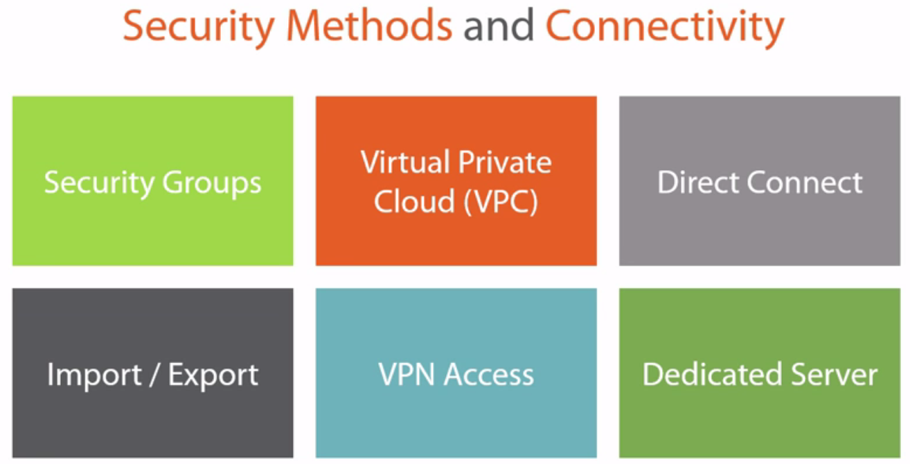

Which servers have access to which servers. Maybe your database servers have access to your file servers or your web servers have access to your application servers and so on and so forth. It is a component that you put into a security group and then you give access to another component. Security groups are very, very important, very, very effective method of using security.

2.) Now you also have this concept of a **virtual private cloud**, VPC. Now virtual private cloud, if we were to take it into enterprise lingo, would be virtual networking. This is what Amazon essentially calls **virtual networking.** When you start to do virtual private cloud, now you all of a sudden have access to access lists. So not only can you use security groups but now you can have access to access lists. Why are access lists important? Well access lists give you that addition level of security.

For instance you can say that this subnet can speak to that subnet or this IP address can speak to that IP address, and it can speak to that IP address on these specific ports, maybe port 443 only, maybe port 80 if this is exposed to the internet and no authentication is needed.

Maybe, I don't know, you have multi-factor authentication and you need to open a specific port. So all of a sudden you've just gained the power of access control lists or the ACLs that you can now also apply against your environment to increase the security. Now access control lists, guess what, this isn't something new. This is something that you've already implemented on premises. So bringing those best practices, bringing the same types of questions you would ask on premises to the cloud in order to configure the environment is crucially important. You gain that with virtual private cloud.

**Direct connect.** So let's say you have certain components that you want to put somewhere in order to get high speed connectivity into the Amazon cloud, right. So maybe your connectivity into Amazon is over a VPN or over the internet and well you know what, that's just not cutting it.

Amazon has partnered with certain data centers, and these data centers that are not owned by Amazon have gigabyte connectivity into availability zones. So if you place your equipment in some of these direct connect data centers, you now have gigabyte connectivity into the Amazon cloud.

So a **good example** of this would be a network access storage, right, or network attached storage, a NAS device. If you have a lot of storage and you don't necessarily want to put all of that storage into the Amazon cloud, whether it's for, whether it's because of cost reason, or whether it's because it's going to take forever to copy that information up to the Amazon cloud, you can leverage direct connect.

Maybe your architecting and application that requires an AS400 and you need to have that AS400 as close to the Amazon cloud as possible because performance might be a problem.

Well if you find a direct connect data center, you can put that AS400 there, you can put that NAS device there, or any other physical device that you want there, and all of a sudden again, you've gained gigabyte speed connectivity to the Amazon cloud.

**Import export.** : Let’s say you have, I don't know, a storage array that has 100 terabytes on it, and this 100 terabyte will take forever if you were to copy, you know, through the standard methods.

What you can do, is you can tell Amazon that you're sending them a storage array and they'll specify the accepted formats of what you can send them. When you send them that data, they will ensure that they import it in a secure way.

Conversely, let's say you've joined Amazon Web Services and for whatever reason, you know six months later or a year later, or whatever, you don't like the service and you want to get out of the service. But no, I have, you know, 500 terabytes of data on Amazon Web Services. Well, you can ask Amazon to export that. Again, there are specific formats that they'll abide by, they'll send it to you maybe on a USB drive or a USB key, I don't know, but they'll send it to you on a specific, in a specific format where, again, now you can attach it to your network and import it on your end.

So they'll be able to export it for you in a very, very rapid way.

**VPN access.** So VPN access is interesting because this is where we get into hybrid cloud. So if you wanted to get, if you wanted to extend your on premises network to the Amazon available zone, to the Amazon cloud, you can build that VPN tunnel between your on premises data center and the Amazon cloud and you can even stretch your subnets. You can have, you'll have local connectivity to your resources via a VPN access into the Amazon cloud.

**Dedicated server**, so let's say, you know, after everything that we've just talked about, you're still not comfortable with the Amazon security levels. Or let's say you have specific applications that have some kind of regulatory requirement where you cannot share that server with anyone else, it will void your license or you'll, whatever, right.

You can request, for a price of course, from Amazon to have a dedicated server that's running specifically your workloads and that you're not sharing with anyone.

-🡪What Amazon's trying to do here, is they're trying to remove all the barriers, trying to remove all of the reasons why not to go to the cloud by making it easy. Even to the point where, well I have an AS400 and that's can't be virtualized so I can't go to the cloud. Well guess what, put it in a direct connect data center and all of a sudden you can go to the cloud. Well I need dedicated servers for certain workloads. Well you can get that from Amazon as well. Again, you shouldn't be in a mindset of trying to convince yourself or building hurdles in front of yourself as far as why not to go to the cloud.

**What I want you to do is appreciate all of the services that are available to you, all the thought process that was put behind these services, all the effort, and try to figure out how hard it would be for you to maintain an environment like this and can you leverage it to your advantage.**

# Identity and Access Management (IAM)

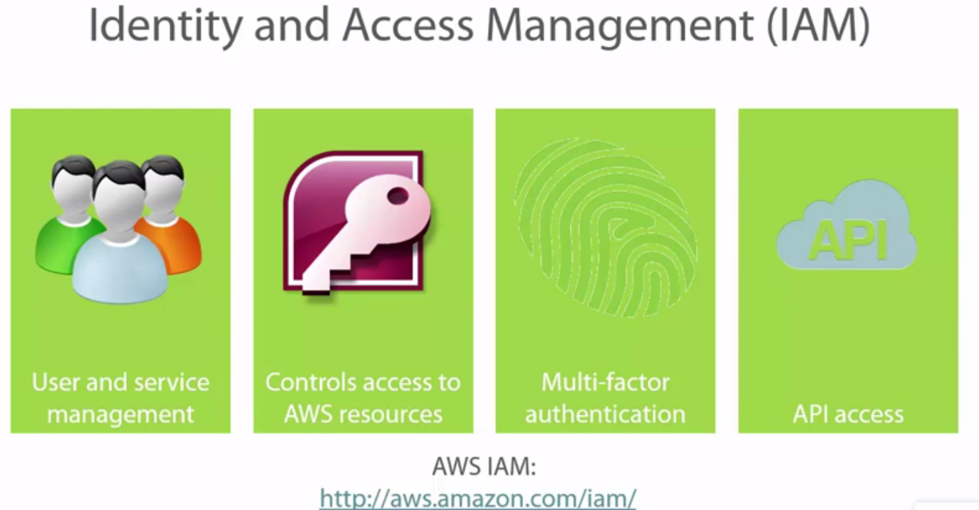

1.)they give you user and service management. You have the highest level of delegation possible in the form of users and groups, in the form of roles, in the form of federation.

**federation** here, is if you wanted to extend your active directory from on premises into the cloud, you can do that with federated services, active directory federated services you can do that.

**Roles** is where you can create a set of privileges that you're putting under a role and then you're assigning a user to that role. So anybody in that role can then get access to a specific set of privileges. These privileges might be the ability to manage storage and manage network and create virtual machines or virtual instances, as they're called with Amazon Web Services. So it gives you very high levels of delegation that you can control with the identity and access management.

2.) **You then have access to controls to AWS resources.** So, again, you can do that via users and services. You can do that via the ability to set security on every component of AWS. **Every component of AWS can have security against it in the forms of security groups or ACLs. All of that can be also controlled very, very granularly.**

3.) **Multi-factor authentication**. So if you were to do multi-factor authentication on premises it would require a lot of configuration, a lot of design, it would require cost. You would have to incur software costs, you would have to configure it. Well with Amazon Web Services you can be up and running on multi-factor authentication in a few minutes. **They give that to you for free.** Go ahead, use it, just make sure everything is secure.

Again, multi-factor authentication is needed, it's important in order to, again, make it even more difficult for someone to try to brute force into username and password. Maybe they can crack a password**. But a password and a multi-factor authentication?** And this comes in several different forms right.

It can come in a key fob, a secure ID fob. It can come off of your phone that can give you a number that changes randomly every 10 seconds or 20 seconds or 60 seconds, whatever it is.

So multi-factor authentication should be part of your best practices in the identity and access management control whenever you're using AWS.

4.) **And finally API keys.** So the API keys are important because you need them or your developers might need them. You might need them to configure your applications so that the applications can speak to other applications and, you know, be able to perform certain tasks. So APIs are important. The misuse of API is what could pose a security threat. So if you're misplacing those keys, you're misplacing those secret keys, then it's a problem. So be aware that you also have API access, and API access is important.

You also have the ability to retrieve passwords using SSL. So again, in order for you, you know you bring up an instance, a Windows instance for instance, (laughs) a Windows instance for instance. You bring up a Windows instance and you're trying to get the administrative password. **The only way for you to retrieve that administrative password is through SSL.** You're going to make an SSL request and it's going to do that.

**If you're trying to gain access to SSH, again, that's also secured with SSL.** You can clear out your passwords on reboot or on boot.

Again, if you have an image of a Windows machine up in, on Amazon for instance, or if you're using one of the Amazon instances. Now that Amazon instance probably has a default password. But the default password that the first person that created isn't the password that you're going to get. On boot, Amazon's going to automatically wipe that password and issue a new one via SSL.

Do you see the level of complexity, to what extent they're going in order to protect security?

So from this page, again, there's a lot of information around how you can use IAM, right.

**identity and access management PAGE :** you have the ability of creating groups, you have the ability of creating users, you have the ability of creating roles.

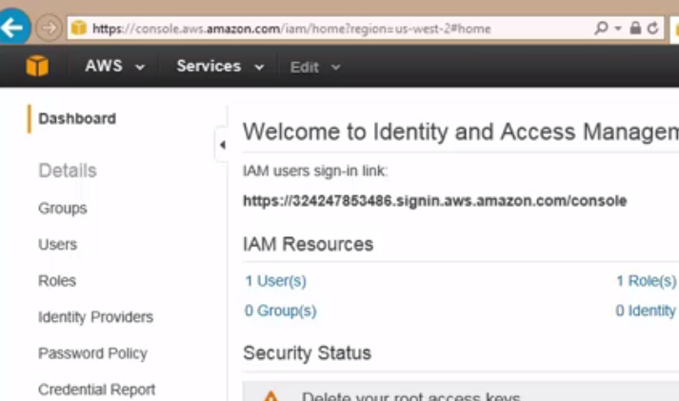Everything is just here at your fingertips essentially for you to create.

-🡪There's a reason why AWS is the 800 pound gorilla in cloud. It's because of all of this flexibility. All of this, keep in mind, you're able to do all of this self-service. You don't have to configure everything on the back-end. Just image how much it took to get to this point where this granularity, as far as the identify and access management is built in while you're able to do it on your own

**Summary**

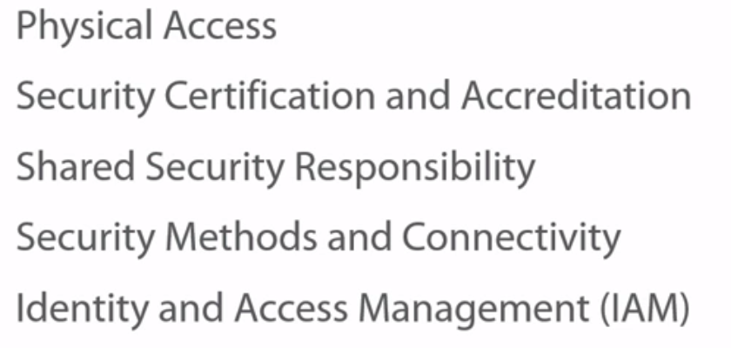

We started by talking about the physical access. We talked about the fact that Amazon, by default, they are going to make physical access difficult, right. They're going to use the best in class security, they're going to use discrete locations, they're going to have video surveillance, they're going to have several levels of authentication, whether it's retinal or thumb or weight or… All of the security that you're used to in a best in class data center are available within Amazon from a physical security perspective.

We talked about the security certifications and accreditations that they have and the fact that they've amassed all of these security certifications and accreditation not by mistake. And these require a lot of work, so these should also be another point in their camp basically or another factor in why you should be able to trust Amazon from a security perspective.

Shared security responsibility, I think we killed this one to death by explaining the fact that there is a responsibility that falls on Amazon as far as security is concerned, and there is a huge responsibility that falls on us as tenants, as people that are using these services.

To understand first what Amazon's security is, what they're doing, where they draw the line, and where our responsibility begins. **This particular thing that I just mentioned is the thing that will make or break an environment, for you to know where your responsibility begins and where it ends**.

Security methods and connectivity, we talked about the fact that Amazon offers a lot of security methods and connectivity, from security groups to virtual private clouds to direct connect to VPN.

And then we talked about identity and access management and how you can extend your active directory, for instance and use active directory federated systems. The fact that you can do highly delegated environments with users, with groups, with permissions. All of that can be done multi-factor authentication. API security, all of this stuff can be done using identity and access management

# The AWS Free Tier

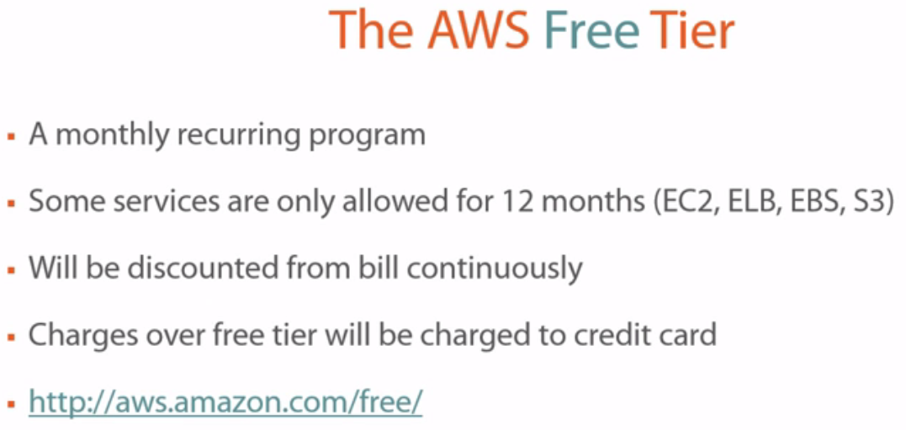

**And the free tier from an Amazon perspective is pretty generous**

Offers basic support and access to resources like: reset of the password, reset of a key fob. That this type of basic support you can get with the free tier so there is customer support that will pick up and try to handle your issue, again, within reason.

If they don't put certain boundaries around this, they're going to first of all get flooded with millions and millions and millions of accounts. And not only that, you're going to probably create multiple accounts. Having a credit card on file, honestly, is for several reasons in my opinion but primarily, it's to limit, first of all, the number of accounts. To limit the number of legitimate accounts so that, again, you're not having multiple accounts out there.

**That's a full year. Again, go back to how generous Amazon is with the free tier. Now what they're trying to do here is they're trying to obviously, get you to understand to appreciate the value of Amazon.**

**Provision Free Tier Resources**

Before Launch Instance--- you should be asking yourself "Well Eli, where do I select availability zones "in my regions?"---Which region and availability zone??

Launch Instance🡪you'll Amazon has all of these AMIs. (AMIs are Amazon Machine Images which is essentially, if you're coming from a VMware perspective or VMware world, it's very similar to the VMD case or the VMXs where, again, this is a virtual machine, these are the guts of the virtual machine, right? The same thing with the VHD if you're coming from a Hyper-V. This is essentially what you're provisioning.)

Now under each of these instances🡪 free tier eligible. 🡪If you go ahead and launch this, you are not going to be charged.-->Lets go with Windows Server 2012 in R2 base here and it's eligible for the free tier

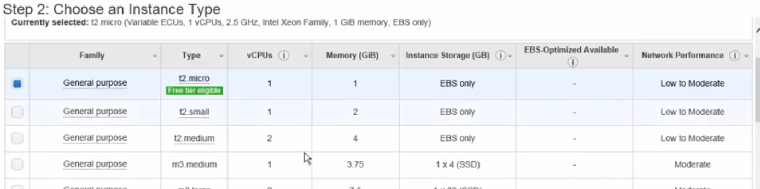

Shows list of Configurations here:

This is the configuration that's eligible for the free tier. 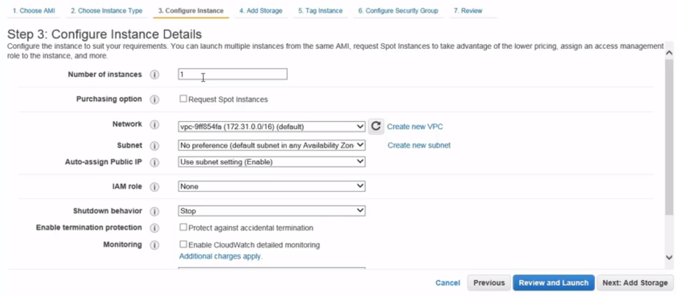

But for instance how many...

Request spot instances: Amazon has capacity that goes unsold, for example, at the end of the month. It has, let's say 100 instances that it needs to sell at the end of the month that are available for whatever reason. Spot instances you can request them. They're very cheap but they're first come first serve. If that virtual machine, if that instance is available you can grab it and you are paying a price for, you're bidding for. Let's say you bid for a spot instance 10 cents**, for example, and someone else comes in and bids 12 cents for a spot instance then I'll bid you even if you've provisioned an instance and you're using it, someone else goes through this process two hours later and they outbid you, it will immediately disconnect you and give your instance to someone else.** Now you're probably thinking that's crazy.

key pair: Amazon does everything very securely and even when you're retrieving a password for an instance, it does that over SSL. In order to prompt, in order to generate that password, it's going to need SSL even on boot. Now, this instance has a default password but you're not going to get that default password. It's going to use SSL to generate a secure password on boot of this instance.

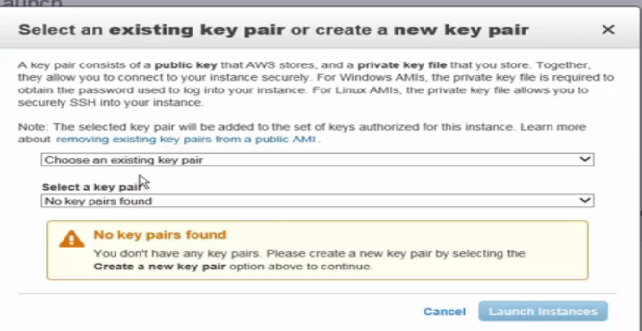 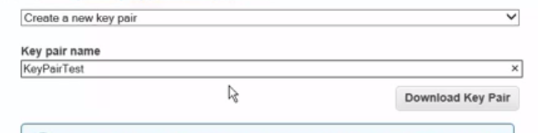

So this is again why you would need to create a key pair. So I don't have an existing key pair so what I'm going to do is from this dropdown here, we're going to go ahead and click on create a new key pair and we're going to give this a name….downloaded this key pair

**ELASTIC IP:**

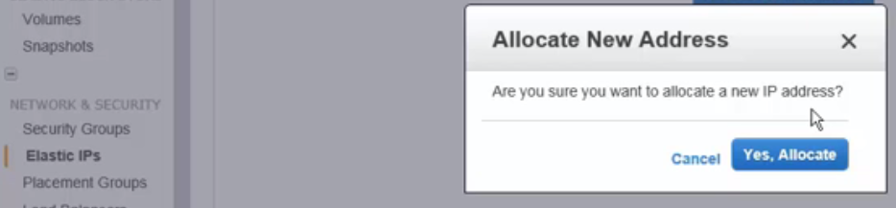

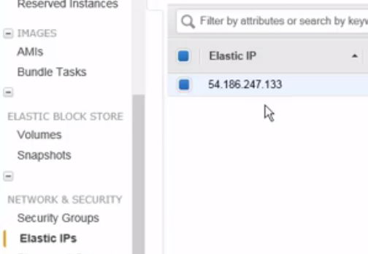

**Interacting with an EC2 Instance**

There's also an easy and quick way to connect to this machine. 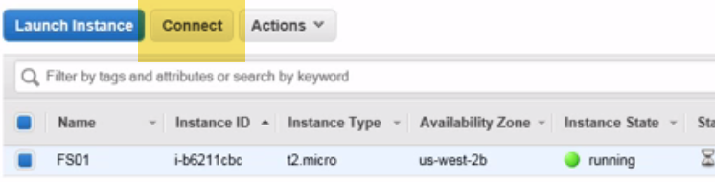

What we want to do first: Want to retrieve the Windows password because if I connect to it and I don't have a Windows password well then I can't log in to it.

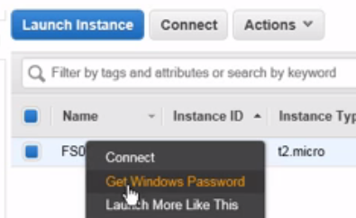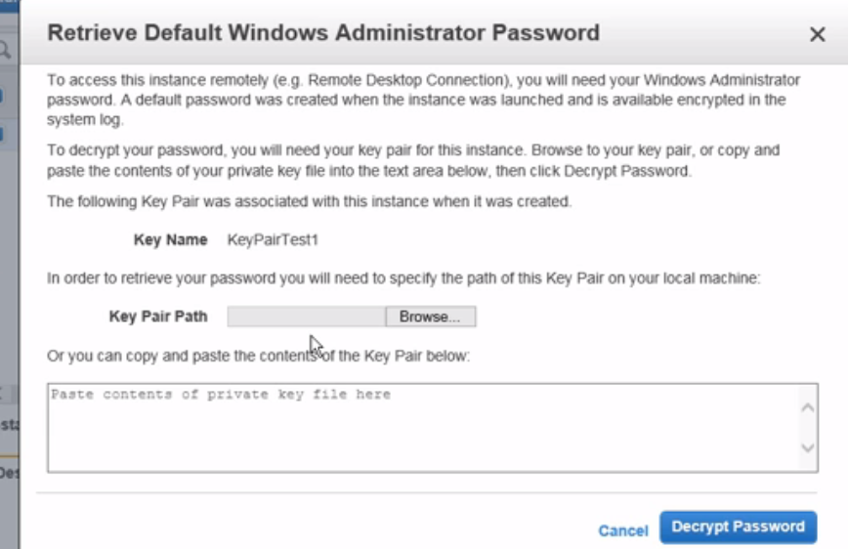

So in order for me to get the Windows password, what we're going to do is we're going to right click on it and we're going to go up here where it says get or retrieve the Windows password.

And what it's prompting you here for is to browse for that private key. So remember when we downloaded that key pair. So key pair test one is now the key pair that we need to use in order to get access to a Windows password.

Now remember, this instance upon boot has a default password but it's not going to give you that default password. It's going to give you a different password using SSL. It's going to generate a new one that would allow you to log in to this particular instance. So what we want to do is we're going to click on browse and we're going to go to the location where we store that private key that we downloaded earlier.

I'm going to select that and then I'm going to click on open and now it pasted the contents of that key pair here. Now you can also go to that key pair and open it in Notepad, copy and paste but this is just easier. Once you have that, now we can decrypt the password and voila. Would you take a look at that? So it's giving you the public IP address so that you can access this instance from wherever you want. The administrator or the username is the administrator and it's giving you the password. So it just decrypted and created a new password for you. You can do a copy here but what I want to draw your attention to is the password change recommended. So while it just generated a new password, it took you through this method of encrypting, wait, they encrypted the password upon boot and you decrypted it using SSL and all of that. It's still prompting you to change it. So this gives you an idea of how far Amazon has taken security, how much to taking security seriously. Can you imagine anyone being able to crack this?

Can you imagine the length at which they're going in order to encrypt a password on boot and then decrypt it using a key pair and then giving you access to that the way I just showed you and then telling you to change it again just to be even more safe, safer, right?

This takes us back to the concept of that shared responsibility. Amazon is doing its part and they're going to the max.

And they're even telling you hey, change this password. Now, if you don't want to change this password and you did what I just did which is to copy and you paste this somewhere on a Notepad and someone gets access to that Notepad file somehow, well they just got access through instance. If your instance isn't protected from a Firewall perspective it doesn't have the patches or the service pack, again, that's your portion that is not being security responsible. So again, that's where that shared responsibility happens in the cloud with AWS in particular. Now when you're done we're going to go ahead and click on close and now you're ready to launch that instance.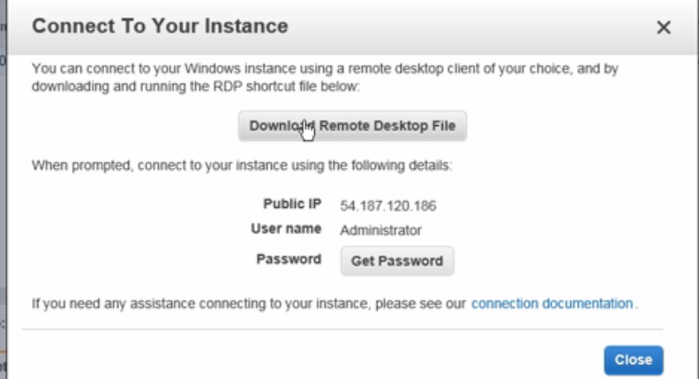

So if you click on connect here for example, it's going to prompt you to download a remote desktop file. So if you click on download the remote desktop file and then you click on open here, it's essentially going to use the RDP client to launch a session to this machine.

**Summary**

How you provision virtual machines there versus how you provision instances on AWS

For instance EC2, you're getting 750 hours per month. For instance you're getting S3, for instance 30 gigs of storage..Working with AWS Storage: Ephemeral and S3

**Understanding Ephemeral Storage**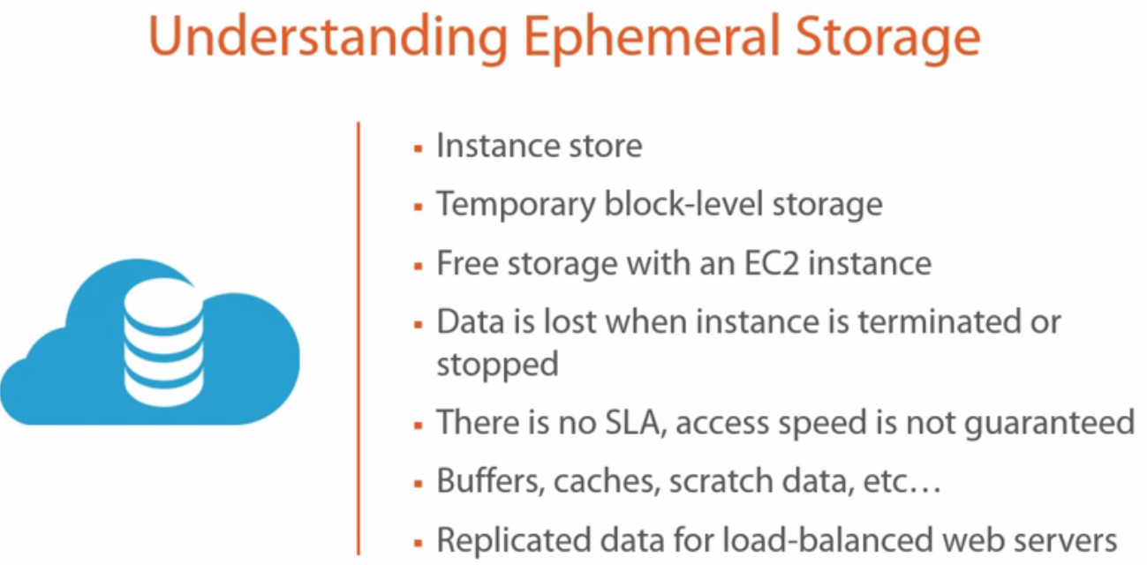

1.)Ephemeral means temporary in dictionary.

As per Amazon documentation, you might find another name for ephemeral storage, which is instance store, or instance store of volumes.

So again, these are another name for ephemeral, which is again, temporary storage.

2.)Now, it's also temporary block level storage, which means the difference between ephemeral and some of the other storage types that we're going to talk about is an :

Ephemeral volume is connected to an EC2 instance and the storage is located on the same server that is hosting that EC2 instance.

So for those of you that come from the virtualization world, for instance, if you have an ESXI host or if you have a Hyper-V host that has local storage and you spin up a VM and you provision that VM with local block level storage on that local server, that would be the equivalent of ephemeral storage in this case. So it's temporary block level storage, which is hosted on the same server that's presenting the EC2 instance.

3.) It’s free storage with an EC2 instance.

4.) That's very important. So ephemeral storage is probably the only type of storage that you get from AWS, which is completely free, which is what makes it interesting and appealing. And we'll talk about some use cases and scenarios in a second. The data, however, is lost when the instance is terminated or stopped. Now, there's a lot of confusion when it comes to this particular statement, because some people think that what do you mean by stopped, Eli? So does that mean when I restart my EC2 instance, my data is going to be lost as well?

**No, if you reboot the instance, then your data is going to persist. However, if you terminate that instance or if you stop that instance completely, then the data will be lost from an ephemeral storage volume or an instance store volume.** So that's the difference here for you to make that determining factor.

Now, if you had an EBS, for example, a volume that was attached and you delete or stop the instance, then that data would persist. You can even delete the EC2 instance and the EBS volume would persist. The difference here is that with an ephemeral volume or with ephemeral storage, that volume per se, is attached to the EC2 instance, there's no way to detach that ephemeral volume from the EC2 instance. They come in one package. It's take it all, right, it's take it or leave it.

5.) There’s no SLA, no service level agreement, for an ephemeral storage. And the access speed is also not guaranteed. So it's all going to depend on how many other users are on that particular server and how much they're hammering the storage. So that will be the determining factor of the access speed for this type of storage. It's ideal for temporary storage, right? For information that's constantly changing.

6.) So for instance, like buffers or caches or scratch data. All of that temporary memory type storage level things, these would be ideal for. They're also ideal, for instance, if you have a fleet of web servers.

7.)So let's say maybe you have 10 or 20 or 100 web servers where the data for these web servers is being replicated or load balanced and replicated, you really don't care at that point if a particular instance fails, because as soon as you bring up another instance, well that data is being replicated, right? So in this case if you're using ephemeral storage, well guess what?

First of all, you're gaining the free storage because you're not being charged, you don't really care about the fact that data is lost if you happen to stop a particular instance or terminate it, because as soon as you bring in another instance into the pool, it's going to start replicating the data too. So again, you see here these are small particular examples of how to use it. **I'm sure you're thinking about development and test and a whole slew of other things where you can use this non-persistent data, per se. It's not non-persistent completely, but to a certain extent it's non-persistent because some of us are going to be worried well, what if I stop completely the EC2 instance because I'm trying to save on usage charges?**

Well, this wouldn't be the type of storage that you would want to have that AMI provision with. So again, depending on the use case will dictate whether or not you're using ephemeral storage.

**Now, there are AMIs that when you're going through the selection of AMIs on Amazon, machine image, there are AMIs that come with ephemeral storage. So you'll have to find the ones that come with ephemeral storage, otherwise they come with EBS. So you'll have to look for those if you're trying to provision them for a particular use case. Again, web servers and other types of load balanced pool servers that have replication by default could take advantage of ephemeral storage.**

**Amazon Simple Storage Service (S3)**

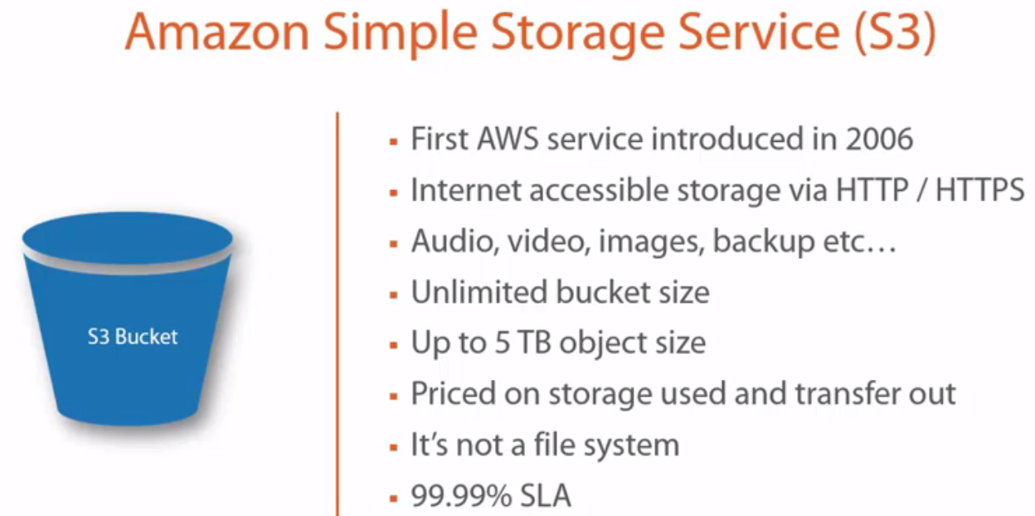

why it's called S3? Again, Amazon Simple Storage Service. Three S's, S3, kind of cool.

1.)S3 is the first AWS service that was introduced in 2006. Now remember, AWS has been around before 2006, but it was in 2006 when officially S3 was the first AWS service. So it's been around for a while.

2.) It's also internet accessible storage via HTTP and HTTPS.

**Now, you're probably wondering why would Amazon start with a storage service.** Now, we're going to talk a lot about S3. S3's essentially the foundation, in my opinion, of AWS just because of its depth and breadth and its capabilities.

And I'm going to give you a real world example of something that happened to me, actually, with my brother and how S3 kind of solved this. But let me go through this real quick. So it's internet accessible storage. Whatever you place into the S3 bucket. So again, S3 has the concept of a bucket. You can think of a bucket as a drive, for instance. Where you can create folders and directories and you can place files in there.

3.)You can store things like audio, video, images. You can store your backups in there. So it's very helpful and it's very easy.

4.)It's an unlimited bucket size. There's no limit on how much you can put in the bucket.

5.) But there's a limit on how much the object, a particular, the single object size can be. So you can only have an audio file, for instance, that's up to five terabytes in size. You can have a video file that's only up to **five terabytes in size.** But you can drop multiples of these files within this bucket, of course.

**6.) Now, it's priced on storage use.** So however much you occupy from an S3 buckets perspective or capacity perspective, you pay for that.

**7.) You don't pay for any bandwidth for importing your data into an S3 bucket. You do pay if you're transferring data out of your S3 bucket.**

8.)Now, the other thing is it's not a file system. Now, when I say that, those of you that know that Dropbox, for example, is running completely on Amazon S3 for that matter, are probably wondering, well, wait a minute, doesn't that kind of defeat the purpose? Isn't Dropbox technically giving me a file system of sort? Or am I not using Dropbox like a file system? I create directories on there, I put files up there, et cetera, et cetera. Well, the answer is yes.

Now, what is the contract, how is Amazon structuring this with Dropbox in the background to allow for this to happen is a different matter completely. But from a use case perspective, Amazon doesn't want you to map a drive, for example, and use S3 as a map drive. You might have some challenges if you even do that. So the idea here isn't to treat it as a file system. It's not for you to substitute that for a map drive. If you're going to do that, then go with a service like Dropbox that has that particular functionality built in.

9.)**REALTIME**: Now, what's a good use for S3 and how could you use it in the real world? And let me give you a perfect example of this. My brother came to me and said, you know what, I'm starting a new business, it's a web based business, and I want to be able to do drop shipping. Now, he's contacted certain companies, he's gotten catalogues from these companies, and he's figured everything out, right, so he wants to sell on Amazon. Actually he's selling on the Amazon eCommerce side of it.

But he's challenged with a problem in that he doesn't know what to do with the amount of pictures for the products that he wants to sell. And I'm talking about thousands and thousands of pictures. Now, without S3 you would have to kind of go to a hosting provider and host the server, a virtual server, and drop these on IIS or Apache and make that particular directory available and hope that Amazon will accept this type of a connection. Because Amazon wants it to be accessible via HTTP and HTTPS. For instance, they won't accept that you put it on Dropbox and it's a challenge to share each and every one of those files and there's just way too many of them. So well, what do you do?

Well, you can drop all of these thousands and thousands of files in an S3 bucket. Because it's internet accessible storage, so you can access it over HTTP and HTTPS. For him it solves the problem almost immediately. He drops those files there, it's internet accessible, he puts it in a spreadsheet, each file and the relevant image to it, uploads it to the Amazon eStore that he has and bada-bing, bada-boom, he is up and running in a matter of minutes. Now that's an ideal use case, for example, for S3. You could also turn S3 into a website or you can host your website on S3. Now, there are caveats. If it's a static website, right? So you don't have a lot of scripts that need to run.

It's not going to have any of those engines that make the website dynamic. But if you have a bunch of HTML files that are pointing to images and text, then you can absolutely host your website on S3.

I'll show you during the demo purposes kind of how you do that, but as soon as you create a bucket, that bucket essentially becomes a fully qualified domain name that you can access from the internet.

-🡪 So for example, if your S3 bucket was for all intents and purposes, Pluralsight, for instance, it would be Pluralsight.amazon.com and you'd be able to access it that way, and if you have an index or a default HTML or ASP or ASPX, whatever it is, files up there, then it would load them, so it's essentially a web service as well where you can host your website on there if it has static content. Now, as far as S3 is concerned, S3 has 99.99% service level agreements, which means it's going to be up 99.99% of the time. Again, remember S3 is a very popular service. It's one of the flagship offerings that AWS has. So from an SLA perspective, you can almost bet the bank or bet the house that they're going to be paying attention on this particular service.

8.)One thing that I want to make clear is that SLA is going to be very different than data durability, which we're going to talk about in a second. But from an uptime perspective, it's important to understand and important to know that they are providing a 99.99% SLA for this. 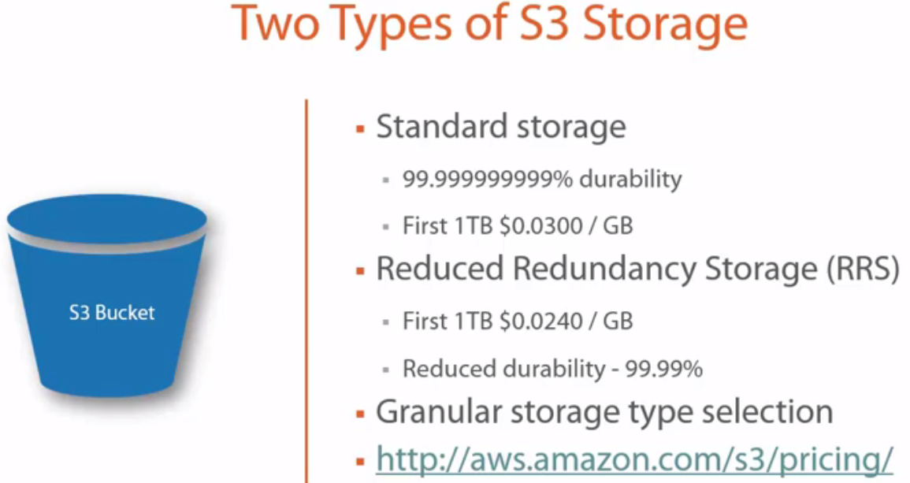

1.)Now, there are two types of S3 storage. There is the standard S3 storage. And I know this is kind of a ridiculous number, but it's true. This is a 99 point I don't know many nine's percent durability as far as the data is concerned. Which means if you store, and this, what I'm about to tell you, comes directly off of the Amazon documentation.

If you store 10,000 objects in an S3 bucket, the amount of loss of data would be one every 10 million years, no joke. This is not a joke. It would be one every 10 million years. Now you're probably asking, well, how do they achieve this level of data durability?

-🡪**What they're doing is they are replicating your data every time you store anything in that bucket, it's getting replicated at least three times on multiple devices within the same availability zone and within multiple availability zones within the same region.**

So if you have a region that has three availability zones, then that particular file is being replicated several times within the same availability zone and then within the different availability zones that make up that region. S3, if you read the documentation, they can sustain up to two availability zone failures and keep your data protected. So it's extremely high durability up time when it comes to that.

2.) Now from a pricing perspective: But for the first terabyte that you upload to your S3 bucket, this is the price that you pay per gigabyte. It's something to the 0.03, what is it, thee pennies or three cents or whatever, that calculation comes to. So that's with standard storage.

**Reduced Redundancy Storage (RRS)** your first terabyte, it's a little cheaper. And you also get reduced reliability. So now you're getting 99.99%. So for example, you might have for every 10,000 objects that you put in S3, you'll have one per year that will fail.

Now for that one that will fail, you can also set up notifications so that you are getting notified that hey, this particular object has failed or is inaccessible, etc., so you have this type of stuff. But again, it's still being replicated, it's just a different type of durability, and that's why the price is cheap. Now, you're probably asking, well, why would I use this?

**What's a good example to use this. If you are uploading your photos, for instance, and these photos maybe you are a photographer or maybe you are a web designer and there are some high resolution photos and there are some low resolutions photos and maybe there are some thumbnails. What you can do is you can put your high resolution photographs on the standard storage, and then you can put your lower resolution photographs or the thumbnails on reduced storage.** They're still going to consume space, so why not put them on cheaper space? That way you can save some money.

--🡪 Now think of this, again, for a company like Pluralsight that maybe has tons and tons of videos. Maybe we're putting the master on standard storage and then if we have different formats for the iPhone or the iPad or for an Android device that maybe has a reduced quality, the size may be different, whatever the idea might be here, you could put that on Reduced Redundancy Storage or the RRS because you have the master kind of in a reliable standard storage with all that durability, but all these different variations of that master can be stored elsewhere.

🡪Now, the beauty of this is you have granular storage type selection. So for instance, you can go into your storage bucket and say, you know what? Video A, I want this to remain on standard storage, which falls under the category of protection of that durability, et cetera. But maybe Video B, which is a lower quality version of Video A, you can again go in, right click the file, and we'll go through that, and you can see how you can specify that as RRS. So you have very granular control over the objects that are in your S3 bucket that are standard storage protected and the ones that have RRS that is applied to them.

**Configuring S3**

AWS management console: try with IE with compatibility mode or try Chrome or another browser.

S3🡪 click on Create Bucket.

**Note:** bucket name has to be a unique name. Recall during the presentation we talked about the fact that S3 is internet accessible, right? Which means users are going to be able to access this. Now, why would this need to be unique? Well, it would need to be unique because it's going to be something to the extent of the bucket name that you choose dot amazon.com. So it can't be something that conflicts with someone else's bucket. Now it has to be unique within all the buckets that are available in this particular region. 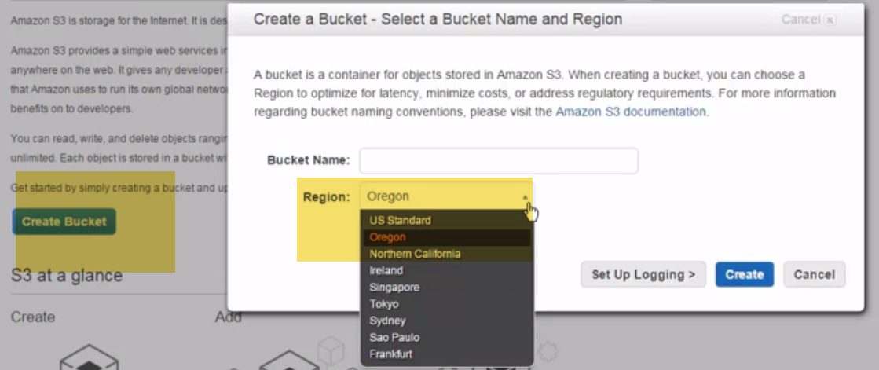

Let's try wired brain coffee as name

I have used this name before, but I've deleted it. So it should accept it. If it doesn't, that means there's a conflict and we would have to change it. Now in your case, if you go ahead and put a bucket name and click on Create and the bucket name comes back with an error, what that means is that bucket name isn't unique. Someone else is probably using it. So what you want to do is make that unique name so that it becomes internet accessible. So if I click on Create here, it accepted it. Again, I deleted this, I've used this bucket name before and I've deleted it, but it still accepted the fact that it's still unique and nobody apparently has used it.

**Click Upload:**

Select the whole batch of files or select single file...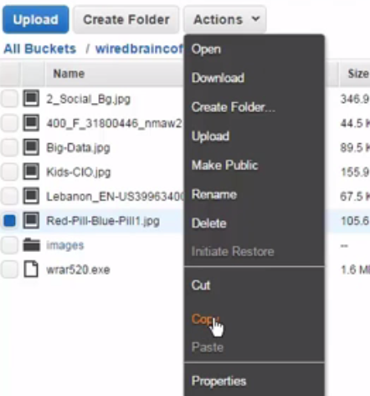

Organize things🡪 Create Folder: Cut, copy, paste, properties..

**Note:** S3 has a flat file structure. So the file system isn't a complicated file system. So whereas we just created a file within images, the way it records it is images backslash that file name. And the file name is, again, it's put into a flat file essentially, very similar to the way databases do it. And the reason they do that is for the speed of search that they can get the thing so they can index things quicker. If you have folders and directories, then you would have to go through all these folders and directories and that would slow that indexing and that searching process. So as a result, it's a very, very flat file where they place everything. So again, in this case it would be images backslash that file name, so it organizes it for you from a UI perspective, from the user interface and the user experience perspective, you're getting the feel of a folder, but realistically in the background that's not really a folder, that's just how it's organizing them.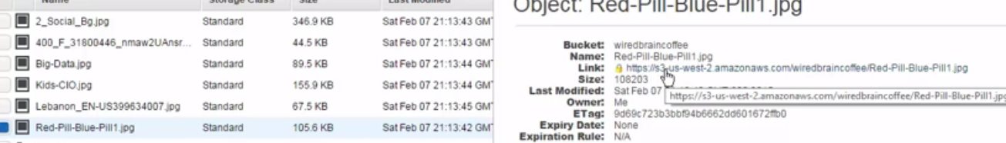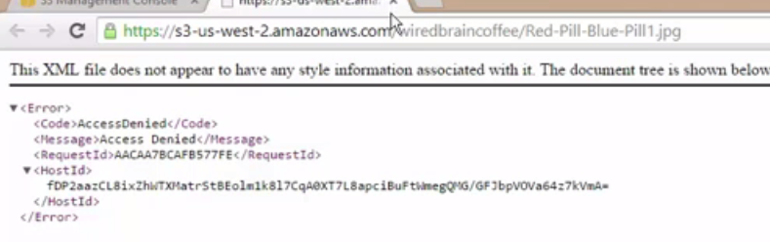

Properties of this file🡪 broken.

So to do that, we're going to go ahead and expand permissions. And right now I'm the only one that has access to this file.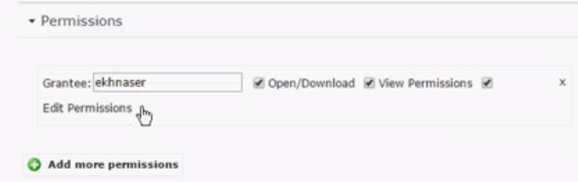

I'm going to go ahead and click on Add Permissions.

And from the drop down you have several options.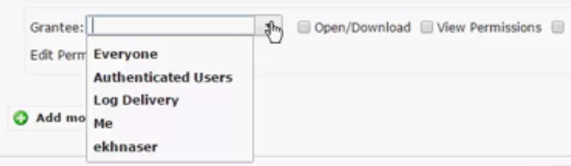 If you click on every one, that means everyone in the world is going to get access to this particular file.

If you do authenticated users, I mean, that's self explanatory, any user that's logged in will be able to do that.

If you use log delivery, that's a user that's essentially a service account that Amazon uses in order to deliver notifications to you against particular files so you can use that.

Me is just an alias for adding yourself in a kind of a shortcut or a quick way. So because I want this to be internet accessible,

I'm going to go ahead and select everyone. And then I need to give it some attributes, right? I need to be able to give it, well, what kind of permissions do you want to use? Now depending on the type of file and how granular and how particular you want to be, you can select for the most part open, download, and view.

Now, this is an image, so they would have to download this particular image and then open it in order to view it. If this was maybe a text file, then maybe view would be enough because they don't necessarily have to download the file and view it.

So again, I find that if you're giving everyone permission, it's pretty safe to do open, download, and view. That's pretty standard in order to give users access to it. Now if I scroll a little bit down, if I click on Save, look what happens if I click on the link now. Voila, right?

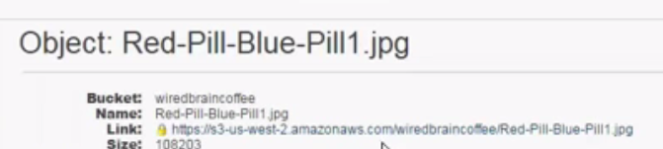

So just imagine, again, in my brother's example, if I needed to do this for his Amazon listings how easy that would be. Now you're probably asking, now Eli, **do I have to do this for all of these files individually like this?** Well the answer is, you could if you want to. Or you can come in here and essentially select files, multiple files. So let's say you're selecting this file and I'm going to hold down the Shift key and up.

And I've selected a bunch of files here. What you can do is you can right click and you can do these make public.

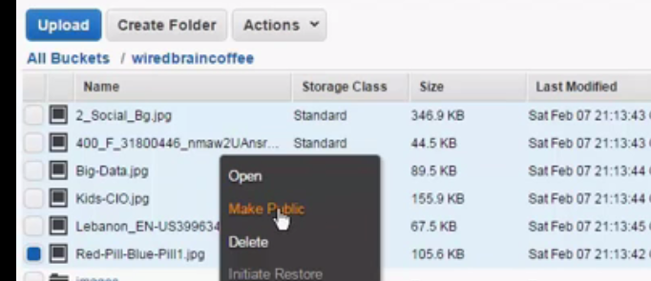So if you click on the Make Public shortcut here. Let me go ahead and say yes. it will make all of them public. Now look what happens if you look at the permissions that were configured, essentially, against this particular file, it essentially the same thing. So it did open view, it did not grant, for example, the view right here but it did make it open download. So let's see what happens if I click on the link. Bada-bing, bada-boom, look at that. So now these images are accessible again from the internet. Now recall during the presentation we talked a little bit about the fact that you can place certain images, certain files, certain things that you have in your bucket, you can either put them on standard storage or you can put them on reduced redundancy. And I told you I'd show you where you can do that. So let's say you wanted to put certain files in the images folder here. And oops, let's go back and let's make sure this is selected and then we can click on properties. So if you wanted to do that, what you would do is from the properties menu if you expand details. And again, you can access property simply by right clicking and going properties, but I find that this is just quicker. You'll find that under details you'll find it right here. So you can either do standard. Or maybe if this is the images where you're going to place all of your thumbnails and you really don't want it to be the standard one because it's more expensive and et cetera, you can put it in redundancy reduced and then you can simply click on apply. You have the ability also of doing encryption. So if this was maybe an important folder, you can apply encryption against it in the form of AES 256 or AS 256 or you can select none if you don't want to get into data encryption. When you're ready you can click on save. Now, recall I told you you can get very granular with this particular setting, right? So if you wanted to do it on a per file basis, you can select that particular file, go to properties again. And again, from the details drop down here, maybe this particular file needs to be standard and maybe you want to apply encryption against this particular file. So you can get very, very granular in how you divvy up or how you divide or where you place the different files and folders within your bucket. Now recall I also told you that you can use S3 as a web hosting, a static web host, essentially. Now, to do that, if you go back up to the main bucket here, if you click on it, and then click on properties, you're going to have a display of all the options that you can perform against your particular bucket. We talked about permissions, but let's talk about static web hosting. So from static web hosting perspective, you have several options. What's selected by default right now is do not enable web hosting. And I'm going to talk about enable it in a second. But you can also redirect it. So if you are trying to redirect it to another bucket or to another domain name, you have the option in here of coming in and doing that. For our purposes, what you want to do here is you want to select an index page, an index document. This could be index.htm, index.html, default.htm or default.asp depending on the type of content that you have the default page, it's that initial page that people will hit on your website. So you would have to specify that. Now because I don't have an index page per se, what we're going to do here is we're simply going to select one of the files that's available already in my bucket and make that act as if it was that particular index file. Now you can also put a description in here. For example, I don't know, let's just do error. Actually let's do the other one, just to ensure that we're not going to get an error here, since it's the error one, let's do kids-cio.jpg. And let's go ahead and click on Save. And now watch what happens when I click on this in particular endpoint. See, it automatically defaulted to this particular file that we selected to be our index file. So if this was, for instance, an index.htm or html, then it would display that and you'd be able to navigate your website from this particular location. All right, let's go ahead and close out of here. Now, other things that you can do here. So again, if I come up here and show you some of the properties of this particular bucket. If we go ahead and collapse that, you're probably looking at this and if you're like me, something is clicking in your mind, you're saying, you know what? This looks awfully like a Dropbox. Well yeah, if you're looking at versioning and you can enable versioning, which means you'll be able to save, every time you make a change to a particular file, it's going to save that version so you can revert back to it. This gives you an idea of all of the functionality for Dropbox is really built in. All that Dropbox really did is they created a Windows client and a Mac client and an OS client and leveraged all of the hooks in the back end of S3 and made it look pretty so that we're able to consume it in kind of an easy, seamless way. But all the features are there. Now, they're able to do that because, again, accessing S3, and Dropbox is not the only one. There are other software that can access S3. They're able to access these functionality, these features, through the rest API that S3 provides. So all they're doing is their particular software is then issuing commands against this platform and they're able to do some really neat things. So again, the UI here that I'm showing you that S3 presents allows you to do certain things. But for example, from a permissions perspective, if you're using the rest API, you'll be able to get a lot more granular within the permissions. You'll be able to grant and deny a lot more permissions than what you have here by default. So again, it gives you an idea for what you can do with S3. Now some of the features here are a little outside the scope of this particular lesson in this course. But again, some of them are also pretty self-explanatory, like events for instance. You can configure events up here. You can configure versioning, life cycle, tags, et cetera. So this gives you an idea of what you can do from an S3 perspective.

Summary

Don't tell me you're not having fun. This was a really cool module. We covered a lot of stuff and it's really cool to see the power of AWS at your disposal, the ease by which you can create services, the capabilities, the creativity that you can use to leverage AWS and for your organization and for your customers. So let's bring this around and let's recap what we've learned. We started off by talking about ephemeral storage. We talked about the fact that ephemeral means temporary. Ephemeral in this case means temporary block level storage, which means it is attached to the EC2 instance and the storage is coming from the same server host that is provisioning that EC2 instance, you're getting access to that local storage on that particular server. Talked about the fact there are no SLAs, there are no guarantees as far as performance. One of the reasons for no guarantees is, again, it's free storage, so you don't pay for ephemeral storage. But because it's also free and there are no guarantees, you might have a noisy neighbor, you might have several users on that particular storage hammering that local storage. As a result, you might see a performance degradation. But it's very useful for things like web server farms where data is being replicated and you don't really care. Talked about the fact that the data will persist on reboots. It won't, however, if you terminate or if you stop that particular instance. From ephemeral storage we moved on to understanding AWS S3. We talked about the fact that it's the first service that was launched by AWS. We talked about the fact that you have two services there, you have standard and you have RRS. And with RRS you have the reduced reliability, but you have the same performance and latency performance metrics that you would get within S3. We talked about the pricing, we talked about SLAs. And then we went into a demo of how to create an Amazon S3 bucket, how to upload files into S3 bucket, how to create folders in an S3 bucket, how to expose these files and these folders to the internet so people can access them. How to turn your S3 bucket into a website. We talked about all the features that you can use from an S3 bucket perspective. Finally, I hope this module was very informative for you and I'd like to thank you for viewing.

Working with AWS Storage: EBS and Glacier

Understanding Elastic Block Storage - EBS

Welcome to Pluralsight. This is Elias Khnaser and you're watching: "Working with AWS Storage: EBS and Glacier". Alright, now it's time to talk about Elastic Block Storage or EBS. EBS is not an internet accessible storage. Unlike S3, EBS is a subsystem of EC2. It is a supporting service to EC2. It is not a service that can stand on its own two feet independent of anything else. It provides a persistent file system for EC2, again, you don't have to worry in this case about rebooting, or terminating, or stopping an instance, your data is going to persist. And it does not need to be attached to an instance. So again, you can terminate, or delete, or stop an EC2 instance but that volume will persist. And I'll show you a little bit later on when we get into the demo, how volumes have a separate section. So you can always provision volumes and not necessarily attach them to an EC2 instance. You can detach them and attach them to a different instance, so you have flexibility from that perspective. Again, think of EC2 as a volume or as a disc that you would add, essentially, to a virtual machine. It can be transferred between availability zones. Now, I want to be careful with this statement. When I say it can be transferred between availability zones, that doesn't mean that this is an automatic seamless thing where you can switch between availability zones and that particular volume will be there. But, you can leverage technologies like snapshots and other to make sure that, that particular EC2 ins-- or , that particular volume, that EBS volume is available across a different availability zone. It supports incremental snapshots which means: You can take the initial snapshot, and let's say that initial snapshot was 30 gigs in size, right? You make changes to that particular image again, and then you want to take another snapshot that's not going to take that entire disk again. It will take the difference between 30 gigs and what was made, what was created, the additional. So, if the additional changes were two gigs in size, it would capture two gig of snapshot, as opposed to 32 gig all over again. So that helps in terms of saving space, but also helps in the agility of that particular snapshot; because it's lighter, it's mobile, it's easier to move around. Now, EBS leverages S3 storage for snapshot storage, right? So what that means, is that, EBS also leverages the capabilities of S3 to store the snapshots that it's capturing. Except, it doesn't store the snapshots in an area of S3 that we can access. So, I'll show you a little bit later on, also that, after we take a snapshot we can go into S3 and we won't find it. So EBS has access to a private area on S3 where it stores the snapshots that it captures. You also have the concept of provisioned IOPS. Provisioned IOPS are very important and they're very crucial sometimes when you have specific workloads that have an IOPS requirement in order to function properly from a performance and latency perspective. Right? So that's when you can go in and say, "You know what, for this particular application to function properly, I need to have 4000 IOPS." With the provisioned IOPS capability, or feature, now you can go in and say, "I want an EBS volume with this provisioned IOPS," and obviously you pay more for this type of service, but at least you're able to get the level of performance needed in order to make sure that your application and your workload perform properly. Now, without further ado, there's a lot to cover. This is going to be a very exciting demo. Let's jump into our demo and take a look at how we can configure a lot of this stuff.

Configuring EBS from the AWS Management Console

Alright, from your AWS Management Console, you'll find that under storage and content delivery, there is no EBS. You won't find it anywhere. Again, and the reason you won't find it anywhere, it's because it's a subset of EC2. So in order for you to access and start provisioning EBS, you have to enter EC2. So, if we go into EC2, you'll find that I have zero running instances although I have provisioned instances, right? So, I have an instance, except, it's not running; we really don't need it for the purposes of this demo. So, if I go back one step here, just so I can show you, kind of, let's go back to the EC2 dashboard. You'll find that as far as volumes are concerned, I have one volume that's been provisioned. Now, that's where you can go in order for you to create your EBS instances. So, if I click on volumes here, you'll find that I have this particular volume, that was created during the provisioning of the instance that I have. So, this is a particular volume in this case that's dedicated to that particular instance. Now, what you'll find here is that the volume type is GP2. Now, GP2 stands for general purpose. Now, if you scroll down a little bit here and you come to where it says, "Volume Type", if you just simply highlight your mouse over it, you'll find that you have several different types of volumes, right? You have your magnetic, you have your general purpose, you have SSD, you have provisioned IOPS, right? So, these are the different types of volumes that you can create. More information that you can gather, essentially, off of this particular volume, is, you have your volume ID, there's the size here, it was provisioned off of this particular snapshot, you know, the creation date, the availability zone that it's in. It's important to note which availability zone it's in, and it's always important to note which availability zone you are in; because when you are creating these volumes, you want to make sure that your creating them in the right availability zone. Otherwise, you won't be able to attach them to the instances that are in that availability zone. So be careful, while creating your volumes, to create them in the availability zone where the instance is located, in order for that attached process to work. Now, what you'll notice, is that, the name here, it doesn't really have a name. As you start to create multiple volumes, you're going to need some way of differentiating these volumes, so that you know which one is fast or slow, or if you want to tier it a certain way. You want to be able to do that. So, for our purposes, what we're going to do, is, We're going to simply click on this little button here, and let's just call this one, "GP", just to keep it simple, for general purpose. You can call this, maybe, "Tier one" or "Tier two", depending on the type of tier-ing that you have within your environment. So, once you do that, it automatically associates that. Alright, so now let's talk about creating a volume. So, the creation process is pretty simple, straightforward, you probably figured it out. We're going to click on "Create Volume" here, and you're going to be presented with this particular window. Now, from the drop-down, as far as type is concerned, you have the option again of either creating a, "General Purpose", you can create an "SSD", you can create a provisioned IOPS, or you can create "Magnetic". Now, the most interesting one of all of those is probably the "Provisioned IOPS", here. So if I select on "Provisioned IOPS", you have the option, again, of configuring a particular IOPS level for you application. So, in order to keep things simple, I mean, I could keep this at 100 gigs and the level of IOPS that I'm getting is 3000, but what I want to do is: probably minimize this a little bit. So, let's go ahead and do, for example, 20 here. Now, as far as availability zone, again, if you forget which availability zone you're in, the easiest way is: to lower this window a little bit and, take a look here, you can see that behind you, you should be in "2B" if you are going to connect it to the same instance that this particular volume is connected to; And that's kind of what I want to do here. So, I'm going to go ahead and select "2B", and... Whoops! So, one of the things that I didn't do here is, when I changed the size of the volume that I'm trying to create down to 20, I also have to, kind of, adopt the IOPS level in order to match that. So, in order for me to recalculate the IOPS level for a disk size of 20 you have to do that... 30 to one ratio basically which means, if I do: 30 times 200, I'm going to end up with 600 IOPS here. And then that should allow me to, again, if I wanted to change the availability zone to "2B" I can do that. You can also base this particular volume off of a snapshot. So if you wanted to create just a blank volume, great; but if you wanted to base it off of a particular snapshot, then you can do that. So, you have all of these snapshots that you can choose from, these, AMIs that you can choose from. This is, essentially, taking a snapshot of the "C" drive or the "D" drive of a particular AMI. It's like stealing their local drive. Now, the other thing to keep in mind here is, if you've created snapshots, and we haven't yet, but if you had any of your snapshots already created here, then what you could do is, you can leverage those snapshots in order to create a volume as well. For the purposes of my demo, I'm actually going to leave that blank. If you wanted to encrypt that, then you can do that as well. Then, what we want to do, is, I'm going to click on create. Now, remember, this particular volume hasn't been attached to any instance yet. But before we do that, let's go ahead and give it a name. Now, I showed you how you can give it a name by simply clicking on this pen-like icon here; but if you wanted to do it a different way, you can essentially select this particular button on right, let's go ahead and un-select that. But you can select that and you can come down here to tags, and tags give you a little more flexibility because they give you some more options as far as, what you can configure. In this case that might not be much, but, you still have the option of creating tags. So, what you want to do here is click on "Add/Edit", and you can click on this particular link and it will give you access to all the different tags that you can create. Whether it's for taxonomy, if you're trying to create it for reporting purposes, if you're trying to do it to make sure how much you're paying. There's 100 different reasons why you're using tags. But, essentially, for my purpose, all I want to do is add a name so I'm just going to click on create. What we want to do here is click on name as soon as I start typing if it's a tag that it recognizes it's going to prompt me. Then, I don't know, maybe we'll do this as "Tier 0" for the fastest tier disk, for instance. Once you're ready we're going to click on save. And voila! It changed the name automatically. Now, in order for you to attach it to an instance, again, it's very simple. We're going to right-click on it down here, you can also use the actions menu up here if you wanted to. Simply come down here to where it says: "Attach volume". We're going to click on attach volume here and then we're going to go ahead and find that particular instance. In my case, I only have one, it found it automatically. So, I'm going to go ahead and select it. You can choose the device. And this will be the device name that shows up for Windows in your disk management in order for you to add and then create a volume out of it and give it a drive letter, essentially. Once you're ready, what we're going to do is we're going to go ahead and click on "attach" here. And bada-bing, bada-boom, take a look at that. It is now in use. So, it went from being "available" to being "in use" which means it is now attached to that instance. Now, let's fast forward a little bit, right? So let's assume that this is two hours later, or three hours later, or a couple of days later, where you've made changes to this particular volume, added data to this particular volume; and now what you want to do is you want to back-up or you want to take a snapshot of this particular volume. Again, taking a snapshot is relatively easy. You either right-click on the volume down here or from the actions menu up here, what you can do is, is you can come down here where it says, "Create Snapshot", and come in here and say, I don't know let's name this, for simplicity's sake: "Wired brain coffee, umm, zero-one", just to keep it simple. You can give the snapshot whatever you want to call it, call it "October 10" for the snapshot. It is not being encrypted. Once you're ready we're going to go ahead and click on "create" The snapshot is being created, or has been created, we're going to click on close. Now, where you can see that the snapshot is available is down here in "Snapshots", you'll see that it's available. Now, recall, during the presentation I told you that EBS stores it's snapshots in S3. So what I want to do is I'm going to take you back to our S3 bucket. So, if we come up here and we go into S3, well, first of all, what you'll notice is that we only have one bucket, which is the "Wired Brain Coffee"; but even if we go into that particular bucket, there you go. There is no snapshot that is available here. So, again, EBS stores its snapshots in a private area on S3 that is not accessible to us. You can again take a look at the volumes here. You have both of those volumes that are now available. Now, if you wanted to create a new volume based on the snapshot that you just created, what you can do is, you can go through the same wizard that we just went through and let's just assume, for simplicity's sake, that this is a general purpose, for example. We want to put it at the availability zone of "2B". Down here, you would have to look for the snapshot ID, essentially. Now, you'll find that there are tons of snapshots here. So, it's a little difficult for you to find the particular snapshot that you're looking for. Now, I'm going to venture out to say that, maybe this is the particular snapshot that we created, but you would have to figure out the snapshot ID. Now, let me show you an easier way, and I'm also going to show you how to find the snapshot ID, but, what is the last four on this? "5-A-6", alright. Let's go ahead and cancel out of here, and instead of being in here, if we go into snapshots you're going to find that (this is the snapshot ID and I was wrong, that wasn't it), but this is the snapshot ID that, essentially, you would be looking for. Now, if you know the snapshot ID that you're trying to create a volume out of, why don't you just come to snapshots, right here, and then just, essentially, right-click on it and go down to "Create Volume". What that will do for you, is, immediately put that snapshot ID up here for you. Then what you could do is go through the standard settings that we went through earlier and put it in the right availability zone. Then create it, and bada-bing! Bada-boom! You're off to the races, right? So, I'm not going to go ahead and create another one, it kind of defeats the purpose, but you guys get the idea here. We're building a volume off of this particular snapshot, and that could be useful again. Depending on whether or not you want to clone something, or if you have a snapshot that you just want to break up into a separate EC2 instance, you can do that. Now, the other thing that you can do is, you can also create volumes a different way, right? So, I showed you how to create a volume from here. You can obviously create the volume from here as well. You can come up here and get into the actions and "Create Volume". So, there's several different ways of doing it, but you can also add volumes at creation time, as you're launching some of these EC2 instances. So, if you're up here on the dashboard and you come into "Launch Instance", for example, and we went through earlier. I'm just going to pick any one at this point. Just to show you the idea. If we go through and select this particular one, and we're going to go through with this. As far as the instance type, let's go ahead and select "Next Configuration" here. I'm going to keep all of these at default and we're going to move on to the next option. You'll find that over here you can now create a new volume. So, if you wanted to do this at creation time, you can also add a new volume here. You can select wethere or not it's EBS, for example. You can also build it off of a snapshot. So again, if you're trying to grab your snapshot or another snapshot off of an AMI, you can also do that at this point. So again, it's the same process it's just different ways of accessing it I just wanted to make sure that I was giving you the different scenarios by which you can access this. Now, the one thing that I want to talk about before we move on to Glacier, let's go ahead and cancel out of here and let's go back into "Volumes". Now, we talked about the fact that you can create what's known as provisioned IOPS, where, you're going in and saying, "You know what? I want to create a provisioned IOPS volume that is 4000 IOPS because I have an application that requires this particular performance level." Now, another thing that you can do, that's an alternative to provisioned IOPS, that you should consider, from a price perspective, just in case it makes sense, is instead of going down the provisioned IOPS route, what you can do is, provision several different volumes, right? So let's say you needed 100 gig and you're provisioning 10 EBS volumes that are 10 gig in size each, right? And they are not provisioned IOPS so they are getting whatever the standard IOPS rate is for the SSD, whatever SSD is giving you as far as standard IOPS is concerned. What you can do is, if you end up with, let's say, 10 hard drives, at least 10 hard drives are each 10 gig in size with a specific amount of IOPS. You can then attach those to the instance, and when you boot up windows, you go into your disk management, disk management is going to realize that it now has 10 new devices. You should be familiar with that, right? It's very standard. As soon as you add a VHD or a VMDK, for instance, or in the physical world, as soon as you add a new hard drive into your server or into your computer, disk management in Windows is automatically going to pick it up, or you can scan for it and it's going to pick it up. So, imagine in this case, if you do a scan, it's going to pick up 10 devices that it now sees in its operating system. What you can do then, is provision these 10 devices and you can create a dynamic LUN out of them, right? Maybe you're creating a RAID 0 LUN, which is striping without parity. Now, striping without parity is going to give you incredible performance. So, maybe, just maybe, going this route might give you the number of IOPS that you need at a lower cost. I'm sure you're probably thinking, "But Eli, if I'm doing RAID 0 without parity that means, any disk that fails in my RAID group, essentially, destroys the entire RAID group." You're correct, but remember what I told you earlier. The durability is very high. Why? Because it is replicating your data in the same availability zone and across availability zones. So, the risk of a drive failing is very, very, very low. So, in this case, you might be able to take the risk because again, the data is available so much, these drives are being replicated so many times, that it's extremely unlikely that a disk will fail. So, it's a weighted risk that you would have to take into account, but it's something that I wanted to make sure I'm mentioning just so that you know, "Okay, well there's more than one way to skin this cat."

Understanding Glacier

Glacier. What a cool name, right? Now, while it has a really, really cool name, Glacier is synonymous with very, very slow. So if you were expecting something rock-solid, you've got something else waiting for you. It's very, very cheap storage. It's like a penny per gigabyte. There's a lot of buzz around glacier, everybody wants to use Glacier. After I show you what you can do with Glacier, some of you might be a little underwhelmed, but it serves a particular purpose really, really well. Now, it's useful for data that is not accessed frequently. It's ideal for backup for example. You can use Glacier not just for backing up your enterprise data, but you can also use it for backing up your personal data. You can use tools like CloudBerry, for instance, Explorer in order to interface with Glacier. So, the thing that I wanted to talk to you about Glacier is the fact that it doesn't really have an intuitive user interface from an Amazon perspective. It was built in order to provide restful APIs so that a 3rd party would leverage Glacier from an infrastructure perspective, would leverage Glacier from a platform perspective, to build valuable services on top of it. So, the same way Dropbox leverages S3, for example, to provide you that interface, that rich user experience, that mobility of the data etc., there are a ton of 3rd party providers that leverage Glacier in the background in order to make it a target, for example, for backups. So, whether you're using it at home, or you're using it in the enterprise, Glacier can be a target for backup if you're using a provider that is using Glacier for that purpose. So, it's very useful for infrequently accessed data, ideal for backups. Now, it's very, very slow from a retrieval time's perspective. Now, when I say very slow and when I say retrieval time, and I have 4 to 6 hours here it might be a little bit less, might be a little bit longer, but the idea here, it's not just a restore process. Even if you were to do a directory listing of the items that were inside Glacier, it will take a very, very long time. I'm sure Amazon is using very high-capacity disks. There's this concept of these cloud disks that are coming out they're very, very large capacity disks, but they're also very, very slow. And you can't write to them more than like 40 or 45 times before the drive dies. So the idea here is, you store this type of stuff for long term retention, but you don't necessarily access it that frequently. So, the other thing is it's high durability, it's going to last for a very, very long time as well. There is a cost for restore so it's not just the fact that you're hosting your storage on Glacier for a penny, for example, a gig, but when you go to restore your data from Glacier you get another set of costs that's associated with it. There is encryption that's available in the form of AES 256-bit. Again, I've mentioned this several times, but, it is a penny per gigabyte it is really, really cheap. Let's switch over to the presentation purposes. There's really not much to show beyond the creation of a vault, but I want to show you how to create a vault and I also want to get into how do you assign a user permissions in order to access Glacier? So, not only do you need a 3rd party software, a user-interface, essentially, to interact with Glacier, but you have to make sure that you have the right permissions configured in the background in order to allow that 3rd party tool, that 3rd party software that you're going to use, to interact. So, you have to grant that permission, it's not something that will happen seamlessly. Let's go ahead and take a look how this works. Alright, so under here, under "Storage and Content Delivery" we're going to go ahead and select "Glacier". Again, it's very, very simple, you pretty much have one button we're going to go ahead and click on "Create Vault" and for my purposes what we're going to do is create "Wired Brain Coffee Vault", let's keep it very simple. And you can go ahead and continue creating notifications and all of that stuff. But for the purposes of our demonstration we're just going to go ahead and create that vault. Now, once the vault is created, you're going to click on it and, honestly, there's really not much to see beyond that. You can either create another vault, you can delete the vault, we're going to get into settings here in a second, and then you have your notifications. So, you're essentially, switching between the details screen and the notifications screen and you can configure all sorts of notifications. You can come in here into settings and you can go with the, uh, you can create the free trial version of it, you can have the maximum retrieval rate. So, you have some options as far as costing is concerned to choose from, but for the most part, from a configuration perspective, this is it, right? So, now what we need to do is create a user account that can associate, that has access, to leverage Glacier on the back-end, so that when you go to a CloudBerry or when you go to a 3rd party that can leverage Glacier in the background, on the back-end you can enter those credentials and get access to it. To do that, what we want to do is go back to the AWS management console here, and under the security, under, "Administration & Security" what we want to do is click on "Identity & Access Management" otherwise known as "IAM" or "IM" depending on how you want to say it. If you go in there you can do one of two things: You can either create a group and apply permissions to the group so that it's a lot more scale-able, you can just drop users in there and those users automatically get access to the same policies and provisions that you've created, obviously that's best practice. For simplicity's sake, what I'm going to do right now is just go ahead and create a new user. And in this case what I want to do is create a user called, "Glacier User", keep it simple; and over here what you're selecting is, essentially, the generation of an "Access Key" and a "Secret Access Key ID" as well. This is, essentially, what the restful API will use. These are, essentially, the equivalent of a username and password, except there are long strings of alpha-numeric numbers that you can use, again, to access this using restful API. So, what I'm going to do at this point is, I'm going to go ahead and click on "Create". And what that has done already, is it's created those credentials for me. So, if I click on "Show user credentials", you'll see that you have that username, essentially, and the password's an alpha-numeric number. I highly recommend that you save this somewhere secure. You can also download a CSV file that has these credentials provided. Now, the one thing to note here is, if you don't download the file, and if you don't make a note of these credentials, you won't be able to access them again. You'll always be able to see your "Access Key ID", you won't be able to see the "Secret Access Key" again. What you can do at that point if you lost it, for whatever reason, you can delete it, you can make it inactive, and you can create a new one; but you can not get access to this same particular one again. So keep that in mind. So, I've copied these to the clipboard, or you can download them, for the purposes of our demonstration we're not really going to use them, I just wanted to make sure that you were aware of it. So, I'm going to go ahead and click on "Close", and I'm going to click on "Close" again. Now, you'll find that it's already created my username, so what I want to do is click on it, and you can offset it to a group; but what we want to do, is we want to associate this particular user with the Glacier vault that we created. So, what I'm going to do is click on "Attach" here, and we want to select the policy. Now, out of the box, AWS does every effort to create kind of, generic policies that you could use to apply to different environments, you know, it'll give you out-of-the box permissions so that you're not necessarily creating your policy from scratch, like: full administrative control, power user, etc. For the purposes of taking you through the process, what we're going to do is we're going to create, we're going to use the policy generator down here, and then, we're going to go ahead and click on "Select". I want... The effect that I'm trying to do is "Allow", you can obviously select "Deny". You want to select the AWS service that you are trying to configure, and in my case, it's "AWS Glacier". I'm going to go ahead and select that, and then what we're going to do is from the "Actions" here, you can get very specific, very granular, as far as, what permissions you want to grant this particular user. For the purposes of our example we're going to go ahead and click on "All". And then over here, you're probably wondering, "Well, what's an ARN?" Well, this is, essentially, that identifier, that identifies the vault. Now, we don't necessarily have that, so what we need to do is open up another tab and go get it, or we can, pretty much, leave this tab. Let's go ahead and actually cancel out of here. Let's go back to the dashboard. Let's go into Glacier. And if I select my vault down here, you'll find that this is the particular ARN number that we are looking for. So, if you go ahead and copy this particular number, and we go back into "IM", we have a user that's already created; if we go through the user, we come down here to the policy, and we click on "Policy Generator", "Select". We're going to allow, what we want to do here is select "Glacier" from the drop-down. And from an "Actions" perspective we're going to give them access to everything, and what you want to do at this point is paste the entire ARN number. Once you're ready, click on "Add Statement". Whoops! Let's try this again. Let's go ahead and wipe it, let's paste it one more time. There you go, "Add Statement". So, once you've done that what we want to do at this point, is, go ahead and click on "Next" here. Now, this is where you can get into some JSON code, and a lot of modifications, this is a very advanced concept, as far as, what's going on in the background to grant this permission. I wouldn't recommend you touch it at this point, again, unless you're a developer and you really know what you're doing, the default of what's going on here is more than sufficient for the purposes of what we're doing. So, I'm going to go ahead and click on "Add". And voila! Bada-bing! Bada-boom! This is very easy. So we created a policy, we've granted the user that we just created, access to Glacier, right? So, at this point we now have the access code and the secret access code ID. So, we have the username and password. We've given the user the permission to access Glacier. So, at this point, the only thing left is for you to select the service that you want to use in order to interact with Glacier. So, whether that's CloudBerry or anything else, any other service that you're choosing in order to backup or any of the other services that leverage Glacier, you will need those sets of credentials in order for you to get access to your vault here. And that's all there is to it, really, from a Glacier perspective, it's really a platform for third-party to be able to extend services to you.

Summary

"Alright Eli, bring it home!" So, we started off by talking about understanding EBS. We talked about the fact that EBS is different than S3, in that it is not internet accessible. It's also a persistent type of storage, which means, you don't have to worry about the fact of, whether or not you're terminating an instance, whether you're rebooting it, stopping it, etc. You can create EBS volumes outside of the instance. So they are not, necessarily reliant on the instance to exist. You can create an EBS instance that's standalone, you can create additional volumes that you make available to attach to that instance or to attach a different instance, you can detach and attach to different instances, you can create snapshots out of a particular volume, you can create a volume based off of a snapshot. We also talked about the fact that snapshots are stored in a separate, private location on S3. We then went in and created a volume on EBS. We did provisioned IOPS, we talked about the fact that you can do something alternative to provisioned IOPS, which is, to provision several smaller sets of EBS volumes and maybe then present those to the Operating System and use Operating System's rate capabilities to give you the level of performance that you're looking for. We also did snapshots and I also showed you how you can create volumes off of snapshots. After that we talked about Glacier. We talked about the fact that Glacier is pretty standard from a configuration, from a setup perspective, as far as AWS is concerned. It's really a platform that you can use with 3rd party tools in order to leverage very, very cheap storage. We talked about the fact that, not only is it cheap, it's also very, very slow, hence the name. And it's very, very slow, like even getting a listing of a directory will take you a couple of hours in order for you to do. It's meant for long-term retention of infrequently accessed data. So, we went into Glacier, we created a vault, we gave the vault a name. We then went into "IM", we created a user and we gave that user permissions to access Glacier. We got the set of credentials, in order to feed whatever 3rd party tool, that we're going to use from an access key and a secret access key in order to have that username/password perspective so that we can use Glacier from that perspective. Finally, I hope this module was very informative for you, and I'd like to thank you for viewing.

AWS Compute Options

Elastic Compute Cloud (EC2)

Welcome to Pluralsight, this is Elias Khnaser and you're watching AWS Compute Options. Welcome to Elastic Compute Cloud (EC2). Elastic Compute Cloud, two c's, Compute Cloud, EC2, get it? Kind of very similar to Simple Storage Service, S3, and here they're doing the same thing with the two c's for EC2. Now recall, EC2 is the second service that AWS launched in the summer of 2006. First service was S3, second service was EC2. Now what is an EC2? It's essentially a pay-per-use scalable platform for hosting Virtual Machines. So you pay for whatever you use, it's a platform that they give you that hosts, for the most part, Virtual Machines. Now, AWS calls VMs, Virtual Machines, Virtual Servers, they call them instances, but you get the picture. It supports Windows and Linux instances, as is the case with most virtualization platforms for that matter. While this is a cloud platform, it still has an underlying hypervisor, and in most cases, Windows and Linus are the prevalent operating systems that are supported. It is based off of Amazon Machine Image, otherwise known as AMI, so you've heard me talk about AMI in the past, and you're going to hear me talk about AMI in the future, and it's important to understand that AMI refers essentially to a virtual disk template. It's a template for the most part. It's very similar to an OVA, or an OVF, and those refer to the Open Virtualization Format, and the Open Virtualization Appliance right? So essentially an AMI can contain a configuration and a virtual disk that you can then use to deploy a virtual machine from. You can also import and export your own AMIs. Now the thing to note here is that you cannot import, or you cannot export Amazon created AMIs, and the reason for that is that there are a lot of licensing issues, it could borderline piracy if they would allow you, for example to export an Amazon-created Windows 2012 R2 AMI because they will have their license key on there. So you can import your AMIs, if you have AMIs that you've created and you want to import them or you want to move them between availability zones, or between regions et cetera, you can do that. You can export and import your own, but you can't export for that matter, Amazon Machine Images, AMIs that are created by Amazon. Now you'll also notice, and I'll show you in a second when we get into the demo here, that you can also provision AMIs, there are third party vendors, Citrix, VMware et cetera that have these AMIs that are available on the Amazon Marketplace that you can then use to provision resources, so for example, a perfect example of this would be a Citrix Netscaler which I've used in several locations for its global server load bouncing capabilities. So you have the ability to deploy that appliance in the AWS cloud off of a Citrix provisioned AMI that's available out there. So it makes things a lot easier. Now one of the things that I definitely want to cover is a little bit of AWS terminology. Some of this is EC2-specific terminology, and some of this is just AWS terminology that you should be familiar with. Some of these we've already talked about, so you're familiar with, but I wanted to make sure that you have kind of a visual of very summarized place, where you're kind of seeing, "What does this terminology "really mean," just so that it clicks in your mind. Now some of you have been introduced to this platform-to-cloud directly via AWS, so a lot of this stuff makes sense. Most of you are probably coming to this from a virtualization background, so some of this terminology might be a little different, so I figured we'd put it in here. Now, "EC2 instances," means a Virtual Machine, or a Virtual Server, whichever one you want to choose. "Amazon Machine Images," or, "AMIs," those can be equivalent to templates, OVA or OVF, that's the Open Virtualization format, or the Open Virtualization Appliance. The, "Elastic Block Storage (EBS)," that's your volume, your hard disk, your virtual disk, however way you want to refer to that. "Ephemeral Storage," essentially means temporary storage. The trick here is that it is storage that's local to the server that's presenting that instance, that is presenting that Virtual Machine, so think of this as if you had your vSphere or your XenServer or your Hyper-V on the server, and that server had local disk. That local disk would be referred to as ephemeral storage. "Simple Storage Service, S3," it's three s's hence the S3, that's the equivalent of Object Based Storage, that's what the industry refers to as object based storage. "EC2 Compute Unit, ECU." ECU is really interesting. Amazon has since moved away from EC2 Compute Units in favor of vCPU, but what ECU essentially means, it's a measure of EC2 processor units right? So what it does with EC2, and we're going to get to it in detail in the other slides, but EC2 essentially creates a common denominator. What Amazon is doing here, is they are selecting for example a particular Intel chipset, or Intel model, and they're saying, "You know what, we're going to build "all of our EC2 compute units based on that," that way as hardware changes they don't have to constantly worry about the hardware changes. They have their EC2 compute units. Now this is kind of a model again, that Amazon has moved away from. The reason I'm presenting it to you here is because depending on the environment that you are going to walk into, or depending on the environment that you're already in to, if they're using EC2 compute units, or ECUs to build their environment, or if you're walking into a new environment, or if you're a consultant where you're walking into an environment that is already using this type of calculation, then I want to make sure I'm giving you the right knowledge for you to be able to either maintain that environment, or even grow it based on that. The last thing I want is for you to walk in there and not know what an ECU is. Hence why it's here, although Amazon has moved away from it, I just want to give that knowledge, depending on the circumstances that you might find yourself in, you might find it useful. A vCPU is more popular than I really need to explain, it's a virtual CPU and most of you that are coming from the virtualization world already know that very well. Identity and Access Management, IAM, or IM as we refer to it that's essentially a very highly delegated system, right, so when you login to your Amazon management console, you go to IM, and you're able to create users, you're able to create roles, you're able to create groups, you're able to create policies, so essentially with IM, you have the ability of doing very highly delegated administration down to the object level. So you can essentially assign permissions on any object within the AWS cloud using IM. IM is extremely powerful, and it is very, very useful. Again, you're able to create users and assign those users permissions, better yet you're able to create groups, assign those groups permissions, because that will scale better and then just take your users and drop them into those groups. They are roles that are pre-configured for you, or you can create roles with the right permissions, and then you have policies that you can also apply. "Elastic Load Bouncer, ELB," that's just a traditional load bouncer. "Route 53," essentially that's DNS. Route 53 is really cool because Amazon has built it from the ground up, it's not a traditional DNS and is the only system that I'm aware of that has 100% SLA uptime, whether it's with AWS or anywhere else, none of the other cloud service providers, as a matter of fact none of the other services will have that level of uptime, so look it up, Route 53 is really cool and we're going to spend a lot of time on it, but I definitely wanted to highlight the fact that it has 100% uptime. So if you're not using Amazon or AWS for anything except DNS, well you're getting the benefit of 100% uptime for DNS, and I don't have to tell you the importance of DNS to an environment. DNS goes down, no matter what you've done with your environment, it absolutely makes no sense, so this is one of the greatest services that AWS presents us with.

EC2 Compute Unit (ECU)

All right, let's talk about EC2 Compute Unit, ECU. This was also sometimes referred to as, "Elastic Compute Unit," so depending on the documentation, or whatever you're reading, this could be one or the other. Now keep in mind once more, this is a concept that Amazon has moved away from, but there's still a lot of customers out there that have based their entire provisioning of instances based on ECU, so I figured we'd cover it just in case you come across it, or you're doing training around something and your company still refers, or still uses ECUs in the computation. So what is ECU? So it's a relative measure of processing power. "Hmm, what does that mean Eli?" So let me see if I can explain this a little further. So it abstracts the CPU hardware changes. "Ahh, that's still not clear." So, what happens is, because Amazon is such a massive infrastructure, and because this massive infrastructure is constantly getting servers deployed, right, it's very likely that you're going to get servers that have different CPU speeds, and different models, and it will just not be a very consistent way of measuring, or even of charging for this computing power. So the idea behind ECU was to establish a common denominator a level, or a measure of charge, that then Amazon could leverage, so if for example, what they did, was they standardized on one ECU is equivalent 1.0 or 1.2 GHz 2007 Intel Opteron or 2007 Xeon processor. Now, sure, this is old processors right, but again, they've chosen a denominator right, this is what we're going to base our ECUs on. So when you went to provision virtual machines, instead of provisioning virtual machines based on a virtual CPU knowing what the actual physical CPU is, here you didn't necessarily need to know what the underlying physical CPU was, but you would know that one ECU is equivalent to 1.0 or 1.2 GHz 2007 Intel Opteron or 2007 Xeon processor, and then you would do your calculations based on that. So for you, it wouldn't matter what the underlying CPU was. It could be the latest version of the Intel processor, or it could be an earlier generation of the Intel processor, it didn't really matter. Why? Because your calculation is based, again, off this particular standard. Now this is helpful because, again, you would end up with a server, for example, with 40 ECUs. That 40 ECUs would be equivalent to the processing power that is needed based on calculations that you've done. So it was a concept that a lot of customers, a lot of us, it wasn't easy for us to grasp, but from an Amazon perspective this was an easy way for them to abstract all those hardware changes that are happening. It's very difficult to keep up with the CPU changes essentially, so let alone an infrastructure like Amazon than has thousands of servers that get deployed on a regular basis. So this was the mentality. They've since moved away from that to a vCPU model, and now you know very clearly what the underlying physical CPU that you're running on is, so you can do that the traditional way that you're used to, but I wanted to share, shed some light on how things were done before, and I'm going to show you where in the management console you can get access to the ECU so that you can see how things were done before. Now it's a consistent amount of CPU capacity regardless of hardware, we talked about that. Each instance type may be based on different physical processors, right, so again because Amazon's getting different families of processors, this was a way to completely abstract the hardware. You don't really care what's under there, you don't need to know what's under there, all you need to know is that one ECU is equivalent to this particular processor, and you do your calculations based on that. So you can manage consistency through benchmarks and tests. So the idea, or what Amazon was telling customers to do is, "Hey, we are telling you that one ECU is "equivalent to x," which is what I have on the screen here, "Now it's up to you to go through and do your benchmarks "and tests," and there are a lot of tools you can leverage out there to figure out if you're reaching that benchmark, if you're reaching those test thresholds that you need in order for your application to function properly, and a lot of customers did that and have achieved success with it based on this particular concept. Now as you get into provisioning EC2 instances, you're going to quickly come up against the idea of an instance type, so what Amazon has done to simply things is they've created families of instances based on the workload type that you're trying to use. So if you have an application that is CPU intensive, they have a family of instances that are dedicated to that, same thing for memory, same thing for GPU et cetera. So let's go through and take a look at the EC2 instance types that are available for you. So for starters, you have Micro instances. For the most part, any time you're dealing with a Free Tier, you'll notice that a lot of Micro instances are available in the Free Tier. Those are essentially an instance with very low resources, very low compute, very low memory, and it will be used for maybe test, maybe development, or if you want multiple small machines that run a particular task, this might be a good use case. But for the most part, the thing to take away here is this is going to have limited resources. You have then the General purpose. General purpose instances are those that have a good balance of CPU, vCPU, memory, I/O, network, et cetera, they're going to be equivalent for a general purpose workload essentially. From there you move on to a Compute optimized. So a compute optimized instance is one that gives priority to the compute, the virtual CPU for that matter, and is specifically designed for workloads that are CPU intensive. So for those you would probably go with the compute optimized, it will have more emphasis on the compute and less emphasis on some of the other resources. You move on from there to GPU instances, and GPU instances have a lot of use cases. I can go on forever talking about the use cases for GPU. I think the first thing that pops into your mind is obviously video rendering, and any time you're doing 3D stuff, it might be useful for the healthcare environment, it might be useful for oil and gas, VDI could benefit from it depending on what you're trying to do. There is just simply a lot of GPU use cases. You could also have workloads that are heavy compute workloads that know how to take advantage of GPUs. That could be another use case for those as well. From there you move on to Memory optimized, that's pretty self-explanatory. For those workloads that are memory optimized you can definitely leverage those instances. And then you could talk about Storage optimized, so for workloads that are going to be intensive on storage, or require intensive storage, you can go into some of these storage optimized instances. What I want to do from here is move onto the demo and show you a lot of the concepts and stuff that we've been talking about.

EC2 Instance Types

From our management console, what we're going to do is click on EC2 and you've probably seen this a few times already but what I want to start with is show you where the AMIs are. Now, again, you've probably seen them, but let's go through and go through that again. So if I click on Launch Instances here, you'll start to come across AMIs. These are AMIs that are provisioned by Amazon, that are available to you. Now you'll find here on the left, that you have the option of, if you have your own AMIs that you've created, well then you can click on it, and they would be listed here so again, you can get those from the Marketplace, or you can have your own community AMIs et cetera. There's a whole list of them that you can get, and you can see here you can filter it more for those that are owned by you, those that are shared with you, 32-bit or 64-bit platforms. So again, there's a lot of options there for my AMIs. You also have AWS Marketplace, so if you go into the AWS Marketplace you'll find that there are AMIs that are provisioned by several different third party for instance. So you can do that, for example, one of the things that I like to take a look at, again I mentioned Citrix during the presentation, so if you go through and you're looking, see NetScaler pops up immediately, that's a very popular AMI that I've used frequently on this platform before, so this pops up immediately, and you can just go through and select the one that you want. So you get the idea of what an AMI is, so it's an OVA, it's an OVF essentially, that you can use to very quickly deploy your instance, your virtual machine from, and be up and running in no time. A lot of these AMIs can be also combined with scripts, what's known as a, 'Cloud formation," where it's not only deploying the instance, but it's also configuring the instance so that you're up and running in no time. There are community AMIs, and then there are the Free Tier, so if you wanted to filter those by the ones that are essentially free, if you're just testing things, you can simply click on the Free Tier, and this will give you a list of all of the free AMIs that you can use, and again, you'll find here that where you can choose the AMI that you want. All right so let's go ahead and talk about ECU a little bit. Now what you'll find is if you select a particular instance that you're trying to deploy, so for example, let's go ahead and let's go find a Windows one, let's select this one for example. If I select this one, you'll find that in this next window here there's vCPU, but there's no concept of an ECU anymore right, but the closest thing that you see for ECU mentioned up here, would be up here, so it's showing you that essentially the currently selected has a variable ECU. OK, well that's not very helpful, but if you select another instance, for instance (laughs), again it'll give you different things up here depending on what you're selecting. Now one of the things that I found valuable, if you are used to provisioning stuff based on ECU, and you still want to see what this vCPU equals in ECU world, what you can do is up here you can do Show/Hide Columns, and you have access to stuff that you can show. So if for example you wanted to see the ECUs, you can click on that. If you wanted to see the physical processor that it is running, maybe under, you can select that as well if you wanted to look at the clock speed, you can also select that, and those become very helpful, very valuable in terms of more information, depending on how you're used to configuring your environment. If you're coming from the virtualization world, and you're in an environment where you don't know about ECUs, ignore it right, all I want you to do is focus on vCPU this is the physical processor that it's running against. It's a very similar concept to what you're used to with Hyper-V, with XenServer, with vSphere et cetera. If you are coming from a world that is used to configuring things based on ECUs, well then you can come down here and you'll start seeing, well, this one vCPU that's running on this physical processor with this clock speed equals three ECUs, and you can do your math accordingly. Now also, you'll find that the particular definition that I gave in my earlier presentation as far as what ECU is basing a single ECU off of, is available here, so you'll find that exact definition is here, as far as that common denominator of how they're doing their calculations for these ECUs. Now you'll also see that it's also specifying the memory, it's specifying the type of disk, so again, we have instant storage. Can someone tell me what instant storage is? Let me see if you guys have been paying attention up to this point, I'm going to be very disappointed if you can't. Actually, what I want you to do, without cheating, without cheating, if you remember what instant storage is at this point, I want you to Tweet that to me. I want you to stop. My handle is @ekhnaser, E-K-H-N-A-S-E-R, I want you to Tweet, and say, "Yes I remembered it." Anyone if you said ephemeral then you're absolutely correct. So in this case, you are getting an ephemeral storage, so this instance will be provisioned with local disk on the server that is going to create that EC2 instance. So think about it this way, if this was on your on-premises environment, and you have an ESXi server, and that ESXi server is not attached to a SAN or a NAS, it just has local disk, and you created a virtual machine, then this particular disk that you're seeing here is attached to that local server. It doesn't have any other disk. Now if you scroll a little bit down here, you'll find that EBS is available right, so if you wanted to attach those alternative volumes that are attached to a NAS or a SAN, or something other than disk on the local server, then this machine would probably be, well is capable of doing that, whereas the others are not. So the others are all going to be ephemeral, and recall ephemeral is temporary storage. It doesn't mean that it's slow storage, or its bad storage, it's just a particular use case. It's going to persist when you reboot. It's going to be terminated when you terminate the instance, or when you stop the instance. So it's very useful for you to do a lot of things, but just keep those in mind. EBS on the other hand, everything that you store there is going to persist because EBS is not directly tied to the instance, and what I mean by tied, is if you delete the instance, you can keep the EBS volume, whereas if you delete the instance, you're automatically deleting the ephemeral storage that's attached to it. Now we also talked about the fact that there are several instance types, there are different families of instances. So how do you make that determination? So if you come up here to where it says, "All instance types," right now what we're doing is we're displaying all the instance types. From the drop down menu up here though, you'll find that all the instance types that I referred to are available. So if you are interested in let's say for example just GPU instances, you can select that, and bada bing bada bong, you'll find that there is a particular instance that's available with those configurations, and you'll find that for example it has 26 ECUs, eight vCPUs. So you can again start to figure out the math here based on how they're doing that to figure out this particular one, but again, this one is configured specifically for GPU purposes, so you can use it for video rendering, for healthcare, for oil and gas, any kind of 3D modeling, maybe even VDI, depending on what you're doing with it. There's a lot of use cases, but again, you're able to filter from this drop down menu here, to the particular family that you're interested in, based on the workload, based on the application that you're trying to deploy. There's the general purpose, which is going to be the more popular one, and then there's the compute optimized, then you'll find that there are several options there. Now I'm going to give you another website that's kind of cool that Amazon technically supports, that aggregates a lot of this information, and we'll be referring to that website a little bit later on in other modules as well. But if you go to this particular website up here, cdn.awsnow.info, you'll find that it gives you access to a wealth of information around a lot of the instances, for example, they'll put them side-by-side. You'll be able to see the processor that it's running on, the architecture of this particular, the instance type, you'll be able to see for example how many vCPUs, you'll see the ECUs right next to it, the memory, so on and so forth. They've even charted this with a pretty graph here that goes horizontally, so for instance, if you go all the way up and to the right here, you'll find for example this particular one has 104 ECUs and 244 gig of memory, and you can play around with it, it's kind of a cool website that's very helpful, not just for the instances, but also for billing, and some other Amazon services that are out there. So for example here it's showing you the different regions and which services are available in different regions. It's just a very helpful, handy website for any AWS administrator or architect to have access to. And that's EC2 essentially. Let's switch back to our presentation and recap what we've learned.

Summary

You know it's very funny. Sometimes as I'm going through this material, I'm like, "I wish I was watching this for the first time, "I wish I was learning this for the first time." It's so cool that it's very much outside of what we've done for a long time, it's different, and I'm like, "Man, this is "really cool I wish I was learning this for the first time," so I'm hoping that you're enjoying it just as much as I am recording it. So we started off by talking about Elastic Compute Cloud, and again, it's named EC2 because there's two c's in its name, compute and cloud, EC2, very similar to why S3 has S3 because it's Simple Storage Service. Now again, recall this is the second AWS service that was launched in the summer of 2006, and it's essentially an elastic platform, pay-per-use platform to launch virtual machines. It's based on Windows and Linux instances for the most part, the instances are based off of an AMI, an Amazon Machine Image, which is the equivalent in the industry of an OVA or an OVF, which is a compilation. It's an aggregate which allows you to deploy a virtual machine from a template that has settings and virtual disks within it. We then talked about AWS terminology. We talked about what is EC2 equivalent to. Well, EC2 instances are equivalent to virtual machines or virtual servers, Route 53 is what AWS refers to as DNS. We talked about vCPU, that's the same. We talked about ECU was an older method of measuring compute, for instance. We talked about the different terminologies that are available out there that AWS uses versus what the industry is kind of used to. We then moved on to EC2 compute unit, ECU, right, that was the older way of how AWS calculated or measured the CPU capacity, and the reason they did that is again to abstract all the hardware changes. Because there are always new CPUs on the market, this was a way for them to kind of establish a common denominator and say, "One Amazon ECU is "equivalent to a 1.0 or a 1.2 Intel Xeon 2007 processor," and then you would do you calculations based off of that. If you needed 100 ECUs, well then you would calculate 100 ECUs based on that common denominator. It was a noble idea, because again, it abstracted completely the underlying hardware. You didn't need to know what underlying hardware was there. You just needed to know that one ECU equals this, and you made your application calculations based on that. Now Amazon has since moved away from ECU to a vCPU model, where they expose now, the underlying physical CPU that it's running on, so you get a concept that you're more familiar with. We then talked about EC2 instance types. We talked about the fact that Amazon groups these instances into families to make it easier for you to consume and provision. We talked about micro, general purpose, compute optimized GPU optimized, memory optimized, and storage optimized, and these were collections of instances, so if you wanted, if you a workload or an application that was heavy on storage, you're going to immediately filter out all the other instances and take a look at those storage optimized instances for your particular application. We then went into a demo and I showed you where you can find these things in the Amazon Management Console. Finally, I hope this module was very informative for you, and I'd like to thank you for viewing.

Understanding EC2 Pricing

On-demand Instances

Welcome to Pluralsight, this Elias Khnaser and you're watching understanding EC2 Pricing. One of the first things that I tell my customers is in the Cloud Era because it's pay-per-use be ready to have a mentality change as far as what your role is going to be. So, your role as a technologist will be maintained, but now you have an additional role which is a business analyst role for you to weave through all the different pricing in order to really come to an understanding of whether or not it makes sense for us to put things in the cloud, and how do we get the cheapest possible utilization? This is what we want to focus on in this module, so as far as EC2 Pricing is concerned we're going to talk about On-Demand instances, and what the price is for those types of instances. We're going to talk about Reserved Instances, how they differ from On-Demand, and what are the savings, if any, that happen with Reserved Instances. We're going to talk about spot instances, and what they'll be used for, and Miscellaneous pricing as well. And, throughout this module we're going to be referring to the AWS EC2 Pricing page that I have on the screen here, for you. So, let's go ahead and dig into these different instance pricing models, and see what each of them offers us. So, let's start off with On-Demand instances. This is the default type, so you know, most people, all people, will start off with On-Demand instances. This is essentially an instance that you just start off with it's the most expensive option. Now, it's the most expensive option when compared to some of the other instance types, or instance pricing that I'm going to share with you, such as Reserved instance. So, with an On-Demand you're essentially, there's no commitment, prices will vary by AWS Regions. So, for example, a region, for example, I don't know. US East might be less expensive than Ireland, or US East might be less expensive than a region in Europe, or China, etcetera. So, the prices will vary by region, so keep that in mind. You're billed on an hourly basis, and this is important. So, whether you start off that virtual machine, or that instance, let's just talk AWS lingo. If you start off that instance and you use it for about 20 minutes and you power it off, you're still going to be charged for that full hour, so as soon you power it on you might as well use that full hour. So, their increment is a single hour, they can't bill you for less than an hour, so that's something for you to keep in mind. If we come to the webpage I mentioned earlier, up here, you'll find that under the EC2 Pricing for On-Demand instances, these are some of the pricing that you can expect and again, you can shift this based on the type of instance that you want. For example, these are Linux instances and you have, for example, for the Micro, the Medium, etcetera. It'll give you an hourly rate here of what you're going to be paying for an hourly rate for an instance with this particular configuration. Now, you can change it by region and also you'll see that, you know, once you change it, for example, it will update the pricing, if there's any update to be made for the hourly. You'll also notice that you can, you know, you can go to Windows, for example, and it'll give you the hourly rate for the particular Windows instances as well. So, On-Demand instances are pretty straight forward, you pay for what you use, they're very simple, they're very easy to understand, and they're not very complicated. But, they're not always the most effective or the most efficient way of utilizing instances on Amazon, especially when you're building an environment that's going to be there for a long period of time. This is where your financial analyst hat, needs to come on. This is where you to understand the interworkings of EC2 Pricing in order for you to design an effective pricing solution that meets your needs. So, you don't want to put all of your instances on On-Demand it doesn't make any sense, especially again, if you're going longer term. So, you would have to craft, you'd have to understand all of the different options that are available to you and then design a pricing model, or a consumption model that would be the most effective pricing for your particular deployment. That's where, you know, my statement of you're not only a technologist at this point, but you also have to be held accountable for pricing. This is the first time that IT is really being held to cost. In the past, with On-premises we would always buy everything it was a capital expenditure, you know, as long as we justified it and put it in a budget, blah, blah, blah you deployed that stuff you didn't really worry about it. And, most of the time it was your directors, your VPs, etcetera they just came up and asked, "Hey, what do you "need?" or "What do you expect that you need?" The Cloud changes that, I even foresee that in the future individual people within the IT department, if not, you know, maybe not individuals at the beginning, but maybe a smaller subset of departments will be held to a budget. But, at one point or another, even individuals will be given a budget of what they can consume in the cloud and as a result you would have to put a plan together in order for you to maximize the money that you're being allocated.

Reserved Instances (RI)

Now, while On-Demand is very straight-forward and is very easy to understand Reserved Instances are a little more complicated. What we're going to do here, together is we're going to dissect it and make it easy for you to digest and understand, but Reserved instances is the way you would move forward in order to maximize your savings and take full advantage of the AWS EC2 computing power. So, with a Reserved instance it's less expensive it requires a commitment however, you have a one to three years commitment that you would have to sign, it's a contract essentially. Now, what I recommend here is never to really sign a three year contract, because once you sign a three year contract you're locked in, your rate is locked in so if Amazon reduces prices within that three year period, you don't really take advantage of it. And, if we take a look at the history though, the track record for Amazon reducing prices it was something like 42 times in the past year, right? So, I would recommend that you do commitments up to a year, or one year because you only have one or three years, so there's no two year option. So, one year would be ideal and as a result you can adjust after that based on what Amazon, again, adjusts from a price perspective if they've lowered it or not. And then, over time you can figure, well Amazon hasn't made a change in two years, or three years let's make a three year commitment, or the changes that they've made were minimal, if we would have taken advantage of a three year contract we would have saved more. At that point you're beginning to understand, you have a better feel for what's going on and you can take, I mean you can make better decisions. In the beginning, my recommendation would be to commit to a year. you have an upfront cost, so not only are you making a commitment to a contract for one, two, or three years, there's also an upfront cost. And, in exchange for that upfront cost they're giving you a lower hourly rate, and I'll show you in a little bit how it differs from On-Demand hourly rates. But, what you're doing here is you're paying an upfront cost for that instance, they're giving you a reduced hourly rate for that instance, and you're locking yourself into a yearly or three year commitment. The RIs, the Reserved instances can be sold on the Amazon, or the AWS Market place. What does that mean? Well, let's say you have Reserved instances that you're locked into, and for whatever reason you're not using it. The project got cancelled, whatever that reason is, but you still have that commitment for a year, or for three years, but you don't really need it. What you can do, you can put it up for the sale on the marketplace. Now, if it happens to be a larger instance you can break it down into smaller, you can reconfigure it into smaller chunks that you can then resell. Now, keep in mind it would have to be an attractive cost for whoever is buying it, otherwise it wouldn't make sense for them to buy it, so there's no way that, you know, if you've made a mistake and you're going to try to essentially sell your mistake to somebody else. It would have to make financial sense for them to do it, but you can sell your RIs on the AWS marketplace. You commit to utilization, this is very important, we're going to talk about this in the next slide. So, before you can understand how to get into Reserved instances you have to understand the utilization profile of that particular instance. You have to figure out, is this something that I'm going to run 24 hours a day? Is this something that I only need to run for six hours a day? This is another decision point that you didn't have to make with On-premises. With On-premises we pretty much, you know, built the environment, powered on the virtual machines and forgot about them, and for most of you I'm sure you heard of the word VM sprawl. VM sprawl came from the fact that we never really turned off anything. We never really were accountable for anything, we really didn't take into consideration that, you know, this VM being powered on is consuming CPU and that in turn consuming power, and requires cooling. There's no accountability. The Cloud forces you to be accountable for everything, because you're paying for everything. Everything is very transparent, as a result, that forces you to recalculate, rethink whether or not certain instances need to be powered on all the time. Why should you have 20 webservers, and all 20 webservers be powered on at all times if you only need 20 webservers once or twice a month? You know, that gets you to think about things. Maybe I can power those off, maybe I can power those off between the hours of 8pm and 4am in the morning, for example. Again, this is where your design criteria comes into play. Now, as far as utilization is concerned, and here's why it's important. You have three levels of utilization that you would have to make a determination as far as which bucket are you going to utilize for a particular instance. You have the light utilization RI, this is ideal for a couple of hours a day usage type thing, maybe a couple days a week, very light utilization. Then you have the Medium Utilization, this is ideal for, again, a couple of hours a day, a little more than the light ,you know the light is twice a week maybe this is, you know, three or four times a week, for example. And then, you have the Heavy Utilization, with heavy utilization you are committing to running this instance 100% of the time, and you get the highest savings from this type of utilization. Now, the one thing to note with Heavy Utilization RIs is if you power it off, it doesn't really matter you're still paying for 100% utilization. So, whether you power it off or not it doesn't really make a a difference so you might as well just keep it up. With medium and light you have the ability to power it down and when you're powering down you obviously are not paying. Now, one of the things I want to draw your attention to is in the table on the left here, if you take a look, I have the Annual Utilization in that first column, now you'll find that if you're going to be using, for example, an instance with 20% utilization, again this is annual, if you commit to a Medium Utilization Reserved instance, you would be losing money. This would be if you're comparing this to On-Demand this wouldn't make any sense because it would be 32% in the red, right? So you would be losing money, you would be better off going with an On-Demand instance, it would be cheaper because by the time you put that upfront cost, yes you get that reduced hourly rate, but because the utilization isn't there, you lose money for heavy utilization that's even worse, it's 233%. Now, if you start to go down you'll find at 40% it kind of makes money, right? So, you make 5%, you know, over the On-Demand, so there's an upside there, but it's really not that big of a deal. You've got -66% for Heavy Utilization, so that's obviously a bad choice, but you'll find from 40% and on for Medium it starts to make sense, and then you'll find that, you know, once you get to 100% you're getting the most savings if you're going with a Heavy Utilization. If you're going with a Medium Utilization you're getting 27% over On-Demand again, both the Medium and the Heavy here represents savings over an On-Demand if you were to run it 100% of the time for the full year, or 80% of the time for the full year. Now, back on our website let me show you here, when you come you're going to scroll down to Reserved Instances, what this looks like because this is kind of cool. So, each one of these types of instances and you can go with you know, the t2 micro, or whichever one you want, you can scroll down there's a whole slew of them, right? So, let's just pick on m3 large, what it's giving you here is what the upfront cost would be, what the monthly would be and then what the effective hourly rate would be. This is the important one, now remember in the earlier slide I was showing you kind of that 20%, 30%, 80% Annual Utilization, here they're giving it to you side by side based on the instance type that you're selecting. So, you're finding that what you're effective hourly rate is you're taking a look immediately at the savings that you would get over On-Demand, you're looking at the On-Demand hourly rate, so that you have an opportunity to compare this with the effective hourly rate, of this particular instance. So again, they're giving you all the data, that's very transparent as far as what you get, and this is for a one year term. Now, if you select a three year term, you come down here you'll find that again you can compare the three year term over the one year term and On-Demand from an hourly rate perspective, so that you can see the savings that you're getting. And, you also should factor in that upfront cost, now again this might seem like "Wow, this is overwhelming, there's a "lot of calculations to do." Sure, it might be at first glance, but once you start understanding this, maybe watch this video a few times, it's really not that difficult, but again, this is where you're putting your financial analyst hat on and you're beginning to understand that there are repercussions for just powering on instances it's not like when it was in your On-Premises data center, when you're just powering something on and you're forgetting about it. In the cloud, there are repercussions from a financial prospective, for just powering something on, you know, indefinitely. So, you have to classify your servers. You have to figure out, do I need this file server to be on 24/7, maybe not. Well, if it doesn't need to be on 24/7 how much or how long can I turn it off, can I turn it off for eight hours? Yes, okay well which bucket would that put me in? Probably the medium, well then you would make a commitment for that particular instance within the medium bucket, and you go down the list the same way. What I implore you not to do, is to not take a check box and say, well all of them have to be powered on all the time. You can do that, because it's the easy way out, but it's not the most financially attractive way. This is how you back yourself into a corner and get to a point where you say, you know what, the cloud isn't really saving me money. If you go into the cloud, with the same concept, with the same mindset of building your environment in the cloud the same way you've built it On-Premises, I will absolutely guarantee you, before you even embark on this project the cloud would be more expensive, but if you take some of the principles that I've laid for you, and you start to analyze your particular instances, and figure out realistically, do they all need to be powered on 24/7 you will find that the cloud will put a dent into the cost of operating you're environment.

Reserved Instances (RI) Scenarios

All right, so I want to show you a few more things, just to drive this point home and to show you that with a simple spreadsheet you can punch in some numbers and it will very easily, and very clearly become apparent, you know, which Reserved Instance you should use. So again, I'm just giving you as much information as possible for you to make an educated decision. So, if we take some of the examples that I have here you'll find that in the utilization rate column on the left if you intend on running an instance for a year for 12 hours or less you'll find that the On-Demand pricing makes the most sense, it's going to cost you $2,678, it makes more financial sense than, you know, running at medium or high. You'll see that if you go into one year, 14 hours, for example, at that point the medium utilization becomes a lot more attractive, you know, you would be saving money if you're running it for that amount of time in the medium column. Now, the interesting thing is if you go, you know, into that light blue, if you're running something for one year, for 16 hours a day you're going to be paying On-Demand 3,571. Now, I don't even want to look at that point, you know, for the medium, yes you will save money with the medium, but take a look at this, if you switch it to 24 hours a day for a full year then with On-Demand you'd be paying 5,357 whereas with the Medium you'd be paying 3,716, and with the high you would be paying 3,306. The idea here is if you're going to run it for 16 hours a day and you're going to be paying 3,571 does it make a little more sense to run it 24 hours a day and pay a couple hundred dollars more for the medium, or pay less if you commit to the high? So, take a look if you run it for 16 hours a day for a full year On-Demand it's going to cost you 3,571, right? If you do 24 hours a day it's going to cost you 3,306. So, you tell me, which one would you choose? So, the idea here, again I'm putting you into that mindset of thinking through these calculations. Now, anything beyond that you can obviously see that, you know, in the orange it's just going to make more sense to use the heavy, this high utilization in terms of what will make the most financial sense for you. I want to show you one more thing on the website, awsnow.info, which I think you'll find very interesting as well. Now, on this website if you scroll down all the way to where it says, for example, you have the option here of comparing them almost on the spot. So, if you come down to Amazon EC2, you can select Linux or you can go with Windows or Windows with SQL, etcetera, but it puts all the instances side by side, so you'll be able to compare On-Demand versus One Year Light, etcetera. So, you'll see all of them, again, in an easy to read, and easy to compare depending on what you're trying to do, you can increase even, you know, how many rows it's showing. But, the other interesting thing here is you have a really cool calculator, so you can come in here you can select the particular region that you want to get pricing for, you can go through the instances, etcetera and it will give you, you know, the utilization period and it will give you the On-Demand price, the Light, Medium, and Heavy Utilization. So, this is again, a very easy way for you to automatically plug in your numbers and ba-da-bing-ba-da-boom you're getting the most up to date information. So, this is why I kind of saved this website for you, because you can use it to do this types of calculations, or you can build some spreadsheets that will automatically, you know, as soon as you put in numbers it will automatically tell you which is the best option to go with. So again, it's not a difficult thing to do, what you need to get into the mindset of doing is just to, you know, put in the extra effort of either building that spreadsheet, leveraging some of these online tools, but, you know, gathering the data and making it easy and dynamic for you to get that information so you're not having to go through the calculations manually or you're not having to dig through, you know, well what is the hourly cost today? Well, did Amazon change that hourly cost? You need a dynamic way of doing it, and leveraging these types of websites, especially this one, you'll see that it will go a long way in making sure that not only it's making the process easier for you, but it's also making it dynamic and you're always getting the most up to date information. So, Reserved Instances, yes there's a little more work that you have to put into it, but you know, it might be overwhelming in the beginning, but I promise you it's not that difficult.

Spot Instances

Spot Instances, you're going to like, or you're going to hate, or you're going to be confused about Spot Instances, but they're actually pretty cool. There a little weird, but there's a use case for them, and they're pretty cool so let's take a look. So, Spot Instances come from all the unused AWS capacity that's out there. So, what AWS does is they have to over-provision a lot of capacity in order to make sure that when folks are going in and trying to request instances Amazon has to make sure that they're able to provision these instances for them. So, Amazon always, always, always has to over-provision. And, you know, I find this ironic because one of the things that we tell customers is in the Cloud Era you always under provision instead of over-provision, as opposed to On-Premises data center, we always tended to over-provision. But, if you think about it, while we the consumer are in the Cloud Era, AWS is in the On-Premises Era, they still have to build data centers, so they're still following the mentality that we were following when we were building On-Premises data center, which is we have to always over-provision in order to take into account all the spikes and utilization that our customers might use. So, I just find that analogy ironic and interesting considering we're in the Cloud Era, but they're in the On-Premises Era, and they'll always be there. So, because they're in the over-provisioning mode, because they have all this unused AWS capacity they have to be able to kind of monetize that in one way or another. So, this is where the idea of Spot Instances comes into play, they're very cheap hourly rate type of instances. So, the difference here between the hourly rate of a Spot Instance and the hourly rate of On-Demand, remember with On-Demand I told you if you power something on and you're using it for 20 minutes and then you power it off you still pay for that full hour. Well, guess what, a Spot Instance, if you power something up and you use it for 58 seconds, or 58 minutes and then you power it off, or not power it off, you get outbid because there's a bidding process, and we're going to talk about that in a second, but if you get outbid at 58 minutes you don't pay anything. So, that hour has to be completed before the billing cycle kicks in. So, it's not guaranteed, so again the idea behind Spot Instances is they are based on a bidding mechanism, and yes I am talking about a bid. Similarly, you go to EBay and you put a bid on an item with a Spot Instance you'll find that, okay there are these available Spot Instances and they're going for, and I'm just going to throw a number out there, for one penny per hour. So, you can go in and bid that one penny and you can get access to that instance and you'll be able to use it. Now, when I say there's no guarantee, because if someone comes in and outbids you, and says, "You know, I'm going to pay "two pennies for this instance," you're instantly, immediately kicked out of that instance and they are given access to that instance. Now, you're probably thinking, "Why would I ever use that?" Well, think about it, this would be ideal for raw processing power, this is grid-like applications. If you have applications that need to independently process something this would be ideal for, this is very useful in the pharmaceutical maybe, this is very useful in oil and gas when they're doing, you know, research you can be able to, again, off load certain tasks onto processing power that that's all you need, is just raw processing power and you don't really care if a particular instance fails or not, or if you lose some instances or not. You are just there to process, you know, the power as much as possible, so you have to harness that for as long, and for as much as possible. So, there are ideal use cases for Spot Instances, where they make sense, even if, you know, you get outbid or you get thrown out of an instance, it doesn't really matter, the idea for whoever's using it is to harness that raw processing power for as long as possible. Now, Spot Instances are also highly scriptable, so you can, you know, put bid limitation, you can put on when you power it off, when you power it on. It's very highly scriptable as far as how you can consume it what price point you want to get in, what price point you want to get out. So again, because they're geared towards these very specific use cases you can do a lot of things from a scripting perspective with Spot Instances. Now, if you take a look at the website for the EC2 Pricing and you come down here to Spot Instances you'll find that the hourly rate for Spot Instances for Linux or Windows is ridiculously cheap. and again you can look at this from a general purpose perspective. So, depending on the workload that you're trying to leverage this for, you can use General Purpose, or if you wanted something a little more specialized for compute, maybe it's heavy compute, then you can take a look at the hourly rate, and then you can keep going down for GPU, for example, which might be useful. In this case, it's not available, but you get the idea of the utilization. the hourly rate is ridiculously cheap and it's cheap, again because you can get outbid, out booted at any moment, or at any second in time. Which is why they make this available and a lot of people are using them for specific use cases. All right, so we've talked about Spot Instances, we've talked about Reserved Instances, we've talked about On-Demand. Now, this is not the only thing that you have to pay for when you are looking at pricing. There are miscellaneous pricing that you have to take into account as well. So, if you go back to the AWSnow website, you'll find that not only do you have to take into account that particular EC2 instance, you also have to take into account some complimentary things that go with it, right? So, for example, if you're going to be using the Amazon Relational Database Service, then you would have to take a look at what it would cost for that particular service, and that would be added on top of EC2. Now, remember with EC2 if you're getting EBS storage, if you're provisioning those volumes and those volumes aren't free, remember the only thing from a storage perspective that's free, as far as the EC2 is concerned, is what? Anyone? It Ephemeral, right? It's that Instance store, that's the only thing that's available for free. So, if you provision Amazon EBS storage for a particular instance, then you have to also factor in the price that you're paying for this particular EBS for instance. If it's optimized, then you click on the optimized tab, and you'll be able to tell how much you're paying. So, all of these calculations need to be added. Now, the other thing that I want to talk about is the transfer rate, again that another thing that you have to factor in when you're looking at your Amazon EC2 Pricing. So, if you click on the transfer tab here you'll find that you're not being charged for any kind of traffic inbound. So, all the ingress traffic you're not being charged for. You're not even being charged for the first gigabyte, right? So, the first gigabyte that you transfer out, you're not being charged for that. Anything from 2 gigabytes essentially, up to 10 terabyte, these are the pricing. And, you know, you can go to the next tier after that, and the next tier, and the next tier up to the point where Amazon basically says just contact me if you have more than those requirements. So again, my idea here is that this webpage can be leveraged not just for the EC2 instances, but for all the other services that you might be consuming from Amazon. So, remember EC2 is just that virtual machine with it's computing power that you're paying for and whatever local storage, Ephemeral storage is there, that's free so you don't even have to take that into account. But, transfer rates, you have to take those into account depending on which category you, you know, fall under. EBS storage you also have to take that into account because if you have volumes that are attached then you also have to make sure, you know, taking those into account when you're calculating the price of EC2. So, this is where folks get a little overwhelmed from an AWS pricing perspective. This is where folks kind of falter and say, "You know what, "this is not making any sense," or they give up and they move on. The fact is if you calculate these properly this will make a lot of sense, but you have to take the time to actually go through this exercise. All right, we've talked about a lot of stuff. What do you guys think we bring this home? I think it's time, let's do it.

Summary

So, I hope at the end of this module you're not overwhelmed with EC2 pricing. I hope I did a good enough job to simplify it, to give you all the data points, give you all the tools, point you in all the right directions, and all the right advice for you to make the right determination and to really understand that it's not really that complicated. It does require some time. It will require some effort on your behalf, but once you have a system in place, once you have your spreadsheets, your go-to websites and everything kind of fits in place, you'll find it's not that difficult. So, let's kind of bring this, you know, full circle and wrap it up. We talked about On-Demand Instances. The fact is On-Demand instances are the easiest to understand, that's probably where everybody starts. You're essentially paying for whatever you're using and it's going to be the most expensive. It's based on an hourly usage, which means if you use your machined for, I don't know, five minutes you're going to be billed for that full hour, so you might as well use the full thing. We talked extensively about Reserved Instances. Reserved Instances have an upfront cost, and they have a one or three year commitment contract that you have to also go into, but they give you a significantly lower hourly rate, and they're available in either light, medium, or high so you'd have to figure out the profile of the instance and figure out whether it's a light, medium, or high to see if Reserve Instances make any sense or not. I gave you a lot of examples, we showed you a lot of calculations that you can do off of AWSnow.info. I showed you the EC2 pricing webpage that compares the Reserved Instances hourly rate versus the On-Demand hourly rate on a particular instance type. So, we went into great detail as far as Reserved Instances are concerned. And then, we talked about Spot Instances. Spot Instances are those instances that you bid on, the idea behind Spot Instances though, if you get outbid you're immediately going to be booted out of that server, and someone else will use it. It has a ridiculously low hourly rate, and it comes from the fact that Amazon, AWS has excessive capacity that they need to get rid of, and it's ideal for use cases where you need access to raw computing power, and you don't really care if that instance gets lost or not, you just need that raw power. We also talked about the fact that you have to factor in other services, for example, if you're using an instance and you have EBS storage attached to it then EBS storage is an added cost that you have to include on top of what you're paying for EC2. So, you have to factor all of those into account. Finally, I hope this module was very informative for you and I'd like to thank you for viewing.

Understanding AWS Networking, CloudWatch, and Auto Scaling

Module Introduction

You know, the way I get hooked on a particular technology, or the way I start to really, really like it, it only takes one small feature. Well, maybe not too small, but one feature that gets me hooked. With VMware, that was VMotion. With AWS, I'm beginning to think it's Auto Scaling. Auto Scaling is this magical thing where you can configure an environment. Where there's, if there's load, you can automagically add new instances to support that load and then shrink back that environment when that load goes away. That's a really cool concept that we're going to cover in this module. Welcome to Pluralsight, this Elias Khnaser, and you're watching Understanding AWS Networking, CloudWatch, and Auto Scaling.

What Is Virtual Private Cloud (VPC)?

So, what exactly is a VPC? Well, it stands for Virtual Private Cloud. You can think of it as virtual networking. In essence, it is virtual networking, it's just different name that AWS gives it, as it gives all of its other technologies. Now, if we were to slap a definition around it, it would be a logically-isolated network in the AWS cloud. Now, I'm going to show you diagrams to better illustrate this in a little bit, here. Now, it also gives you control of network architecture. Now, what that means is you're going to get control over your topology, over your subnet architecture, over your IP address routing, over your gateways. It's also going to give you enhanced security in the form of egress security groups. So, typically, you would get ingress security group access. With the use of a VPC or with VPC's extensive enhanced security, now not only are you able to put security groups on inbound traffic, but you're also able to put security groups on outbound traffic. You're also able to put routing rules. You're also able to put things like access control lists in place. So, all of the traditional networking security that you're used to in your on-premises data center, you're able to port these practices. You're able to have familiar access to things that you've done on premises in order for you to do the same thing in an Amazon Virtual Private Cloud. You have the ability to do internetworking with other organizations. This is really cool, VPC peering. We're going to talk about it a little bit later also with diagrams to better illustrate it. But if you have a VPC in the AWS cloud, you're able to also interconnect that VPC to someone else's VPC, whether you're a partner that you're trying to help, you're a consultant. Maybe it's a different line of business that you're trying to connect to. Whatever the case is, you can interconnect your VPCs. You have the ability to get elastic IP addresses. Now, when you spin up an instance on AWS, you're going to automatically get an elastic IP address, which essentially means a public IP address, but you have the ability here of adding additional IP addresses to your VPC. The first elastic IP address that comes with the instance is free, and then the second one comes at a cost. Now, you can also enable your hybrid cloud. What does that mean? So you have the ability of extending your on-premises data center to connect to your VPC in the AWS cloud, and we're going to talk about the different gateway in VPN technologies that are available. It's essentially a site-to-site VPN, but you have the ability of doing direct connect and some other technologies as well to have better bandwidth, better throughput, lower latency, better performance, et cetera. A VPC costs you nothing. It's free. As of this recording, VPN costs were about five cents an hour, so, again, anytime I talk about costing or pricing, keep in mind, I'm doing this as of this recording, so you always want to double check that because a lot of the pricing with AWS and most of the cloud providers, for that matter, is constantly changing, so I would highly recommend that you're always double checking these prices. Let's talk a little bit about what it looks like from a VPC perspective. So, the VPC, let's assume this was the Internet. Now, on the Internet, AWS has to be able to kind of logically isolate its infrastructure from the rest of the world, from the rest of the Internet. So, even AWS, think of even the AWS Global Infrastructure as a large VPC. It's essentially a logically-separated instance within the Internet. Now, because AWS is going to have multiple tenants that live within their global infrastructure, they need to provide these tenants with a way to isolate themselves from each other, essentially. That was where the concept of a VPC came about. So, within the AWS Global Infrastructure, AWS makes available the Virtual Private Cloud, virtual networking, which allows you to isolate, to put up this logical instance out there within that Global Infrastructure, where you can put your resources within it, and then logically secure yourself from your other tenants. Now, you're probably wondering, Okay, well this is from a networking perspective, but what do I do for the rest of the Amazon services that are out there? Let's take a look at what an AWS, kind of a reference architecture looks like, and that'll make the picture a little clearer. So, from a reference model perspective, you have the AWS Global Infrastructure we just talked about in a second. On top of that immediately is your networking. On top of networking, now you can have your compute, your storage, your database. Again, networking is able to put that wrapper around all of these services to make them isolated and make them essentially just accessible by you and whoever else you give access to. Now, on top of that, you get application services, and you get deployment and automation. This is a typical AWS reference model. Now, if we take networking here, it branches out into VPC, and as you can see, within your VPC, now you can have logical control over the compute, over the storage, over the databases, over the other services that Amazon also offers, so within that VPC, you're able to put all of these controls in order to logically isolate yourself from the rest of the tenants that live on the AWS Global Infrastructure. VPC Access. We talked about the fact that you can connect to the VPC from your on-premises. There are several different ways of doing this. You have gateways, and you have VPNs. From an Internet Gateway perspective, or otherwise known as IGW, essentially what this is, is it's a device, a virtual device, that will allow ingress and egress traffic to the Internet, inbound and outbound traffic to the Internet. You have what's known as a Virtual Private Gateway, VPG. That is the AWS side of a secure VPN, so if you needed a device to connect to on the AWS side, it would be a Virtual Private Gateway. Now, a Customer Gateway, or a CG, is the customer side of a secure VPN, so on premises, you would have whatever device that you have there. That device would connect to a VPG. Those are the gateway options that you get with VPC. From a VPN perspective, you have two options. We're going to start off with Direct Connect. Direct Connect is, you use that whenever the VPN connection is no longer enough, so with a direct connect, it's a dedicated and isolated communication link into your VPC so there's no Internet there. You have high-availability connectivity is supported and recommended, obviously, so you have, essentially, it's like an MPLS. Think of it as MPLS, so it's another node on your MPLS network, or it's a direct connection into your VPC, so it gives you that extension of your on-premises with high availability. It gives it to you with dedicated bandwidth and throughput, and you're able to put quality of service on there because you know what you're expecting out of this link. It's no longer reliant on the Internet. Now, for the most part, you also have access through a traditional VPN, and that traditional VPN could be hardware-based. So if it's hardware-based on premises, you can use that again to connect over the Internet to your VPC. HA connectivity is supported. Third-party brands are also supported, so if you're using Cisco or Juniper, or whatever VPN hardware appliance that you have on-premises, make sure that it's supported for access to VPC, but the point here is there's broad support for this type of connectivity. So, again, you have your traditional Internet access to the AWS cloud. Depending on the types of workloads, the types of applications that you're going to put on Amazon, you know, latency might be a problem. Maybe if you're putting a tier one application out there, you're not going to be able to establish that using a VPN because what you're going to get dinged on is latency. It might need a five-millisecond or less latency, and at that point, that's when you start considering Direct Connect. Direct Connect, again, gives you those faster-length lower latency predictable performance and availability.

VPC Network Security

Now, it's also important to note that the VPC is region-wide, so you can, you know, your VPC is going to be accessible region-wide. Now, that being said, it could be accessible across multiple availability zones within that region. Now, subnets, on the other hand, are availability zone-specific. However, the thing to note here is that all subnets can route to each other by default, so if you have two availability zones with multiple subnets in it, they will route to one another by default, and it's up to you, again, to restrict them. That goes back to that shared responsibility model here. They are giving you all of these resources. It is now up to you to secure your network the same way that you would secure your network on-premises. It's the time to scrutinize the network now, figure out what is set up by default when you're putting up a router. There' s a lot of things that are setup by default that you might want to switch off or turn off. Same thing applies here. You're going to have to figure out what Amazon is giving you, what comes with that VPC by default, and you take it back a notch, you turn off whatever you don't want to be accessible. It's also important to note that your resources are going to get internal IP addresses. They're not always necessarily going to get a public IP address. Some resources will, like an instance. Other resources won't. It's up to you to provision elastic IP addresses or public IP addresses for those resources that need to be Internet-facing if they don't come with an elastic IP address. Now, I also mention security groups and access control lists when we were talking about VPC-enhanced network security. So, with a security group, what you're getting essentially is resource-level traffic firewall. This is very important, because this is kind of the differentiator between the different security models that the VPC offers you. So, with security groups, you're getting resource-level traffic firewall, which means you're able to place those controls at the instance level, or, essentially, at the object level, so whether it's an instance or it's an ELB, or whatever that object may be, you're putting it at that object resource level. That's where the firewall rules are being set. Now, you can set ingress and egress traffic, so inbound and outbound, and it's stateful, which means the return traffic is always going to be allowed. Those are some of the highlights of a security group. On the other hand, with access control lists, and for those of you that are network savvy or that are network engineers and administrators know this very well, the difference between security groups and access control lists, but I definitely want to give you kind of a high-level overview here, just so you have an idea of what you're in for. With access control lists, you're able to do source and protocol filtering. You're able to do subnet-level traffic firewall. So, again, subnet-level traffic firewall versus resource or object-level traffic firewall, where you're able to separate inbound and outbound of rule sets. You're able to do stateless, which means you're able to scrutinize the traffic, and you're able to strictly filter it. So, return traffic is not always going to be allowed. You might be able to, again, set different types of rules against it. So it gives you a lot more flexibility. Once you get into access control lists, again, this type of security model has been around for a very, very long time, and all of network engineers and anybody that's dealt with the network is probably an expert at how to configure these. This won't be different than what you've done on premises. You just have to apply the same best practices. All right, we talked about VPC peering, and this is a really cool concept, so let's say you have a VPC, and again, VPC peering will only be allowed region-wide, but let's say you're a consultant. You're a consulting company, and you have a VPC on Amazon, and you happen to have other clients on Amazon. Well, what you can do is you can establish these links. You can extend your network to connect to your other companies. Let's assume VPC2 and VPC3 were two companies of yours. Well, you can connect into their subnets. You can connect into their network. Now, this is not necessarily a gotcha, but what you need to make sure happens here is that your IP address scheme has to be different than their IP address scheme. They cannot overlap, so that's one thing you have to take into mind. That might change in the future, so, again, as of this recording, these are some of the limitations, but make sure you double check to see if that's still available now. I've given you the example here of a consulting company. Now, you're probably wondering, "Well, Eli, what if I'm VPC3? "I'm this company number three here, "and you're my consulting company, "and you're VPC1. "Does that mean that I can now jump through you "and get access to VPC2?" The answer to that question is no. That's where no transitive peering is allowed. You cannot use me as kind of a jump board to get access to somebody else's network. That will not be allowed. Amazon specifically restricts that. But the VPC peering is very helpful because, again, if you're a consulting company, and you're connecting to your client's network, now you have also access to the full power of that network behind there, all the network links that are connected to it, the MPLS, everything. You have access to that backbone. That's one thing. This can also apply for different lines of businesses. If you have different lines of businesses within your organizations, acquisitions. This would be so easy for an acquisition, if both companies are using AWS. If you have partners that you're trying to connect to, whether it's for applications, for APIs, for integration, this is just a phenomenal little gem that AWS has out there. Again, you can't use it to jump from one company to another. That's not allowed, but you have the ability of connecting your VPC to multiple other VPCs. Again, within the same region is the gotcha. So, inter-VPC routing, that's available. You have to have, you can use the same or different AWS accounts to do that, and there's no overlapping network addresses will be allowed at this point.

Elastic Load Balancing (ELB)

Elastic Load Balancing is probably one of my favorite topics at AWS. I love ELB, it has so many features. It's got so many good use cases. Let's get right into it. Let's talk about what it offers. So, it's region wide load balance, so keep that in mind. It can be used internally or externally, which means you can use it to load balance or use all of its other features, whether you're accepting traffic from the outside or whether you're trying to load balance internal resources. It has SSL Termination and processing, and that's really cool. I'll get into that once I start showing you diagrams. What SSL termination and processing essentially means is that behind that load balancer, you have several instances. Let's just take web servers. If you have two or three web servers behind that load balancer, without SSL termination, that would mean that you are going to be required to have an SSL certificate on each of these web servers. With an SSL termination, now you're putting the SSL certificate at the load balancer level, and as a result, the rest of the servers behind the load balancer no longer need an SSL certificate. Now, if I was to simplify this and give you kind of a visual for how a load balancer works, a load balancer might essentially create a virtual server at the load balancer level, and you're installing that certificate at that virtual server level in the load balancer. That would be, you're getting a certificate for that virtual server name. Now, the load balancer spreads the traffic, so the security is happening through that load balancer, which is why you don't need multiple SSL certificates. Now, as far as processing is concerned, the SSL processing is also happening at the load balancer, which means it's removing a performance hit that you could possibly take if you were processing SSL at the server level, which means if you have a certificate at each one of those web servers, and you're routing the traffic to it, now it has to process that SSL. It has to make sure it's doing that encryption, decryption for SSL. Instead, by offloading the processing to the load balancer, all of that processing capability is now happening at the load balancer. As a result, your web servers are going to perform better. It's really an awesome feature. ELB EC2 health checks. This is also really cool. At the load balancer level, you're able to establish, or you're able to perform health checks against those servers, in my example, against those web servers that are behind that load balancer, so if a particular server is experiencing heavy load, if it's offline for whatever reason, then the load balancer can take it out of the pool of where it's load balancing traffic, and it's not sending traffic to it anymore. I'll show you this again in a diagram in a second. Route 53 will also perform ELB health checks, and this is extremely cool because this avoids a single point of failure at the ELB level, at the load balancer level, so you're able to have multiple load balancer instances. Let's call them our appliances in Route 53, which is AWS's DNS, will be able to make sure it's performing health checks against these load balancers, and if it detects that a load balancer isn't performing or is offline, then it kind of takes it out of the DNS route table so that the users that are requesting access, they're not being routed to that load balancer anymore. They are being routed to the load balancer that's online, which is why DNS is so crucial, not just at AWS, in general. In any kind of a data center build-out, DNS is the most crucial component, because if DNS is out, forget about it. You can have all the high availability, all the redundancy that you want. It only takes DNS to go down for the rest of the stuff to be kind of pointless. Let's take a look at some diagrams that will further clarify everything that we've been talking about. So if I'm a user, and again, I'm trying to establish a connection to a web server, so the user is going through Route 53, that's the AWS DNS. The DNS is pointing them to that elastic load balancer. The load balancer is then spreading the load to the web servers, let's say, in that availability zone, so keep in mind here, I have them in one availability zone, and I have my load balancer in one region. Now, if a health check is performed and one of the servers is deemed to be problematic, whether it's offline, whether it's consuming a lot of load, whatever the case is, and it's not meeting the particular threshold that you've configured at the load balancer level. Then what you simply do is you're removing that particular instance out of the pool. At that point, the load balancer is spreading the load, that's the incoming load that's coming in against the two servers that remain in my availability zone that are meeting that criteria. Now, I'm giving an example of three servers here. It could be 200 hundred servers, but the point is the health check is going to go through that determination, and if a particular instance isn't meeting the criteria set, then it takes it out of the pool. It's really, really cool. All right, let's take another example. What if I'm a user that's connecting through DNS, and again, keep in mind that while it is region-based, you can have ELB kind of spread, or load balance, across multiple availability zones. Again, the same thing applies here. That load is coming in. Maybe you want the load balanced across two different data centers because you have, I don't know, maybe faster servers, or you're trying to transition, and this could be an awesome way for you to transition from one data center to another, if you're trying to do that, or in this particular example, you can also use this in the form of an Active/Passive Data Center. In this case, maybe you make one of the links, the availability zone two, for example, inactive, so let's assume for a second that was an inactive link. In the event of a disaster, and availability zone one is out, that's your data center, your primary data center, that's out. All you would have to do is then configure that elastic load balancer to essentially disconnect that link from availability zone one and voila, as far as your users are concerned, now they're being routed to availability zone number two. It's really cool that you're able to do that, again, at the region level. Now, you can use global server load balancers and spread the load balancing across multiple regions. There's a lot of different ways of architecting these types of things, but the elastic load balancer that AWS provides is region based. If you're using a NetScaler, which has the capability to do global server load balancer, and you're installing that as an appliance on AWS, then you could do a cross-region, for example, load balancing and some of this other advanced stuff. Now, let's assume, we talked about this, that you're worried about the load balancer being a single point of failure, and that's a very legitimate concern because, again, if that load balancer goes down, well, essentially, you've lost access, I mean users have lost access. That's where Route 53, Amazon's AWS's DNS, is able to perform health checks against the ELBs. If it detects that a particular ELB, let's say, is offline, or is not meeting certain criteria, whatever the case is, if it's offline, let's say, what it does then is it's going to remove it and it's going to fail over that DNS in the routing table to the load balancer that's actually functioning, and the load balancer that's actually functioning will then take over the load or the processing of that load to your instances. It's really a beautiful thing.

VPC Walkthrough

What do you guys say we take a look at the VPC and see what are the configurations that are available to us, and how do you create one? Let's go ahead and jump into our management console real quick. When you're coming to this familiar screen again, you're going to scroll down, and under networking, you're going to find VPC. Once you've launched VPC, you're going to see that you already have an instance, but you're going to be like, "Well, "I didn't really create one." Well, the first VPC's going to be automatically created for you, so if you go ahead and click on that VPC, you'll be able to give it a name if you wanted to, like with all the other services, so for example, this could be my, I don't know, production VPC, so I can give it a name, and you'll find that, again, it gives you what kind of subnet address block that it's creating, so the address here, and it's a slash 16, and it gives you all sorts of information around this particular VPC, and down here you get a summary of what's going on, and any kind of tags that you've configured for it as well. Now, creating a VPC is very easy, so you just, up here you click on Create VPC, and we're not going to go through the creation process because there's really not much to see. You're just going to give it a name. That's the name tag. You're going to select your block, your subnet block, so whether, so 192, 168, or it's a, you know, you're going to do a slash 16 or slash 24, whatever the case might be, and you're going to select your tenancy, whether you're going to have it distributed or you're going to have this dedicated, or you're going to have it default, essentially. So, for the most part, everybody uses the default tenancy for this. You're not going to have a dedicated VPC for something particular like a line of business, or anything like that. Once you've filled out this information and you've created it, there's really nothing beyond this. It just pretty much adds an entry that's very similar to this, but in the background, what it will do is it will go through and create your subnets, for instance. So, based on the subnet scheme that you've created, it's going to come in here, and it's going to create your subnets for you, or you're going to create some subnets based on that, and you can come in once you start to configure your subnets and you're adding your route tables and your network access control list. This is where you would come in to add those network access control lists, and your route tables are in here, so once you've done these, and depending on what you've done, then you can begin to name these subnets, so maybe one of them will be private. The other one will be public. Again, based on the rules that you're giving them, you'll be able to give them a friendly name so that you can pull from these subnets when you need to, when you're provisioning other resources. On the left here, you can click on route tables, so again, I'm taking you through this, but as a network administrator or someone who has dealt with networking in the past, this should be very, very familiar for you. Nothing is really different here. You can go ahead and click on Create Route, and you're essentially adding the name tag and you're specifying the VPC against which you want to do that, and you can go through the process, and it will allow you to start building these route tables that you need to do. Internet gateways, it has one again that's selected, and down here you have an option of taking a look at what are the configurations for it. You can add text for it. You can create an additional Internet gateway if you choose to do so. So, again, things that you should be familiar with. Your DHCP configuration happens in here, so if you need to use DHCP, you can do it in here. Elastic IPs, these are any public-facing IP addresses that you want to provision. Again, you can do them from here as well. Your peering connection, as we talked about, the idea of having your VPC connect to other VPCs, this is where you can come in and configure that also. So you click on peering here, and you're filling out all the necessary information. Now, down under security, you have your network access control lists that you can configure. Again, very typical type of stuff, nothing ground-breaking or different than what you're used to. Security groups, again, remember security groups are object-based, or instance-based, or resource-based, so you're able to come in here and, again, start building those. Your VPN connections, whether you're trying to specify your customer gateway or you're specifying your virtual private gateway, or any type of VPN connections that you want to establish, whether they're with hardware or direct connect. Again, you can do all of that from your VPC, so you see how the VPC kind of consolidates your virtual networking for your entire environment, and allows you to isolate yourself from the rest of the tenants with an AWS.

Amazon Route 53

There are so many cool services that AWS offers, and honestly, every time I start talking about one, I kind of start to like it more than the other, but Route 53 has got to be up there. Route 53 is, it's a kick-ass DNS service. There's really no other way of putting it. Let's take a look at why I'm saying this. So, DNS is crucial for any environment, right? We talked about this a little earlier. If your DNS goes down, no matter what redundancy you've built, no matter what you've done in the data center, it doesn't matter. Nobody's going to be able to get access to you. Nobody's going to be able to find you. Nobody's going to know how to route to you. So, DNS is crucial. DNS has to be up, and depending on the line of business that you're in, if you're in eCommerce, then DNS becomes all the more important, and depending on the business that you're in. If you're an organization that is an eCommerce organization, for example, that's spread worldwide, and you need to have access, you need to give someone that's connecting from Australia has to be able to connect to find the DNS server that's closest to them, so that it can resolve that IP instead of sitting there trying to connect. Now, that's why it's important when you're signing up for a DNS service, or when you're thinking about hosting your own DNS service, to say, well, how many DNS servers can I bring up? One, two, three, four? Well, what is the latency going to be? What's the response time going to be to those DNS servers? If I'm putting those servers, for example, I'm in Chicago, if I'm going to put those four servers in Chicago, and I have customers in Australia, am I expecting those customers to travel all throughout the continents, essentially, to get access to these DNS servers? You know, that's going to be, it's not going to be responsive enough. Your customers' experience isn't going to be ideal. One of the things that you can use Amazon web services for is DNS, and this is a service that you can use outside of all the other services. You don't have to use any other Amazon web services service, for that matter. You can just use DNS. The reason I say this is, you know, from a Route 53 perspective, it is world-wide distributed DNS. Amazon has more DNS presence worldwide than probably any other providers. Recall in earlier modules when we were talking about the edge locations? Well, Route 53 is one of those services that is available at every one of those edge locations worldwide that AWS has. Now, you're probably wondering, "Well, how many edge locations does it have?" Let me refresh your memory. These are all the edge locations that AWS has. There is a DNS presence in every one of those edge locations. See up here? It says CloudFront, and we're going to talk about CloudFront later, but AWS Route 53 is available in every one of those Edge locations. So, again, think about it. If you're an eCommerce business, wouldn't you want to host your DNS with an Amazon, for example? I sound like a commercial here, but it's the truth, right? I mean, look at this. There's a DNS server everywhere. The likelihood of a user in any part of the world not finding a DNS server that will respond in a timely manner, I don't know. You tell me. So, this is why sometimes offloading some of these services to a cloud service provider will extend the capabilities of something that we couldn't do even if we wanted to. Even if our on-premises data center is awesome, we couldn't do this. I mean, it's next to impossible. It would be cost-prohibitive for us to do this. Even if you're not leveraging the cloud for everything, you should understand that the cloud has some features and capabilities that we will never be able to reach, which is why leveraging AWS for certain things, like Route 53. Well, in my opinion, you should leverage it for a lot more, but in particular for something like DNS, is almost a no-brainer. All right, back to our presentation. So, are you impressed yet with Route 53? Nah, not yet? Okay. Well, what if I told you Route 53 has a 100% SLA uptime? Amazon is saying Route 53 cannot go down. It will not go down. It has an SLA of 100% uptime. Beat that, if you can. That is pretty cool. Let's talk more. So, Route 53 also has an API. If you are a developer, if you are an organization where your primary application required some kind of an interface or automation to DNS, well, as with most of all of the AWS services, they have APIs, Route 53 also has an API. So, theoretically, if GoDaddy was an organization, for example, that decided, "You know what? "We are going to leverage the Amazon DNS servers "for our applications." Well then, theoretically, GoDaddy can interface with the Route 53 API so that every time you register a domain, or every time you want to create some kind of a record in your DNS entry, GoDaddy's able to automatically add those entries within the route tables for DNS. That's just a simplistic use case, obviously, depending on what you're doing and the type of application. It could be a lot more extensive, but again, there is an API out there which you can use. Now, another cool thing. Server health checks. Now, let's say you are not hosting your servers, your instances, your VMs, whatever you want to call them, on AWS, but you want to use AWS's Route 53 DNS service. Well, the DNS service itself allow you to do server health checks. So, let's say your servers are on premises, and they're public-facing, and you have servers one, two, three. Well, you can configure your Route 53 so that it is constantly pinging these servers, and in the event that it finds that a server is not responding, it no longer resolves to that particular server. In speaking of that, it also has the ability of doing some lightweight load balancing, where it can load balance the traffic between some instances. So, it has the capability of doing that as well, you know, some form of round robin, you have a little more handle as far as that, but essentially server round robin from a DNS perspective, so you have the ability to do a lot of cool things with Route 53. This is definitely one of the flagship services that Amazon offers.

AWS CloudWatch

Now, if you're anything like me, you probably don't like monitoring systems. As a matter of fact, when I was in corporate America, I used to despise them just because of the number of alerts I used to get, and they were honestly useless. I mean, it's up, down. The only time I would look at it is when something was broken, or when something was red and it needed my attention. But as you start to get into cloud, monitoring becomes crucial. It becomes crucial because, again, this is not an environment that you've built. This is something that will alert you when something goes wrong, and a lot of things can go wrong, but it can also be used for billing. CloudWatch is essentially your monitoring system that AWS provides in the cloud. Now, you get basic monitoring, which is an offering that you get for free, and that allows you to monitor up to seven metrics. So your CPU, memory, I/O, instance, ELB, whatever it is, up to seven metrics that you can monitor for free, and you get to query these metrics every five minutes, so you have a five-minute interval when you can query them. Now, this is the basic monitoring, again, that you get out of the box with AWS for free. You have a little more advance monitoring or detailed monitoring, whatever you want to call it. You can get over 10 alarms, one million API requests, so again, if you have, and like I said before, almost every AWS service has an API, including CloudWatch. It has an API that you can integrate with. So if you have a third-party application where you're integrating with CloudWatch, or you have your own built application that you're connecting via API, you're able to get up to one million API requests and you have an interval response time, you can query those every one minute. So, again, that gives you an idea of what you get with the advanced type of monitoring. You have the ability of setting alarms and alerts, and also taking action against them. Now, I'm not going to spend too much time on this because you're probably experts at this, whether using Ops Manager from Microsoft, or WhatsUp Gold, or you know, there's a slew of them out there. VMware has one, everybody's got a monitoring system, and depending on what you're using it for, it's either the best thing that's ever happened, or you know you hate it and you dread it. Now, setting alarms, alerts, and taking action against them, it's something you've done, so you might set an alert or an alarm, if a particular server CPU goes over 80% and stays there for 50 minutes, and that might be in your opinion something that's abnormal, which will trigger a notification that goes out to and then will also, at the same time, maybe you reboot that server. Maybe that is what you've set as the next step for fixing, or addressing this issue, would be to reboot that server. That's one aspect of it that you're familiar with. The aspect of it that you're probably not familiar with, and which is why I like CloudWatch, and it becomes crucial for Cloud, is billing. One of the things that you have to learn about the Cloud, if you haven't figured this out so far, is if you don't have the discipline of knowing what you're paying for, you're going to end up spending a lot of money. To be honest with you, as you start your journey into Cloud, as you start your journey into AWS, you're probably going to be spending a little more than what you honestly really need, but that's until you establish that threshold. However, if you're given a budget of $1,000 to spend, and you end up spending $5,000, that could become a problem. In order for you to stay within the limits of what you're able to spend, even if you're spending more on certain things, maybe you're spending more on a particular instance's uptime, or whatever service you're consuming, maybe you need to spend $200, and you're spending $300, but it's still within that $1,000 budget. What you should do is set alerts and alarms around your billing, so that for example, if you're $1,000 budget for the month, and here's, we're a week into the month, and you're already at $800, well without an alert or an alarm, or a notification that goes out, you're most likely, you're definitely going to be over that $1,000 budget, and you're going to come at the end of the month and find, "Okay, I got a $5,000 problem "that I have to deal with." But if you set alarms, which means I want you to alert me via email, text message, whatever it is, when I spend $250. Then you're going to get a trigger. That's going to go out to you and say, "Hey, you've just exceeded $250 in spend." And then another trigger may be at 500, another trigger at 750, and maybe a huge, big trigger at $1,000. Well, that gives you the ability of figuring out how much you've spent so far, what day of the month is this, how much more money do you have, if you need to tweak anything to make sure you're lowering your bill, so it gives you that flexibility. CloudWatch is huge when it comes to getting your billing under control. Definitely use it, especially if you have budgets that you have to adhere to, so that you're keeping everything in check. Use it for all the monitoring capabilities, but, again, I'm not going to spend time because you're used to it. Specifically, use it for your billing capabilities. It gives you notification via either Simple Email Services from Amazon, or Simple Notification Services, like text messages, SNS, also through Amazon. You have the ability of doing custom monitoring through API, so again if you've built up a particular application, and you want to configure it to tie in to the CloudWatch API, you have the ability to do that. Again, all Amazon services are going to have an API of sort that you can tie into. It integrates with Auto Scaling. We haven't talked about Auto Scaling yet, but we are going to. But, before I do that, the last thing that I want to leave you with before we move off of this slide is that there's also a mobile application for basic monitoring and management, so you can download this on your iPhone or your Android device, your Windows device, whatever it is, you can download this particular mobile app and you're able to do some monitoring and management of CloudWatch. Now, this is useful because again, if you're not waiting for those emails to come in or those notifications to come in, and if maybe a mobile application is something that you are more comfortable with, something that you like to check every so often, then you can do that for basic monitoring and management, and again if you're configuring billing, you can go into your mobile app and see, hey, how much have I spent so far? It's very useful, but let's go back to Auto Scaling. We talked about the fact that it integrates with Auto Scaling. Before we talk about, "Well, how does it integrate with Auto Scaling?" let's define what Auto Scaling is.

Auto Scaling

Auto Scaling is one of the coolest features, in my opinion, that AWS offers. For starters, what it gives you is the ability to expand or shrink your EC2 instances on demand. Now, if you think about it, that is at the heart of the cloud proposition, right? The cloud proposition is all about that elasticity, that ability to add more workers, more servers when you need them, and to shrink those when you don't need them, and the ability to automate that process so that if that if your servers are running at 80% CPU, well, hey, guess what. That's the time to add, to provision new EC2 instances in order to offload some of the work that's happening on some of the other servers onto newer servers, in order to provide a better user experience. Hence, why we said Auto Scaling integrates with CloudWatch. Because if CloudWatch is that monitoring system that you have for your AWS services, and if CloudWatch is going to be the one that determines well, the servers are now running at 80%, CloudWatch is now going to trigger Auto Scaling to then provision newer EC2 instances in order to bring that threshold within the acceptable guidelines that you have specified, or within the acceptable thresholds that you expect your services to be running at. That is that integration portion that we talked about with CloudWatch. Auto Scaling allows you to expand and shrink, so that's really, really cool because it's doing that also automatically, and you don't require a lot of programming or a lot of development skills to do that. That is the beauty of why I love this particular feature so much. Now, you can do this again using CloudWatch. We talked about that extensively, or you can also put this on a manual schedule. So, if you wanted, for example, if you know that at the end of every month, you're going to require additional EC2 instances, well then, you can configure Auto Scaling on a particular schedule. Hey, I want you to at the 25th of every month to provision five new EC2 instances, and then I want you at the 30th of every month to deprovision these five particular instances, so you have flexibility in either integrating it with CloudWatch or building some manual schedules that you can configure in order to accomplish this particular task. Now, you have the ability of also being notified, so if your Auto Scaling is provisioning newer EC2 instances, you're going to get notifications, again, a number of different ways that you can get notified, so notifications are a big thing. And, finally, the best of all, Auto Scaling is free. Now, when I say Auto Scaling is free, the service itself is free. You don't have to pay to use Auto Scaling, but keep in mind, nothing is really free with Amazon. So while they're giving you the service for free, it's technically an incredibly smart thing to do. What does this service do? This service in particular provisions other services, so they want you to provision other services because those other services are going to consume compute, they're going to consume storage, they're going to consume database services. They're going to consume ELBs. They're going to consume a whole slew of peripheral service or additional services that Amazon offers, which is why they'll give it to you for free. Why not give it to you for free? This is the perfect service that allows you to provision additional services. But, I get it, you know you need a visual to kind of see how Auto Scaling works, so I put together this awesome animation that I want to share with you on how Auto Scaling really works, so you have your users that communicate with Route 53 DNS, and DNS is going to point them to the load balancer. Now, the load balancer's going to point them to the least busy servers. From the servers, the instances that are available, the web servers that we have in this particular example. That's traditionally how it works. Nothing crazy here. Now, these web servers happen to be in an Auto Scaling group, essentially. You'll see that on the right, I have availability, so availability that is not currently being used. Now, what happens is based on health check, for instance, it can also, obviously if you have health check here and one of those servers isn't functioning properly, we've talked about this earlier, it can take it out of the pool, so all of that is part of it as well, but health check is also going to help you determine if there's a load on these particular servers. If you're integrating it with CloudWatch, for instance, and it's detecting a particular load, if these servers are starting to all be utilized at 80% memory, or 80% CPU, or maybe the storage isn't performing up to your standards, there's a lot of load on these particular servers for whatever the reason is. What Auto Scaling will do is it will then provision three new instances, three more web servers automatically. It will drop them into that pool, that Auto Scaling pool, which is also configured behind that elastic load balancer, so now your users are being spread across six instances as opposed to three instances, and that load should technically go away. Now, conversely, once that load goes away, maybe the load balancer, maybe those thresholds go back down. Maybe you're no longer performing at that high of a threshold. What the Auto Scaling can do is it will then shrink back once those levels come back within acceptable uses. Now, I took back all three of them. Maybe Auto Scaling will determine that well, I need four in order to maintain the thresholds, the performance that you've required, out of this particular system so it'll leave four as opposed to, it'll remove two as opposed to removing three. But you get the idea. You have the ability of shrinking up or shrinking down, and growing, or expanding your environment more than what it is in an automated fashion, which is why Auto Scaling is so cool.

Module Summary

This was probably my favorite module to record. It goes to the heart of the AWS proposition. It goes to the heart of the cloud proposition. It also highlights the importance of the certification track. Just imagine as a consultant, as a cloud architect, what you can do and how you're going to be able to help your customers or your organization migrate to the cloud or build services on top of the cloud. Very, very crucial. So, let's go ahead and summarize what we learned real quick. We started off by talking about Virtual Private Cloud, VPC. What is a VPC? We talked about the fact that it is a way of logically containing, logically securing your resources on the AWS cloud, so that they're isolated from other tenants on the global infrastructure that AWS has. So you're able to put all of your services and figure out or dictate who can or cannot get access to them, so you get extensive security in the form of security groups and access control lists, and so on and so forth. We talked about Elastic Load Balancing. We talked about the fact that with an ELB, you have the ability of doing server health checks, so you're able to check against the servers that are in that pool that you're load balancing against, and figure out if there's a server that's offline or a server that's not performing adequately. You can take it out of that pool and load balance across the others. Elastic Load Balancing is a fantastic and very powerful tool as well. We talked about Route 53. Do I need to say anything else about Route 53? It is an amazing global distributed DNS that has a 100% uptime with locations across the world, so your response time from a DNS perspective is just phenomenal. We then moved on to CloudWatch. CloudWatch is the ability, is that technology that allows you to monitor your instances, not just your instances, all of your AWS services. You're able to monitor them through CloudWatch, but in particular, we focused on how you can monitor your spend, your billing, and getting alerts as far as how much you spent and making sure you have control over that. CloudWatch is also very, very cool. Finally, we talked about Auto Scaling. Probably again, my favorite AWS feature, and that's the feature that, again, goes to the heart of the cloud proposition. That elasticity that we've been talking about, the ability to grow and shrink the environment on demand, automatically, automagically, without necessarily having to write a lot of code, a lot of scripts to do that. So, with AWS, if you have a pool of servers, and these pools of servers are, for example, reaching a particular threshold where they're not able to cope anymore with the load, well, with Auto Scaling, you can provision additional resources to help get that load off. And then, conversely, when that load is gone, you're able to shrink that environment in order to, again, first of all, save money because you don't want these instances to be running if there's no particular load that justifies them, and second you don't want to spend that money, right? So Auto Scaling allows you that flexibility of growing the environment and shrinking it. Finally, I hope this module was very informative for you, and I'd like to thank you for viewing.

Amazon Database Options, APIs, and Lambda

Module Introduction

There's no way we can talk about The Cloud without talking about databases. I mean databases are essentially the engines that run all of the applications. So in this module, what we're going to do is, we're going to focus on the Amazon database options, we're going to talk about APIs, and we're going to talk about a new compute service called Lambda, which allows you to automatically execute your code against the compute platform. Really, really cool stuff. Hi, I'm Elias Khnaser, and you're watching Amazon Database Options, APIs, and Lambda.

Amazon RDS Options

As with everything else on the AWS platform, you'll find that you have a lot of choice. And when it comes to databases, AWS gives you a lot of options. So for starters, you have the traditional relational database services, right? You have then non-traditional RDS or relational database services. You have in-memory-type databases and for this one in particular, there's a product called ElastiCache which is essentially an in-memory cache database, very, very fast type of database. You have Redshift for data warehousing. That's a petabyte-scale-type data warehousing database. That's how large this type of database can be. And then you have custom. So what custom means is if you don't want to use any of the managed services, any of the managed hosted database options that you have with RDS and non-RDS, and you simply want to maybe you know, put up your own operating system and install your own database software on it, maybe it's Microsoft SQL, and you want to go through that installation and manage it and maintain it yourself, then you absolutely can do that. So those are all the database options that AWS provides, and we're going to dig into some of them. The in-memory and the data warehousing, it's a little outside of the scope, I just wanted you to be aware that as far as in-memory caching is concerned, that's the ElastiCache, as far as data warehousing is concerned, that would be the Redshift, and as far as custom, that's again, something that you're used to, that's something that you've done many times in the past where if you're installing the operating system, you're installing the database software, and then you're managing and maintaining it. What I want to focus on here are RDS and non-RDS. Now for more information on running databases on AWS, I've also provided you with a link that essentially takes you to the starter page for AWS database options. Let's first talk about Amazon RDS options. Now, for those of you that don't know what RDS stands for, that's relational database services. Now this is the traditional type of databases right, this is where you have a structure for the database, where you have tables and these tables are linked to other tables, it's a very structured type of approach to a database. And you'll find that most of the popular databases at least from a vendor perspective, are, fall under the RDS option. So for starters, you'll find that you have an option as far as MySQL is concerned, you'll have Oracle, again, you know, a mammoth as far as databases are concerned, Microsoft SQL, again, one of the most popular types of databases out there, you have PostgreSQL, also again, a type of RDS server, and finally you have Aurora. These are the essentially five types of RDS options that Amazon will support when it comes to RDS.

Non-RDS Options

And then you have non-RDS, well Eli, what's non-RDS? Well, it's exactly the opposite of RDS. While RDS is very structured and you have tables and everything is organized and follows rules, non-RDS, think of it as a flat file essentially. Everything goes into one table, everything goes into one file and it's up to the software to kind of make sense of it. So as far as non-RDS options are concerned, Amazon offers, you have SimpleDB. Now SimpleDB is a very highly-available, very scalable managed service, managed database service that Amazon offers. Now this is typically good for databases that aren't going to grow beyond 10 gigabyte. And then you have the more popular option on Amazon, which is DynamoDB. Dynamo DB is a very fast, it's very scalable, very reliable database, again, it's no SQL extension. They're both, all of the non-RDS are based on non-SQL or no-SQL, which is funny, considering the others are all SQL, and SQL by the way is not a Microsoft product. While Microsoft kind of popularized the term SQL, the SQL database is not really a Microsoft term, it's an industry term that refers to a specific language. So when you say no SQL here for SimpleDB, DynamoDB, and some of the other options that I'm going to show you, that just means that they're not following that structure that I was talking about. They're not following these policies and rules. They're putting all of these things in one file and then the software, the intelligence comes from the software as far as how to handle this. Now the reason they put everything in one file is because it's much faster to query. It's much faster to index, as opposed to having all the data in different tables, and then when you want to query you have to go through the different tables, and then you have linked tables that you have to go to those as well. When you have everything in one file, you're able to crawl it, you're able to index it, you're able to query it a lot faster, hence why they're the claim to fame to a lot of these non-relational database services come in. Now these are the two managed services type of non-RDS databases that you can get access to at AWS. But you also have things like MongoDB, or things like, for instance, Couchbase and both of those are supported in the custom field. Now when I say supported, Amazon specifically mentions some of these third-party databases and again, you have to double-check always for some of this data to make sure that it's up to date, because things change frequently. But those two databases are spelled out specifically with Amazon that they are AWS friendly, they have hooks into AWS, that doesn't mean that you couldn't, again, stand up your own instance and install whatever type of software that you want. So again, these are the non-RDS-type of databases that are supported with Amazon. Now without further ado, instead of me just continuing to talk about it, let me show you where you would go into the management console, where you would be able to configure a database, just to give you a feel for what it's like to configure a database on AWS, and while I'm doing this, what I want you to do is compare that with what it would take you to configure and install database on premises, right? What I want you to do, and just for simplistic sake and most of you have probably done this before, I've installed Microsoft SQL many, many, many times, right, and most of you probably have done the same thing. So what we're going to focus on in the example that I'm about to show you is how to configure a SQL instance on AWS. As I'm doing this, think of what it would take you to do the same thing on premises. Think about it from a time perspective, how long it would take you, from an effort perspective. From a patching and security perspective, from a high availability perspective, from a synchronization perspective, replication perspective, all of the things that Amazon is offering you as a service, which means you no longer have to patch it, you no longer have to maintain it, you no longer have to worry about HA and scalability and all that stuff, they're doing all of that in the back end. So think about that effort, all of the money for the hardware, for the software, for the maintenance, for the patching, think about, I want all of these things to be going through your mind while we're doing this.

Database Creation

From the management console, what we want to do is under databases, we want to click on RDS. This brings us to this particular screen. Now again, I haven't created any kind of instances before so I get the get started type of screens. Otherwise it would have probably dropped me into kind of the overview or the dashboard here. But for now the dashboard for me looks like this. So let's go ahead and create our first instance. So what we're going to do is click on get started here. And then you have the option of selecting the type of relational database that you want to configure. Now, I'm going to go ahead and select SQL, and the thing to know here with SQL server as we start to go through this, is when it comes to some of these applications, anything above the operating system essentially, you have the option of bring your own license. Anything below the application level, so operating system and below, you cannot put your own license when it comes to AWS. So you can't bring your Windows Server 2012, for example, operating system license and plug it into your instance. But, you can bring your SQL server license, and I'll show you when we're going through this wizard where that comes into play and where you can plug it in. But just keep that in mind as we're going through this just so you have an idea. So you have the express version, this is the free version, you have the web version and you have the enterprise version and for these, your standard edition, your enterprise edition, for these you're going to have to bring your own license, and especially for this one, I believe. But let's go ahead and go with a standard edition and see what the wizard looks like. Again, I want you to be thinking about comparing this process to what it would be if you were doing this with on premises. So I'm going to go ahead and click on select. Now the first thing that you're prompted with here and this is really cool in my opinion, do you want this to be, do you plan to use this database across multiple availabilities, in other words, do you want it to be deployed across multiple availability zones or do you want this to be deployed across a single availability zone? Now again, I know you guys probably know this, you should know this by now because I've made you experts on AWS, but and availability zone is a data center, remember? So I want you to also think how easy it is, it's a radio button here, hey, do you want to deploy this across two data centers or do you want to deploy this in one data center only? So again, think in the back of your mind what it would take for you to stand up both of these SQL servers, am I going to put replication, am I going to do mirroring? You know, what type of link do I have to worry about? All of these things to be, and think how long will it take me to do this, how long will I get hardware in there? Remember, this has been what, a minute or two that we've been doing this. So I'm going to go ahead and select yes for multiple availabilities, that means I'm going to go ahead and click on next, and this is where you get to the point where now you're configuring your database. Now again, continue to compare that with how long it would have taken us if we were doing this on our own to get to the configuration part, right? So the database engine is selected already. This is based on previous options that we've made. The license model, so from the license model from the dropdown here, you have the option of bring your own license, or you can consume a license as part of the price that you're going to pay. So as far as I'm concerned, I want to make sure that my license is included, I don't want to have my own license. You're going to have the database engine version that you can select from here, I'm just going to leave the default. The database instance class, again, this is where you select the number of VCPUs, the number of RAM, so again, just to keep things simple and cheap for right now I'm going to go ahead and select the one VCPU, not ideal obviously for a SQL server but again, you guys get the point. And here, we're doing a multi-availability zone deployment, yes, and it's going to be doing it via mirroring. Again, you can select no from the dropdown menu if you want to change your mind. If we scroll a little down, now you have the storage type, so remember, this is, again here, it's putting it on general purpose SSD from the dropdown menu you can select other options if you wanted to do so, I'm going to leave it at the default. I'm also going to leave the storage capacity at the default. Now as far as the database instance identifier, you have the option here again of selecting whatever you want. For us let's just do, I don't know, wired brain. And then you have your username and you have your root password, so as far as a master username, let's just do root for now and then for password, I'm going to go ahead and enter a super-secret password here. And then when you're ready, we're going to go ahead and click on next. And as you're going through and progressing with this, you'll see that on the left here, it's telling you kind of the steps that you need to take and where you're at in the process, and again, just think about how simple and easy this is and how seamless this is and how quickly you can get to the point where you're already up and running, you're giving this database, you're either you're the database administrator, or to the application owner so they can begin to do actual work on it. Now here's where you can configure your network and security, you select the VPC if you have multiple VPCs you'd select the one the you want to drop it into. For now I'm going to leave it at the default. So our subnet group, again, you have the option of selecting if you had subnet groups configured in here you would select that, I'm going to keep it at default. Publicly accessible, yes or no, again that will depend on what you're doing again. I'm going to go with all the defaults here. Availability zone, if you had a preference for availability zone this is where you would need to deploy it. Make sure this is accessible from your instances or the applications that are going to connect to this database. So for me I'm just going to say no preference at this point. VPC security groups, again you have the option of selecting the VPC security group that you want, and you can keep scrolling down, right? These are the database ports, this is the parameter group, the option group, you're enabling encryption or you're not enabling encryption, whether or not you want to back it up and how often do you want to back it up? So again here, it's had retention period of seven days so you can choose up or down, depending on what you want here. Your backup window, you can select a window, or no preference if you don't really care when you want that to be backed up, so I'm just going to leave it at no preference. Maintenance, do you want it to automatically upgrade minor versions? So if there are minor versions, do you want that to be upgraded, yes or no? Do you have a preference or a maintenance window that you want to put in here as far as what time, what day of the week, et cetera, you can select those as well. Again, all of this stuff you should be familiar with, and if you're not familiar with your database administrator or application owner should be able to give you a lot of these instances. Now once you're ready it's as simple as bada bing, bada boom, and we are going to be up and running with a database instance in no time. So, my database instance is being created. At this point I am done, so I can see essentially here my database instances, so I'm going to go ahead and click on it. It is still in the initialization phase. If I come back up here to the dashboard, now the dashboard is kind of familiar to what the dashboard looks like with, for example EC2 that you're used to. And you'll find that you have quick links to your running databases, your instances, et cetera. So if I click on the instance, it's up and running. Now you can point all of your applications to this database instance that are running on Amazon for example, on AWS. The takeaway here is the simplicity. It's the ease. We just deployed a database folks, across multiple availability zones with mirroring configured between them in probably less than 10 minutes. I don't know where we would be at at this point as far as on premises, maybe even in the planning phase. So, this is the ease, this is the value add that I want you to take away from The Cloud. Is, how long would it have taken you to do this? At what cost? What's the ongoing support, the backup? All of that was built into a couple clicks that we went through. That is the power of what AWS brings to the table.

Amazon APIs

Amazon APIs. Now we've talked about APIs in probably almost every module that we've recorded. Now, API stands for application programming interface. If we were to slap a definition around it, it would be an application-to-application communication method. Now Eli, what exactly do you mean by an application-to-application communication method? These are developer tools, right, these are developer capabilities that I'm not going to delve very deeply into them. What an API is, it's essentially a communication method that allows you to communicate with any of the services on AWS. So take for example, S3. You could write an application, maybe like Dropbox, a perfect example of that would be Dropbox. Dropbox is an application that interfaces with S3. So every time a user stores a file on Dropbox, that file is stored on S3. Every time there is a delete command that is made, Dropbox is issuing that delete command to the S3 platform via the API and so on and so forth. If you want it to launch an instance, for example, on EC2, you could write a front end application through the API that interfaces with it and launches that EC2 instance. You could do the same thing for Glacier. Actually Glacier is a perfect example of how you can use, as a target for backups, for instance. If you have a front end application that is doing the backup, it could interface to Glacier through an API, and do your backups or store your files that way. So it's an application-to-application communication method, almost every AWS service is API capable. If you go on Google, Google knows everything, right? And you're putting S3 API you're going to get the documentation for the APIs and I'm not going to go through that, it's again, a lot of code, a lot of language that's beyond the scope of this course, but if you are a developer, then you're in heaven, right? Because there's an API for every service that Amazon offers. So, you know, go crazy with it. Search for the EC2 APIs, the S3 APIs, the databases API, again, an API for pretty much every service that's out there by AWS. They also offer API Wrappers. Now again, those of you that are developers probably know what an API Wrapper is, I'm just going to go through this very quickly for those that aren't. And the reason I'm bringing this up is, if you're a developer, you should be aware that there are Wrappers that are available out there. Now what is a Wrapper? A Wrapper allows Amazon to simplify things for you. So if you're writing things in IOS or in .NET, the Wrapper will kind of be that translator and then the commands that are actually issued are actual AWS commands in the language that AWS understands. So AWS again provides these Wrappers to the developers to make the process easier. So again, if you're coding against a particular platform, it's taking that and sort of translating those commands into an AWS-type of command. So again, it makes things a little easier and a lot faster to go through. Now API authentication. Recall, when you're creating an IM user, for example, you're issued a set of code, right? A username that's a set of alphanumeric numbers and then you have a secret code that's, again, a long string of alphanumeric numbers. That's how you can, now just log in or use the AWS's platform through a username and password for example. You can use it through an application. So if you wanted a particular application, like let's say Dropbox because we talked about it. In order for Dropbox to be able to have permissions to place files or move files, edit files, it needs to happen through some form of authentication and that's where you can plug in those numbers that will allow the application to authenticate. So again that's the API authentication. So developers will typically use API authentication when they're writing applications in order to get the right permissions to do a particular function.

Amazon Lambda

Are you ready to have your mind blown away? I'm about to tell you about a really, really cool service from Amazon called Lambda. When I was first introduced to this service I was like, wow, this is pretty cool. And while this is geared a lot towards developers, I was even impressed with it, and I'm an infrastructure guy! But it was really cool because you can understand the concept, you can understand the power of what you can accomplish with something like Lambda. Now, while Lambda is a compute service, and we're talking about databases and APIs here, I just found that it kind of fits the particular subject that we're talking about perfectly in this module. And as I go through it, I'm hoping that you also agree with me that this is the perfect location to talk about Lambda. So what is Lambda? Lambda is a compute service, but it's not just a compute service. It's an event-driven compute service. Eli, you're not making sense. Well so, what an event-driven compute service means is that you're able to take action against an event. That event could be any number of things. It could be maybe a file that got created on S3, as soon as that file gets created, an event gets triggered that hey, a file was created on S3, and as a result you could have code run immediately and do something with that particular file and we'll give examples in a second. But the idea here is that you can run code against something that happens, a trigger of some sort, that trigger could be event-driven, and it could be data-driven, and we'll talk about some of the examples. But again, it's a service, it's a compute service essentially, that allows you to run code against an event. So it runs codes triggered by events, it does not require an instance. This is the beauty, this is the secret to this particular service, why this service is so valuable. It doesn't require an instance. Well what do you mean, Eli? I mean it doesn't require a VM. It doesn't require a server. Well how's the code going to run? Well that's the beauty of it, right? So the code is running against a compute platform. So instead of having a server, think of the server here as a huge platform where Amazon allows you to run your code against that platform whenever an event is triggered. Now I know this might, it's not, it's getting clearer in your mind, but it's not a hundred percent, and I was in the same place when I was kind of reading and understanding this. So as I start to give you examples, this will get clearer, so just bear with me for a second. So again the idea here is, it doesn't require an instance. It doesn't even require an infrastructure. What do you mean? Well, I don't need servers. I don't need all the prerequisites that come with servers in order to run my code. Now being able to react to an event-driven trigger of sorts is not new, we can do that today. The question is, how can we do that today? What is required for us to do that today, and I'm going to show you all that in a second. The idea here is they are simplifying how we react to an event, how we react to a trigger. They are simplifying it to the point where this is like, wow. And they're doing that for a lot of different reasons, because the technology requires it. But I want you, again, stay with me for a second. So it does not require an infrastructure. It's rapid response to events. You know, you're talking two milliseconds or less response time to an event. As soon as that event is triggered, you're able to respond with whatever code you see is necessary to take action. You can do thousands of functions that can run in parallel at the same time. So you can have one function that's running against one particular event that got triggered, or you can have thousands of these functions that are running at the same time. So it's a very scalable environment. And you run it only when needed. That is the beauty of it. So again, outside of everything else, if we wanted to do this today, we would have to stand up an infrastructure. But that infrastructure wouldn't be run it when you need it. The infrastructure, once you stand it up, it's going to be up, right? The beauty here, is you take your code, when the event is triggered, you run your code. You pay money for that, obviously. When there's no event trigger, guess what? You don't pay anything, your code's not running. That is the beauty of this platform. So start thinking about it. It's a compute platform. When I was listening to this, you know what came to mind immediately? Our spot instances. I'm like, this sounds, you know, why wouldn't I use spot instances for it? This goes beyond that. Yes, you can use spot instances probably to do something like that, because you need these pools of servers that will be able to run code for you when you want. But the idea here is, you don't even need that. You don't have to maintain those, you don't have to install code on them or update them worry how to deploy to them. It's just a platform, worry about the code. You write the code, execute the code against that compute platform, the compute platform will run when needed. That's the beauty of Lambda. Let's take a look at some use cases. Now again, I'm going to take very simplistic use cases, well, for a couple of reasons. First of all, I'm not a developer. And second of all, I wanted things that don't take us into the weeds, things that are going to be easy to understand, it's a simple example. Again, as a developer, if you're a developer watching this or listening to this, you can go crazy with this and go ballistic. Go as deep and complicated as you want. But for us, these are probably going to do. So if you have, I don't know, if you have a photo-sharing website, and what you want to do is as soon as an image is added to an S3 bucket, you want to be able to create a thumbnail out of it. Not too complicated, right? You could probably do that today. That's one example, right? One use case. Another use case is that you know, maybe you have an application that stores addresses in Amazon DynamoDB. Well maybe you want to check every time a new address is added, if that particular address is well-formed. Again, very simple use cases. Now, we can do these today. Let's take a look at what it would take for us to do this today. What kind of infrastructure, what kind of operations am I looking at to accomplish these very, very simple tasks that I just laid out? So before Lambda, is the title that I chose for this slide. And the reason for that is if you wanted to, for example, use the example that I gave with creating thumbnails for images as soon as they're dropped into S3. Well, you would have to provision a fleet of proxy machines to capture the uploads. That's the first thing you're going to need. Right, so you're going to need a bunch of machines that capture that upload. For each upload, you're going to have to que a job and then process it, right? Now, you're going to have a provision, a second fleet of machines in order to read and process the job. Now keep in mind how many machines we're talking about here, it could be as little as one or two, or it could be 10, 20, 200, so regardless the process is the same. As a developer, you shouldn't care about infrastructure, you don't have to worry about infrastructure. All you care about is your code. Now, you also have to pick a deployment solution, right? How am I going to deploy my code? How am I going to update my code? You also have to worry about capacity. Do I have enough servers? Do I not have enough servers? How many servers do I need? What's my long-term utilization? Can I burst, which means, are you going to have to over-provision? How quickly can you provision? Now, the good news here is if you're using auto scaling and you have your code on AWS, the question of burstability becomes, you know, you kind of, we self-answered that, right? Because I can autoscale, grow and shrink the environment as I need. But outside of the growing and the shrinking, you still have operational requirements in order to manage this. You still have to plan for capacity, right? Autoscale is helpful for shrinking and for growing the environment, but it's not a long-term strategy. You still have to have some kind of a baseline of instances that are created. Now, you also have to monitor these instances and you have to monitor them on 24-7, 365 day basis. Depending on the criticality of the application and the code that you're deploying. Someone has to do that monitoring of the infrastructure. I'm not even talking about monitoring of the code or anything like that. Someone has to monitor these servers. Someone has to patch the operating system. Someone has to patch the databases. Someone has to make sure that, you know, you're able to migrate from instance to instance whenever maybe a new type of instance comes out. So, after three years, how am I going to migrate my application, my code, onto new instances? All of these are challenges, they're operational challenges that as a developer, you shouldn't have to worry about. But all of that aside, think of how long it would take you to build this environment and get it to a point where you can run your code against it. And take into account the stages that you have to go through, right? So you have to build the environment, you have to test the environment, and then you have to release it into production. Well here comes Amazon saying, you know what, you don't need any of that. You don't need this infrastructure environment. You're a developer. Give me your code, your code will be executed against a compute platform. So what you care about here is a compute platform, right? You want that computing power so that it can execute, I will give that to you, let me handle all of the rest of this stuff in the background for you. I will monitor it. I will worry about patching. I will secure the operating system. Don't worry about the migration. Don't worry about the provisioning of a second fleet or even a first fleet. Just worry about your code. Beautiful, beautiful service by AWS. Alright, so it's an event-driven compute. So what does that mean? So it's stateless, request-driven code called Lambda functions. So again, these request-driven codes are called Lambda functions, and the reason I want you to remember this is because if we reference them you have to remember that they're called Lambda functions essentially. And they're triggered by events. And events could be simple things like, you're putting something in S3, that's putting a file in S3. You're writing something to a Dynamo database table. You're doing a transition in EC2 state instance. You're doing a message from a simple queuing service que in Kinesis, for example. Any API call or resource transition. So again, all of these are triggers, but again, let your imagination run wild with what you can do with this thing. And finally, this is a sort of connective tissue. I call it a platform, this language comes from AWS, it's a connective tissue for all AWS services. And what that means is that you can use Lambda across all of the AWS services to make it more active, to bring it alive. I don't know if it's in your mind, the internet of things is coming to mind where something like this could be useful. And if you're thinking about that, then you're going to love the second slide, because absolutely you could use something like Lambda for the internet of things. So let's take a look at what we can use it for. So we talked about server-free backend. We killed that one, right? We talked about that one to death. You don't need a server backend of any sort. You don't need an infrastructure of any sort to be able to run your code, so that's one use case for it. You can use it with any kind of data triggers. These data triggers can range from things that are as simple as placing something in an S3E bucket to the EC2 instance change to a notification going off. Anything that will trigger an event can be used against a Lambda function. Internet of things. Can you imagine what you can do with this platform with the internet of things? If you have your sensors, and these sensors can be as simple as temperature changes, that's an event that gets triggered, and I don't know what type of action you would want to take against temperature change, but that depends on what you're using the sensor for, right? If the sensor is maybe used for protecting food, well maybe that particular event will trigger notifications that go out to the right people to say hey, you know, your meat is about to get spoiled because the temperature dropped by 10 degrees. Just an example of what you can use this for. Maybe if for safety reasons, there's a sensor in the car and someone gets into a car accident, that automatically triggers a call, a 911 call or a call to the ambulance or to the police or the fire department, whatever. So there's a lot of ways where you can tie the internet of things with a platform like this. You also have stream processing, so you're able to leverage this for stream processing these types of functions that would require this type of functionality. And you can use it for indexing and synchronization. Again, a large portion of AWS customers will use the platform for indexing and synchronization type services. Again, you can use Lambda to address some of these issues as well. Now at this point I'm pretty sure you're wondering well how much does this thing cost? And I'm going to show you some really cool pricing as far as the Lambda is concerned. So it's based off of a number of things. The first thing is the number of requests, and the number of requests is per million. So it's essentially 20 cents per million, essentially. And then it's also based on execution time in 100 millisecond and I don't know how many zeros or how to read this, I just know that it's a zero dot, there's six zeros behind it, and then a 21. So execution time in 100 milliseconds, hopefully the developers that are watching this understand this a little better than I do, as far as what this means exactly, because to me it really doesn't mean much. And then finally, it's the amount of memory. And the amount of memory is calculated also 100 milliseconds at 128 meg. Again, we're starting to go into territory here that's a little interesting, but I wanted to put that out there. Now, Lambda is also available as part of the free tier. As part of the free tier you get one million requests and up to 3.2 million seconds of execution. So, again, I mean you're getting something in the free tier that you can use this particular service. And I don't know if these numbers are good, are low, are high. Again you would need a developer to say yeah, you know what, one million requests, that's really not a lot. And 3.2 million seconds of execution is not a lot for me, I'm like oh, it's a million so it's got to be a lot. But again, at least they're offering you something in the free tier that you can get started with.

Module Summary

So you like it? What do you think? Good module? I think so. Let's recap what we've learned. We started off by talking about the different Amazon database options. We talked about the fact that Amazon offers RDS, or relational database services, non-RDS, which are the non-relational database services or anything that's in that no-SQL essentially. We also talked about the in-memory cache-type database that they offer. The petabyte scale, warehousing database, and also the fact that you can bring your own database, right, if you still want to load the operating system and install your version of SQL or Oracle or whatever, MongoDB on that particular instance, feel free to do that, Amazon will support that all day long. We also talked about the fact that with RDS you have several different options from Oracle to Microsoft SQL, to MySQL, to Aurora, so you have different options there. In the non-RDS you also have SimpleDB, you have MongoDB, you have DynamoDB, Couchbase, you have several different options there that are supported as well. I took you through and I showed you within the management console how to provision a database and how quickly that is, how easy that is to go through that. We also talked about the Amazon APIs. We talked about the fact that almost every service on AWS has an API. It's an application programming interface. Essentially, it's an application-to-application communication language. Which means an application can issue or can leverage the APIs to execute a certain function against a service on the Amazon platform. We talked about how you can use APIs for authentication as well. We then talked about Lambda. Lambda's probably, it's climbing the charts as far as my favorite Amazon Web Services service. It's essentially a compute service. It's a compute platform that allows you to run code against that platform without the need for an instance. Without the need for an infrastructure. And the beauty of it is that you can run this code when you need it. And you pay for it when you're using it. So as opposed to standing up an environment and using it sometimes and not using it a lot of times, with Lambda, you have the code and that code is executing against the platform. It's a compute platform and it executes against events that are triggered by any number of reasons, right? So that's where the power of Lambda comes into play. Finally, I hope you enjoyed this module. I'd like to thank you for viewing.

Amazon Simple Services

Module Introduction

You know, when you start looking at the services that Amazon offers, at some point during this course you were probably saying, well, I already have this, or I already can do this, or why do I need this? And I think as you started to progress through the course you started to notice that, hey, the abstraction layer that became very popular with server virtualization, that abstraction layer is now affecting me. I am being abstracted from the complexities of my own doing, essentially, of my own environment. That is the beauty of Amazon. Everything that we've talked about so far you can do, and you probably are doing yourself. The question is how quickly can you do it? How effectively can you do it? And how cost effectively can you do it? So not just effectively from a technology perspective, from a technical perspective, but also from a cost perspective, and how quickly can you do it? How seamlessly can you do it? In this module we're going to talk about three new services. Well, not new in the form of they're new to Amazon, but new as far as this course is concerned, and they'll begin with the word simple, and they end with the word services. So we're going to talk about the three Amazon simple services, I call them, which are the Simple Email Service, the Simple Queue Service, and the Simple Notification Service. SES, SNS and SQS. Hi, I'm Elias Khnaser, and welcome to Amazon Simple Services.

Simple Email Service (SES)

First up is Simple Email Service, SES. Now this one is probably the one that I get questions about the most because we've been running email systems for a very long time. And depending on your experience with email systems, you probably have an appreciation for the complexity, for the management, for everything that goes into it. And outside of you feeling this this could probably compromise your job, and you know, you're going to get redundant, and this is going to replace you, if you have the capability to look beyond that, because that's not what it's intended to do, and we'll go into that in a second, you'll start to have an appreciation for what Amazon is abstracting from you from a complexity and ongoing management and monitoring and all of the stuff that we've talked about throughout the course. So what is Simple Email Service? It's essentially not an exchange server. It's not something that you can use to start creating mailboxes and give to your users. It's a cost-effective bulk email service, so it allows you to send emails from your applications that are hosted on AWS. So if you're a marketing company, or if you're not even a marketing company, but you have marketing functions within your environment where you need to send marketing campaigns through a particular application, well, you need some kind of an email service, a very effective email service that would be able to manage those bulk emails that are going out. Well, Simple Email Service will take that into account and will be able to fulfill that for you. So the cost is based on the number of emails sent. Outbound only email sending service. So this is not, again, this is not something where you're going to send and receive email. It's not a replacement for Microsoft Exchange, but it is a replacement for a service within your organization where if you're trying to send, again, emails at bulk, 10, 20, 30, 40,000 emails. I don't know, maybe you're a grocery shop, and you need to send coupons every week to thousands of subscribers. Maybe you're a company that just wants to send a marketing campaign to, again, people that visit a shopping center. Maybe you're a shopping center, in the management office, and you're trying to send out these particular marketing campaigns. This type of service would come in handy. It leverages Amazon email reputation. So what does that mean? So when you bring up an email service that is going to send bulk email out into the world, you have to build a reputation. That's known as an email reputation. Otherwise, well guess what? Your emails are going to be flagged as spam, and they're going to be filtered out, and they're not going to reach their particular destination. When you're leveraging the Simple Email Services with Amazon you're leveraging Amazon's email reputation. Now that being said, that doesn't mean that is a green card for you to go out and do whatever you can from a spam perspective. Amazon's actually going to monitor and filter their own services to make sure that you're not taking advantage and that you're not abusing the system. But you're also able here to jump start the process. Instead of, you know, spending weeks and months building your email reputation and subscribing to all the different services that will allow you to get on the safelists and then maintaining those, and worrying about that whole entire process on the back end, you're able to immediately, in a matter of minutes, start to leverage Amazon email reputation. So that's really very powerful again. If you've managed email services in the past, specifically bulk sending email services, you'll have an appreciation for what it takes to maintain these systems. Well guess what? Using Simple Email Services with Amazon, now you can again leverage this type of technology without necessarily having to stand up an infrastructure. You're initially limited to about 10,000 emails a day. You're able to send five emails per second. You're able to up that. You'll be able to contact Amazon after a while and say, hey, I need to send more, and there'll be a bunch of justifications that you need to do, but you're able to send more if you need to. But initially you're limited to 10,000 emails a day. So that's the Simple Email Service. What I want to leave you with is as you start to think about cloud architecture, as you begin to think about how things happen in the cloud you'll start to notice that things in the cloud happen in small chunks. They're very decoupled from each other as opposed to the way we've built them on premises with servers, large scale servers where everything is kind of very tightly coupled. In the cloud there's something known as the service-oriented architecture where not everything is on the same box. Not everything is on the same server, but you're able to call on different services as you need them. So if you need email services, you're able to make the call from the application to that email service. If you need database services, you're able to make the call to the database services and provision more database services. If you need more instances, you're able to spin up more EC2 instances. As opposed to on premises where we probably had a lot of these systems on the same server. In the cloud in general, and in Amazon in particular, you have all of these services that are independent from each other but can tie, can integrate into one another in order to extend the service. And this is a perfect example of a simple email service. If you have your instance on EC2, and it requires some form of bulk email service, well guess what? The Simple Email Service is a couple of clicks away. You no longer have to bring up those email services within another instance and configure that. You configure it directly against the email service that AWS is offering you. That's the whole mentality of a service-oriented architecture, or SOA. It gets a lot more complicated, but again I'm trying to summarize it here, and make some sense out of why you have all of these decoupled services that are available out there.

Simple Queue Service (SQS)

Next up is the Simple Queueing Service, or the Simple Queue Service, otherwise known as SQS. SQS is also very cool, and we just finished talking about this idea of decoupling things and being able to leverage services whenever you need them. Well the Simple Queue Service kind of falls in that category. When your application is trying to communicate with another application, and it's sending that other application data streams, everything's fine because that other application is able to process the data immediately. But if, for whatever reason, your application is sending data, and the receiving application or the receiving end isn't able to process them as fast. Maybe the application that you're sending from has faster processors and memory and better hardware, and is able to create a lot of messages and send them over, but the receiving end is slower processor and is unable to process these messages as quickly as possible. Well, what do you do? Well, as a developer you have to create something known as the queue within your applications so that these messages are stored in the queue, and you're only sending what the receiving end is capable of processing at a given time in order for your application to not fail or data corruption to happen. Now typically you would have to build that within your application and worry about how much you can put in the queue and how big the queue can get, how much you're going to put in memory, how to not consume all of the memory. So a lot of design goes into that, and it's a lot of headache. Well guess what? Here comes Amazon that says, you know what? Don't worry about queue services for your applications. I'm going to offer that to you as a service. When you need a queue, have your application point to me. It's a beautiful thing, isn't it? Again, back to that service-oriented architecture type of an environment. You need a queue? Queue's available to you, you just call on it. So it's fast, it's reliable and it's scalable. We just talked about all of those. It's unlimited messages and queue size. Unlimited, folks. Now, would you able to make that statement if you were doing this on your own? Maybe, but you would have to throw a lot of hardware, and in order to back that statement you would have to constantly be throwing hardware, and you're resizing and making sure the capacity's there. So with Amazon, again, we go back to that abstraction thing. They are abstracting all of this complexity. Don't worry about it. You just need a queue, right? I'm going to give you a queue with unlimited messages and queue size. I don't know how you can beat that proposition. Payload up to 256 kilobytes. So that message that you're sending, again back to our example from application to application, can be as large as 250 kilobytes. Now it's billed in chunks of 64 kilobytes, so if you're sending a single payload of 256 kilobytes, well it will bill you in four chunks of 64 kilobytes. So that's how the billing happens, but the payload can go up to 256 kilobytes. Now keep in mind this is, again the idea here is Simple Queueing Service, right? So you're not going to be sending large files. You're not sending megabytes or gigabytes sized files. These are small files, right? These are queue files that you're sending. So you have to keep in mind again the use case for these services. This is not a replacement for an S3 or a Glacier or any of them. This is a queue that's there to process these payloads that could be up to this particular size. Your first one million requests are free. Now earlier on in the course we talked about the idea that the free tier with Amazon is constantly being added to the bill. So it's constantly being credited from the bill. This is kind of what I mean by that, so if you subscribe to the Simple Queueing Service, at the free tier you're getting one million requests for free. Well, once you start to pay, you decided you want to subscribe and you start wanting to use this for production, your first million is still free. That is a thing that you get with the free tier. They are going to continuously credit that for you. So the first million is free, and then after that the cost of using the service is essentially $.50 cents per million SQS requests. Fifty cents, folks. I mean, seriously I know... It's just hard for me to fathom how much it would cost to maintain, to build something like this on our own. And can you realistically come to a number that says this is how much it would cost us? This is the beauty of Amazon. Yes, if you don't do it right, yes, if you let yourself go wild, it will cost you a lot of money. But again, it's very transparent. They're telling you how much it costs. It's up to you now to put on your business analyst hat and figure out how to properly use these different services.

Simple Notification Service (SNS)

Simple Notification Service, SNS. Probably the coolest of the three. I don't know why the coolest, but you know, maybe because it rhymes with SMS, and I really like SMS. I find it's very useful, very handy, and I don't like email, so anything that email in the title to me is kind of a no no. Simple Notification Service or SNS again, is a service that will go around between the different services, and it's able to carry messages and notifications between the different services. Let's take a look at what it offers. So for starters it offers push messaging services. So again, this could be triggered by anything. Maybe you have servers that are creating logs, and you want to be notified when a particular log happens. Then you can use Simple Notification Services for that. Maybe you want to be notified when a particular file is stored into S3. Then a trigger can go off, and you can get a notification for that. So there's a lot of use cases as far as notifications are concerned, especially when you're doing monitoring and logging type stuff that you can leverage this for. Again, this is another service that's decoupled from the rest of the services. When you need notification services, pull from SNS. Email services, pull from SES. Queueing service, SQS. You go back to that mentality of a service-oriented architecture. Everything is decoupled. Everything is available in smaller chunks that you can call upon, as opposed to everything being in the same big place. You can do this over HTTP/HTTPS. You can do this via email. You can do this via email-JSON, which is again you can leverage scripting and languages to take advantage of that as well. You can do it via SMS, so again, I was a big fan of SMS. If you want to be notified via SMS, then it supports it as well. And you can do it via Amazon SQS queues. So it integrates essentially, the left bullet means that it integrates with Amazon SQS queues. What that means is maybe you've configured your servers to check with the queue every so often. Of maybe you want to configure Simple Notification Service as soon as a particular file is dropped in the queue, and this particular file is a file that is relevant to web server number one. You can configure the Simple Notification Service to essentially notify web server number one that, hey, you have a file in the queue that is yours or that you might be interested in. Go check it out, and whether that's a human that goes and checks it out or whether you have an automated process that checks for a particular file when a notification is sent, this is how SNS can then integrate with the queue in notifying either a person, a group of people, or notifying another server or another service that hey, there's something waiting for you in the queue. Why don't you go check it out? Alright, let me show you how it works if we go through the management console.

Configuring SNS

Alright, from the AWS management console you'll find that all of these simple services are available under essentially Application Services or under Mobile Services. So you'll find if you want to create a queue, you'd go in here. If you're trying to create an email service, you'd go in here. What we're looking for the purposes of our example is SNS, so drag down here and click on it. The first thing that we want to do is create a new topic. What are we trying to do with this? So what I want to do is I'll create a new topic, and maybe for me I'm going to call this WBC Architects. Maybe I want to notify the architects. Down here, Display Name, if you're trying to send this via SMS and you need a display name, what do you want that display name to look like? You know what? For us let's just do WBC, keep it simple. Again, you guys kind of get the idea. So what we're trying to do here is create who's going to receive it and how they're going to receive it. So the first that we're going to do is we're going to go ahead and click create that topic. Once you do that you can click in here. And then you're going to create a subscription. Once you create a subscription, this is where you're basically specifying how are they going to receive it, right? So we've specified who, but how are they going to receive it? If it's an HTTPS, for example, you'd put in here whatever the parameter for that should be. So to make it simple, again, those are the things that we talked about earlier. You can do HTTPS, HTTP, email, email-JSON. You could do Amazon SQS. That's if you want to connect it to a queue of sorts. And then you could do application. Now you're probably saying, Eli, where is SMS? You told me that SMS is also available here. Now recall, during the course we talked about the fact that certain services are only available in certain regions, certain availability, certain regions in particular. So if you're not seeing SMS in the dropdown, that means it is not supported in this particular region. So in this particular region you might be able to use email. So if we go to email here and say, you know what? I want this to go to maybe WBCtech@wiredbraincoffee.com. Once you're ready to do that, we're going to go ahead and click on Subscribe. And we're going to go ahead and click on Close. Now what happens here is a subscription email is going go out to that particular user, and they would have to validate that yes, this is a valid thing that I am doing, and it's not spam or somebody who's messing with me. So you would have to do this. Two things I want to draw your attention to. In order for you to program this to work with other services, what we want to do is essentially capture the ARN name here. So what you want to do is select or highlight the whole thing. Copy that to your clipboard. Now if you wanted to configure this with a particular service, you can do this with a lot of services. The easiest probably one to demonstrate would be with Glacier. So if I was to go back to my summary screen here and click into Glacier, you'll find that I have my WBC vault that we created earlier. Under that, once you've selected that, you'll find you have a Notifications tab. If you select the Notifications tab and come down here to where it say enabled, you will need to configure it with an SNS ARN number. So I've already copied that SRS ARN number to my clipboard. I'm just going to go ahead and paste it in here. And now down here you have the option of what do you want to be notified about? Do you want to be notified every time there's an archive, for example? Or if there is a vault inventory change that happens? Of if you select both of them, let's say for instance, and then when you're ready, you're going to go ahead and click on Save. And folks, bade-bing bade-boom, it's really that simple to configure a notification service that goes out via email so that whenever a change happens, right, whenever any one of these two triggers happen, right, for this particular vault, I am going to get an email sent to me that says, hey, something has changed. It's as simple as that. Alright, now let me show you what happens in order to get that SMS to work. Now we're in the Oregon region. If I from the dropdown menu select the Virginia region, which is a region that will get most of the new services kind of out of the box, and we go up here and get the summary screen. If I scroll down here to SNS, and we go through this process again by adding a topic, and I'm going to go through this a little quick. Just do WBC here, and we're going to do WBC for the display name as well. And we create it. And then we want to create a subscription from the dropdown menu. Voila! Badda-bing badda-boom. So this might be a service that's available right now in the Virginia region. At some point it might trickle into some of the other regions so that it's available there as well. But at this point, this particular service is only available here. So if your application, or if for whatever reason you require specific SMS notification, then you would have to have your workloads available in the region, which goes back to the design. As you're designing your application, and you've laid out all the requirements for your application, notification services is obviously going to be a bullet point in those requirements. And if SMS is a requirement, then that would dictate where your workloads are going to land in order for you to use this particular technology. Pretty cool, right? Let's go ahead and cancel out of here. Let's switch back to our presentation and recap what we've learned.

Module Summary

I love to explain to people the difference between a service-oriented architecture and a traditional architecture that we've been building for the last 30 or 40 years. That just brings out the value of the cloud. It just brings out the value. It makes sense, right? Why would I build these massive things, right? Why can't I just consume what I need when I need it, and decouple them. When you decouple things you're able to provide better scalability and availability for each of these services, outside of having to do these massive AS400-type approaches to things, right? Now that's the value proposition of cloud, and it's only do-able with the cloud because with cloud you have the ability to provision things very quickly, which is what happens. Now let's recap what we learned in this module. We started off by talking about Simple Email Service. We talked about the fact that you can use your own email services if you want, but if you're trying to use bulk outbound email, well then Simple Email Service is perfect. You're leveraging the Amazon reputation, and you're able to abstract all the complexity of maintaining these types of systems and offloading that to Amazon. If you have an application, a marketing campaign, whatever, that needs a bulk email send outbound service, then go ahead and use it. This is not a replacement for something like a Microsoft Exchange. It's not going to create mailboxes for your users. We then talked about the Simple Queueing Service, Simple Queue Service, and how you can also use this in conjunction with applications. So an application is going to communicate with another application by sending it data streams, right? By sending it data. Now if the application is able to receive the data as fast as the application sending the data, then well, there's no problem. But there are a couple of reasons why this could get complicated. First, well maybe the receiving end has not as good of a hardware as the sending end, which means it's going to take longer to process. What happens then? Well, the sending end is going to be sending a lot more messages or data than the receiving end can receive, and as a result you need some kind of a staging area or some kind of an area where they can sit, right? That area is the queueing service. Outside of the Simple Queue Service, you would have to build that within the environment and within the application code to create that queue, and that queue will either leverage the hard disk, it's going to leverage the memory, how much to put in memory without consuming the entire memory of the server and crashing it, someone has to maintain it. It just becomes very annoying. With the Simple Queue Service, Amazon is saying, hey, how about you offload your queue to me? You've got unlimited queue and unlimited data to send. Offload it to me. Don't worry about it. I will take care of it. If you need queueing services, I've got them for you. Just point your applications at me. Beautiful thing. Then Simple Notification Services. Notifications are important. They're a crucial part of everything that we do. We need to be in the know. We need to be notified when something happens. That's as far as we're concerned, right? Now you also can configure notifications to interact with other servers or other machines, where you're creating a notification whereby web server one knows that a particular file that it needs to grab is now available. It can go get that file. Or you're creating simple notification for simple things. Server A is down, so you get an email or an SMS message. Or a service has failed, and you get a notification message, so on and so forth. You're able to leverage the notification service that Amazon is making available to you, as opposed to having to build that on your own. Again, you're finding these simple services that are decoupled from one another, but that you can leverage whenever you need them. Finally, I hope this module was very informative for you, and I'd like to thank you for viewing.

CloudFront, CloudFormation, Elastic Beanstalk, and CloudTrail

Module Introduction

If I start talking to you about websites and tell you that hey, we've just launched this website and we want to make it available worldwide, and we want to make it available fast, it's not a very interesting topic for you probably. You're probably like, you know what, sure. I mean, we can build redundancies, we can put web servers in different places around the world in order for it to be accessible. Not really cool, right? I mean, we've done that, been there, done that a million times before, so it's not really interesting. What if I told you in this module, I'm going to take this very uninteresting topic at this point in time and make it cool? If you are ready, we're going to be talking about that and a lot of other cool stuff in this module. Hi, I'm Elias Khnaser, and you're watching CloudFront, CloudFormation, Elastic Beanstalk and CloudTrail.

CloudFront

I wasn't joking when I said I am going to make websites and web hosting a lot more fun than what you're used to. So traditionally, if you are the architect of a global e-commerce store, you would probably make a recommendation to put web servers around the globe so that your users are accessing the closest web server in order to get the best response time. Well, Amazon has come up with this idea of leveraging its global infrastructure, its presence around the world to deliver content, and that is what CloudFront is for. So CloudFront, in essence, is a global content delivery network. Now we've talked in earlier modules about the fact that there are edge locations in the global infrastructure, in the Amazon global infrastructure, and these edge locations tend to serve specific purposes, Route 53 or the DNS is one of them. Well guess what, CloudFront is the other face of that global infrastructure leveraged by those edge locations. What you do essentially is if you have a website, and this website by the way does not necessarily have to be hosted on AWS, it doesn't have to be an EC2 instance or an S3 static page or anything like that, but you can create a CloudFront distribution point it to your website, and that will automatically generate a long URL, create a DNS hostname or alias that points back to that long URL and voila, you have now leveraged the entire global infrastructure of AWS. I went a little too quickly on that, but what this means is, let's go through some of the definitions. But what this essentially means is that you are leveraging all of the AWS edge locations. Well, leveraging them how? Well, you're caching static content. So everywhere, AWS has an edge location, and let us say that your website, just for conversation purposes, hosts static content, which means content that does not change frequently. Well, every time this content is requested by a certain geographical area, it will be downloaded and stored and cached on these edge locations, so everybody in that geographical area will now be able to access this content. Think of it very similarly to a WAN accelerator. A WAN accelerator, once you've deployed it, will also cache information so that it is not requesting this information frequently from the central location. So think of this but on a global level, right, where you have hundreds of these WAN accelerators all over the world that are dedicated to caching this content. Now this is not a WAN accelerator, I'm just giving you an example of how they are leveraging this. So they have all of these edge locations that support S3 from a DNS perspective, but they're also able to cache your static content for your websites. But you're probably thinking, "Hey, Eli, my content "is not static, I have a dynamic site." Pages changes frequently, et cetera, which is the case with a lot of other websites these days. Well, for dynamic information, what it does is it proxies the information. So instead of pointing all of the traffic towards your website and your web servers are still going to have to do a lot of things other than present content, the edge locations are able to offload certain tasks so they're not putting a lot of pressure on the actual server, which will increase your response time. So it's accelerating that traffic by caching it when possible and delivering it locally to those users. It is leveraging the global infrastructure presence of all of these edge locations that Amazon has spread all across the world, and it is proxying dynamic information. It's a really great thing. It works with AWS and non-AWS services. So again, you do not have to host your website on S3 or in an EC2 instance. You can have it wherever it is today, and the configuration of this is really, really easy. It's just difficult to kind of demo. But what you would have to do is if you have an existing website that you want to use CloudFront for, you go into CloudFront from the AWS management console, you create a distribution, and that distribution will ask you for a bunch of information. Actually, let us go through, I'll take you as far as I can from a demo perspective. So from the management console, we're going to click on CloudFront and this is going to bring you to this point, right? So here, go ahead and click on Create a Distribution, and whether you're doing it for web or you're doing it for RTMP, whatever the case is; for us, it's going to be for web, so you're going to create this, and you're going to go in and you're going to fill out all of the information. So the origin domain name, the path, the ID, et cetera. You're going to fill in all of this information that it asks you for. Now if I was to boil down all of this information and kind of summarize it so that it's digestible, what you are doing here is you're creating a link, an integration point, between your current website and AWS CloudFront. That is what is known as a distribution. Once you have filled out all the information in this form and you click on the create button, what it's going to do is it is going to generate a URL. This URL essentially will now be what your users are going to point to in order for them to get access to this global infrastructure. So once the distribution is created, AWS will then start to spread the content, the static content where it can, and cache it, and it will use proxying for the dynamic content. Now you are probably saying, "Well, I do not want to use "this URL that AWS has generated." That is where DNS comes into play. You can go into your DNS, create a CNAME with your www.mydomainname.com, that points to this URL that AWS just created. And as far as your users are concerned, it is a seamless experience, they don't know that they are accessing a CloudFormation distribution. It is honestly a beautiful thing.

CloudFormation

CloudFormation, this brings us to CloudFormation. This particular service I have dealt with quite a bit because it is really cool. And if you are like me, I love automation. I love to be able to be as lazy as possible, and if there is someone that will do most of the work for me, hey, I'm going to leverage it to death. Now I'm going to tell you a story about how I use CloudFormation with deploy Citrix XenApp environment on the AWS cloud, but let's go first through the definitions. So a CloudFormation essentially automates AWS resource provisioning, which means if you are trying to deploy a system of sorts on AWS, and for conversation's sake, because I brought up Citrix XenApp, let's talk about that. So Citrix XenApp has a bunch of requirements that you need in order to deploy on the AWS cloud, right? You need your XenApp farm that requires a database server, you're going to need a bunch of XenApp servers, et cetera. It has a bunch of prerequisites that need to be brought out. And then once you have brought them up, you have to be able to integrate them. The XenApp servers have to point to the database server and so on and so forth. So I have to integrate all of this together. And then if you want to deploy, for example, a NetScaler or an Access Gateway in front of that so that your users are able to proxy in via SSL from the outside, then you have to deploy a NetScaler instance and also configure that to talk to your XenApp farm. There are just a lot of different components that tie into this environment. You could do it manually and, for the most part, we've been doing it manually for the longest time, and that will take you a couple of hours, days, whatever it needs in order for you to get all of this right. Well, what if you can use something like CloudFormation, where it is essentially scripted? You deploy a file, I'm going to show that you in a second, it will prompt you for a set of parameters, the IP addresses, the names of the instances, et cetera, and once you've filled out that form, it will deploy the entire environment for you. I am talking soup to nuts. You'll have your database, you'll have your XenApp servers, your NetScaler, the whole thing deployed in half an hour or less. Now to me that would be a really cool proposition, and that is essentially what CloudFormation offers you, is the automation of AWS resource provisioning. Now you can create your own CloudFormation so that, let's say, maybe you work for an organization that requires the deployment of a web server, an application server and a database server on a frequent basis because you are dealing with a lot of developers. Well, you can create your own CloudFormation. That way, you are constantly redeploying that same template that deploys more than one instance and integrates them together and does all of that automation. So you're able to create it yourself, or you are able to download it from someone else that has created one already, that ties into the right AWS resources. And we'll talk about that because I have downloaded one that I want to show you how it works to some extent. We won't be able to go through the whole thing, but you'll get the idea. It's a free service. So using CloudFormation isn't going to cost you anything and again, there's really no gotcha here. The idea is if you are leveraging CloudFormation, you're going to be provisioning EC2 instances and S3 storage, et cetera, so you're going to be using a lot of the other services that AWS will be able to charge you for. As a result, it gives it away for free. The other cool thing about CloudFormation is, because you are deploying an entire environment, you're not deploying specifically one instance and that is it, you're going to be leveraging several different types of services within AWS. If at one point you want to delete this environment, what it does for you is it cleans up. So it will delete everything that was deployed, all of the instances, all of the services that were deployed, except data. So if you have data that is stored somewhere, it will steer free or steer away from the data so that it is not touching that because data tends to be sensitive. But everything else, it deletes for you. That way, you're not getting billed for it. Now let me show you how a CloudFormation works. We're going to go as far as we can go, but you're going to kind of get the idea. I think you are getting a feel for how it works. Let's jump into our presentation real quick. So over here on the deployment and management, we're going to click on CloudFormation. And what this brings up is the ability for you to create a stack, or you can create a template from your existing resources. So again, you have existing resources that are spread out there and you want to kind of tie them together, you can do that as well. For the sake purposes of this demonstration, we're going to go ahead and click on create a stack. We're going to give this a name. So since we started off with XenApp, let's stick with XenApp. And what I have done is I have already downloaded a CloudFormation. So I want to use an existing file in order to start the process of deploying this new XenApp farm that I have. So what I want to do here is I'm going to go ahead and click on choose a file, and then I have downloaded this file into my downloads folder. So I want to go ahead and select it. Once you click on open, you've given it a name, et cetera, it's loaded up here, we're going to go ahead and click on next. And that essentially kickstarts all the information that this CloudFormation needs in order to deploy your environment properly. So for example, it's asking for your Active Directory private IP address. What do you want the IP address for your Active Directory to be? Now again, you would have to select an IP address that matches the subnet scheme that you have in your virtual private cloud, right? So as you have gone through and you have configured your virtual private cloud, you've configured all of your subnets and you know what is internal and what is external, you will be able to do that here. You'll be able to add another Active Directory for a private IP address for your second Active Directory server if you need to, and these are useful, especially if you are deploying across multiple availability zones. So this one will be in availability zone one, this one will be in availability zone two, and this is what brings up the availability zones. So here is where you can choose which availability zones you want to deploy this environment in. And again, based on this, you'll be able to select the right IP address scheme up here. So you get the idea of all the information that this particular script requires in order for it to begin the process of installing or installing and configuring and deploying your environment. Once you have all the networking and you click on next, and it'll ask you a bunch of other questions, finally, you'll get to a point where it is ready to deploy, and I'll go through and it will deploy all the right instances, it will deploy all of the right services that are tied to it, for example, here, you see Active Directory, in multiple availability zones. No kidding, in less than a half an hour, bada bing, bada boom, you have a Citrix XenApp environment that is deployed and ready for use. That's the power of CloudFormation. That's some of the automation that you get. And by the way, if you are wondering, where is it getting all these resources? So it is leveraging AMIs. So for example, from an Active Directory perspective, it is going to be calling an Active Directory AMI that might be available in the Amazon Marketplace that this particular CloudFormation has tested against. So this CloudFormation is a bunch of scripts backend that are tying to AMIs and a bunch of other configurations to deploy the environment. So they have tested an Active Directory image, they've tested a NetScaler image, they have a Citrix XenApp image up there that they are also referencing and calling. So all of these backend tie-ins to these, I'll call them, virtual machine templates or AMIs, whichever makes it easier for you to understand, and it is deploying them then it is integrating them, configuring them and bringing the environment up for you to add your final touches on it before you can use it. It is really cool stuff.

Elastic Beanstalk

Now with Elastic Beanstalk, it's very similar to CloudFormation. As a matter fact, Elastic Beanstalk leverages CloudFormation. However, the differentiator is Elastic Beanstalk is more geared for developers. What it does is if you are a developer that has created an application but you don't know a lot about infrastructure, you do not know how to deploy instances, you do not know how to create auto scaling groups, you do not know all of that, it's created sort of, we call them, profiles for the different languages that you have created your application in, that will aid you in the deployment process. So if you go in and say, "I want to deploy something "for IIS," it will go through and provision the right instances, the right services that you need for an IIS-type application. Now the way that it is doing this type of provisioning is it is doing it leveraging CloudFormation templates. So if you are saying IIS, then it's probably calling on a CloudFormation template by IIS to deploy all of the right Amazon AWS instances required for this particular application to run properly. Now you're probably wondering, well, if it is doing that, why does it warrant a service on its own? Well, because it gives developers a lot more control over what services to deploy within that CloudFormation, so it's not just deploy the template and kind of back off. It gives them control over what to deploy, how much to deploy. So there's a lot of integration and capabilities there as far as what they can and cannot do, but it is geared a lot more towards developers. And the way to access that through the management console is under deployment and management here, you'll see Elastic Beanstalk. And you can go in here and again, you can select essentially what you are trying to deploy. So for instance, if you are trying to deploy something with IIS, you would select that and launch now. And it would take you, again, through a series of things that you would have to configure and select in order for it to deploy a default environment built around IIS. So again, you will start to see what it is doing in the backend, like provisioning EC2 instances or creating S3 buckets, all of the stuff that you would have to do manually, it will now be provisioning for you on the fly in the background. So as you can see, this was very easy, very quick for me to begin that deployment of this particular environment, and it'll take a little bit of time but you'll start to see here what it is doing and what it is completing from a task's perspective so you can continue to monitor it. But you can see the power of what you get with these types of services. Now the idea here is while I very quickly was able to deploy this environment, and it is taking time to provision all of these instances and all of these services in the background, I can just as easily discontinue or delete this particular beanstalk when I am ready, and it will go through and it will delete everything that it is currently creating as well so that it kind of cleans up and I am not getting billed for all of this stuff in the background. So it's a very helpful, very handy tool to use here.

CloudTrail

Now the last service that I want to talk about here is called CloudTrail. CloudTrail is one of my favorite services because I like auditing and security, and I want to make sure that I have visibility over what is going on in my environment, especially when I'm using things like cloud, right? So with CloudTrail, that is a particular service that gives you those capabilities. So it records all API calls that happen in your account. Now when I say all, I mean everything, right? So the identity of the API caller, who, which caller, who did this API call? The time the API call was made, the source IP address of the API call? What are the parameters that this API call requested, right? What were the response elements that were returned? So what did the API return as far as response elements? What did it give back to that user, or to that requester? So very powerful information that it logs for you here, and it keeps, it maintains a history also. It maintains a history of the API calls that were made through the management console, through any kind of SDKs, through the command line tools and through other AWS services, for example, anyone, anyone? We just talked about them. Right, CloudFormation, right? CloudFormation is one that... it would keep a log of that, or Elastic Beanstalk. These are types of services that it would maintain a history for, for who has called upon these APIs.

Module Summary

If I was on the receiving end of this module, my blood would be boiling at this point. I want to just jump into AWS and start creating stuff, or I'd want to go out there and start finding clients or customers that I can architect environments over AWS because some of this stuff is really, really frankly very cool. And as you start to work with it more, you will start to have even more appreciation not just for the service itself but for the effort that was put in, in making it so simple and automating it and bringing it down to a level that we can consume it so easily. So what did we cover in this module? We started off by talking about CloudFront. CloudFront is a content delivery network that leverages all of the AWS edge locations to cache static content or to proxy dynamic content. It is a very effective way of delivering your content worldwide, leveraging the global infrastructure from AWS. We then talked about CloudFormation. CloudFormation is a way by which you can automate the provisioning of an entire environment. You're able to script things in a very easy way. CloudFormation allows you to do that, and I showed you the example of how you can begin deploying a XenApp farm within your AWS cloud by downloading the proper scripts from Citrix or whoever else has written them, and then leveraging CloudFormation to deploy that entire environment. We also talked about Elastic Beanstalk and the fact that Elastic Beanstalk is more geared towards developers that are writing their code but do not really have an idea of what is the required infrastructure to deploy. Elastic Beanstalk leverages CloudFormation. It has profiles for IIS, for PHP and others, where it will deploy an environment for you and allow you to have that application work there. It will also give you a lot more control over what gets deployed and how the integration happens. And finally, we talked about CloudTrail. CloudTrail is a way of keeping an audit of all the API calls that are happening within your account. You are able to lock things from your management console, from SDKs, from your command line, other tools like CloudFormation, and it maintains a history of who called upon the API, the time, what were the resources requested, what was the response as far as what the API caller received from a resources perspective. So it gives you a good idea of what is going on within your environment. Finally, I hope this module was very informative for you, and I'd like to thank you for